Weather and Climate

March 2014
Riverina Environmental Education Centre

Table of Contents

The following resources can be used as stand-alone pages or used in the sequence given. They are intended to assist students to understand the background science of climate change at Stage 3 level. The pages mainly contain graphics and data for interpretation and explanation.

1. Our planet
15. Natural greenhouse effect
16. Human enhanced greenhouse effect
17. Water and climate change
18. Water and heat energy
19. Ocean currents
20. East Australia Current
21. Water as a solvent
22. Evaporation
23. Condensation
24. The water cycle
25. Plants and animals
26. Past Climate change
27. Tree ring evidence
28. How is our climate changing?

2. Weather and climate
3. Australian climates
4. Measuring temperature
5. Measuring rainfall
6. Measuring wind speed and direction
7. Identifying clouds
8. Sunlight
9. World temperature
10. Seasons
11. The atmosphere
12. Atoms and molecules
13. The air we breathe
14. How greenhouses work

1. Our planet
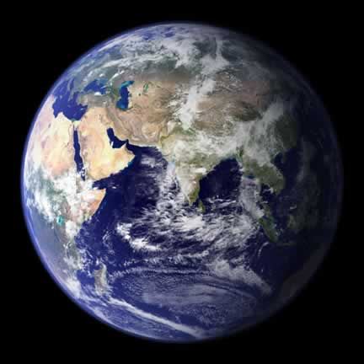
The one planet which supports life.

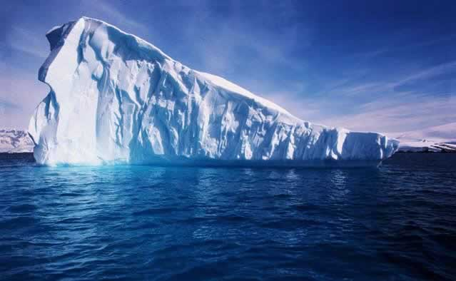
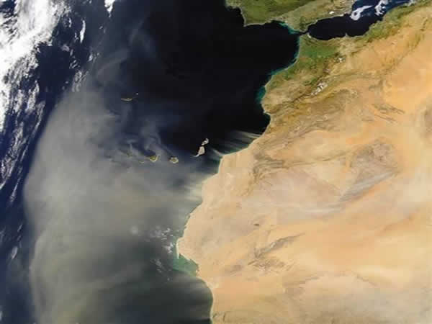
Sand storm over the Sahara Desert
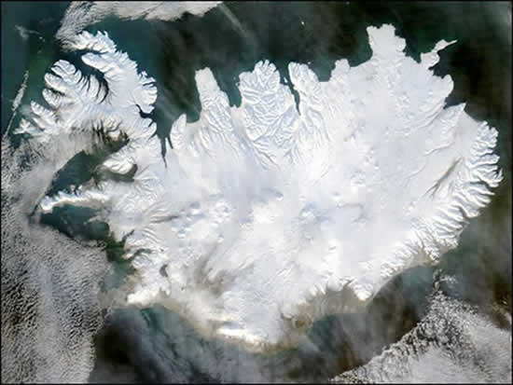
Iceland
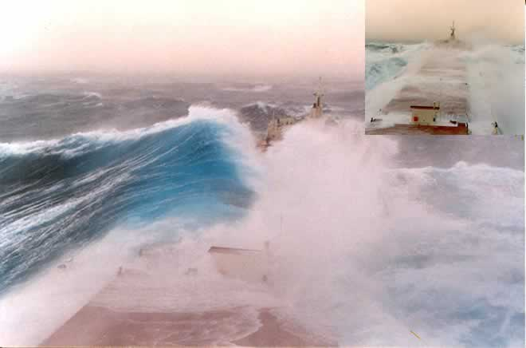
The power of nature
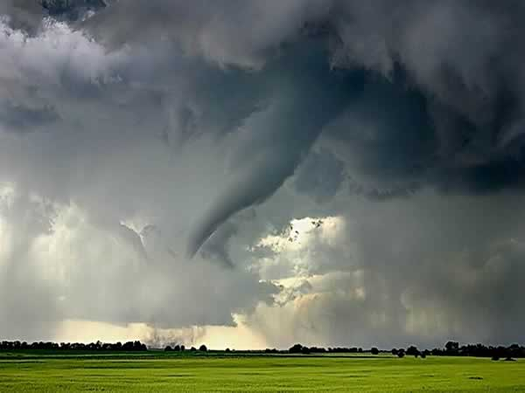
Tornado

- Look at the pictures. Choose one to write a simple poem using a noun, an adjective and a verb in each line.
- In the middle column write the names of some of the things you can see in the picture (noun).
- Then in the left column write a word (adjective) that describes the thing in the middle column.
- Then in the right column write a word (verb) that says what these things are doing.
Adjective | Noun | Verb
Blue | planet | spinning

2. Weather and climate
Go outside and see what the weather is like. Weather is the current condition of the atmosphere and varies from day-to-day.
- Is the temperature hot, warm, cool or cold?
- Is it sunny or cloudy?
- Is it dry or raining?
- Is it windy or still?
- Describe the weather if you were sitting on the beach in the photo below. Use the four weather elements (temperature, cloud, rain and wind) in the four dot points above.
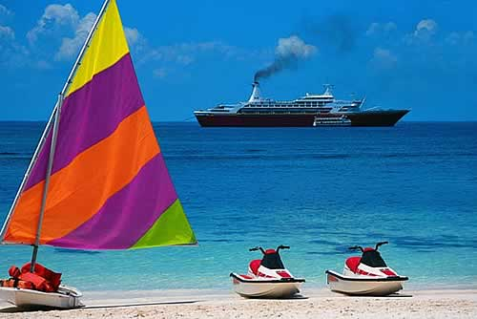
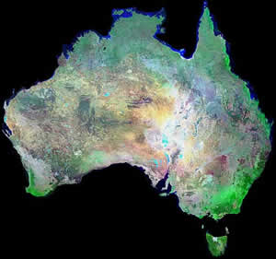
Climate is the general weather condition for a place. It is what you expect it to be like over a long period of time. Technically it is the average weather condition for a place.
If you visited central Australia would you expect it to be:
- hot or cold
- wet or dry?
If you visited a rainforest in northern Queensland would you expect it to be:
- hot or cold
- wet or dry?

3. Australian climates
There are different ways of classifying climate. One way is to divide Australia into six main climatic regions on the basis of air temperature and humidity.
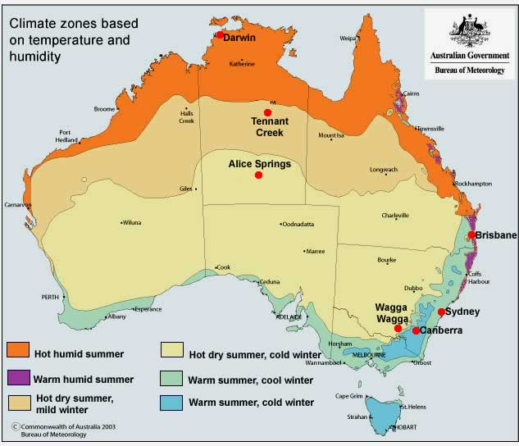
- How does temperature vary from north to south?
- What would you expect the weather to be like if you were in Darwin in summer?
- Name a city you would live in if you wanted warm summers and cold winters.

Average 9.00am temperature ⁰C (close to the average daily temperature)
Location | Jan | Feb | Mar | Apr | May | June | July | Aug | Sep | Oct | Nov | Dec | Annual
Darwin | 27.9 | 27.6 | 27.4 | 27.0 | 25.2 | 22.9 | 22.4 | 24.0 | 26.6 | 28.5 | 29.0 | 28.7 | 26.4
Tennant Creek | 29.2 | 28.2 | 27.0 | 24.1 | 19.9 | 16.3 | 15.7 | 18.6 | 23.1 | 26.8 | 28.9 | 29.8 | 24.0
Alice Springs | 28.3 | 26.8 | 23.9 | 19.1 | 13.8 | 10.1 | 9.4 | 12.6 | 18.1 | 22.7 | 25.9 | 27.8 | 20.0
Brisbane | 25.7 | 25.3 | 24.1 | 21.3 | 17.8 | 14.7 | 13.8 | 15.5 | 18.8 | 21.8 | 23.9 | 25.4 | 20.8
Sydney | 22.3 | 22.3 | 21.1 | 18.2 | 14.5 | 11.8 | 10.6 | 12.4 | 15.5 | 18.3 | 19.8 | 21.6 | 17.4
Canberra | 19.1 | 18.3 | 16.3 | 12.3 | 7.9 | 4.9 | 3.8 | 5.8 | 9.4 | 13.2 | 15.5 | 18.1 | 12.1
Wagga Wagga | 22.5 | 21.8 | 19.1 | 14.5 | 10.0 | 6.9 | 5.8 | 7.7 | 10.8 | 14.7 | 17.8 | 21.0 | 14.4
- Where would you go if you preferred little variation in seasonal temperature?
- Would you go to inland or coastal locations if you preferred large seasonal changes in temperature?
Average monthly rainfall (mm)
Location | Jan | Feb | Mar | Apr | May | June | July | Aug | Sep | Oct | Nov | Dec | Annual
Darwin | 422.6 | 360.6 | 318.8 | 98.9 | 21.3 | 2.0 | 1.4 | 5.7 | 15.4 | 70.7 | 141.8 | 247.9 | 1707.1
Tennant Creek | 100.5 | 129.9 | 58.2 | 15.7 | 8.0 | 4.5 | 5.0 | 1.9 | 7.9 | 19.5 | 36.8 | 72.1 | 460.0
Alice Springs | 38.0 | 44.1 | 32.3 | 17.3 | 18.9 | 14.5 | 14.0 | 9.8 | 8.6 | 21.6 | 27.5 | 38.1 | 284.7
Brisbane | 159.6 | 158.3 | 140.7 | 92.5 | 73.7 | 67.8 | 56.5 | 45.9 | 45.7 | 75.4 | 97.0 | 133.3 | 1146.4
Sydney | 98.2 | 112.8 | 119.5 | 106.4 | 103.6 | 118.5 | 68.8 | 79.1 | 60.5 | 71.3 | 81.2 | 74.1 | 1094.0
Canberra | 60.0 | 55.6 | 51.8 | 47.8 | 46.4 | 39.3 | 41.5 | 47.3 | 52.7 | 64.4 | 63.5 | 52.5 | 622.8
Wagga Wagga | 40.2 | 39.4 | 42.3 | 42.5 | 53.6 | 50.2 | 55.7 | 52.7 | 50.7 | 60.6 | 42.8 | 44.4 | 575.1
- Would you go to inland or coastal locations if you preferred wetter climates?
- You like to grow plants which require an even monthly rainfall. Where would you live?

4. Measuring temperature
Air temperature is measured with a thermometer in degrees Celsius which is normally written as ⁰C.
A red liquid in the thermometer expands when it gets warmer and is forced along the tube, when it cools, it shrinks and goes back down the tube.
Maximum and minimum temperatures
Many people like to know how hot or cold it got in a day. The maximum thermometer records the warmest temperature for the day. The minimum thermometer records the coolest temperature.
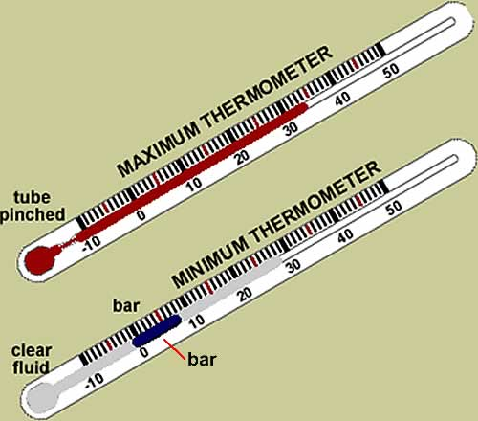
The maximum thermometer has a pinch in the glass tube which allows the fluid to rise into the thermometer as it gets warmer but the pinch stops it from retreating back into the bulb as it gets cooler. It is reset by shaking it.
The minimum thermometer is filled with a clear liquid and a coloured glass bar. The bar cannot break through the liquid so it is dragged back by the liquid as it gets colder. When it gets warmer, the bar stays stationary, it does not move up with the liquid. The minimum temperature is read at the top of the bar.
QUIZ

Temperature is measured by a _________________
Temperature is measured in degrees___________________

5. Measuring rainfall

A rain gauge records the total rain that fell in a given time. | A pluviograph records how much and when the rain fell. The graph paper takes 24 hours to turn once.
A rain gauge might show 25 mm of rain fell in a day. The pluviometer might show that the 25 mm of rain fell during a storm in a 30 minute period or it could show it fell as gentle rain over 10 hours.
- Why is a pluviometer sometimes better than a rain gauge?

QUIZ

Instrument which measures the total amount of rain that fell?

6. Measuring wind speed and direction
Wind speed can be measured with a cup anemometer. The counter below the cups records the speed. The black units are metres and the red units are one tenth of a metre. If the anemometer started at zero and read 054 2 after one hour, the wind speed was 54.2 metres an hour.

Wind direction is measured by a wind vane and is recorded as the direction the wind is coming from. If the wind vane was pointing half way between E for east and NE for northeast, the wind direction was east northeast.

QUIZ
Instrument which measures wind speed?

7. Identifying clouds
Clouds consist of minute droplets of water or ice crystals and are a good indicator of weather conditions.
Download an A4 size cloud chart to use outside. (Courtesy NASA CERES S'COOL Project pdf 1.0mb)
Clouds are classified (named) on their appearance and height.
Name | Appearance
cumulus | a heap
stratus | a layer
cirrus | a hair

Height | Description
over 6000 meters | high
2000-6000 metres | middle
under 2000 metres | low

High clouds over 6000 metres | 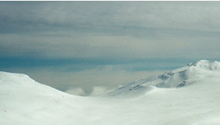  Cirrocumulus (Cc) rarely seen, rippled, ice crystal.
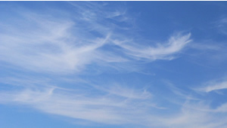Cirrus (Ci) feathery, ice crystal clouds.
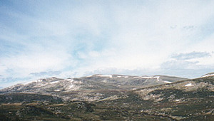
Cirrostratus (Cs) whitish sheet of ice crystals.
Middle clouds, 2000 to 6000 metres | 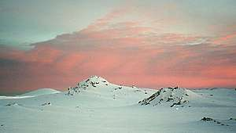  Altocumulus (Ac) puffy, wool pack, appearance.
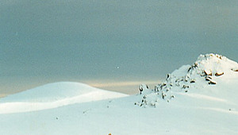
Altostratus (As) grey blanket, mostly water drops.
Low clouds, under 2000 metres | 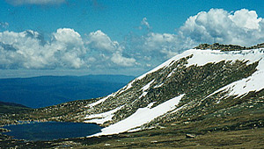  Cumulus (Cu) puffy, woolly appearance.
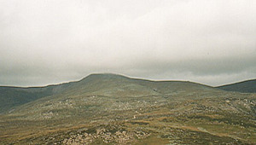
Stratus (St) low, uniform, grey sheet.
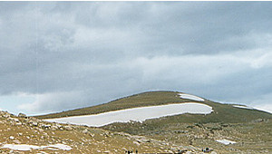  Stratocumulus (Sc) bumpy, grey/white. | 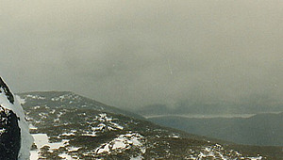  Nimbostratus (Ns) thick, dark with rain.
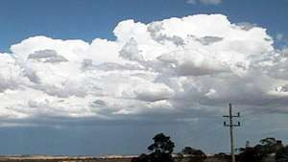
Cumulonimbus (Cn) thunderstorm clouds.
- Go outside and see if you can identify any clouds.

QUIZ

Clouds are classified (named) according to their appearance and _______________

8. Sunlight
The sun gives out waves of energy called solar or shortwave radiation.
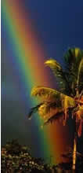
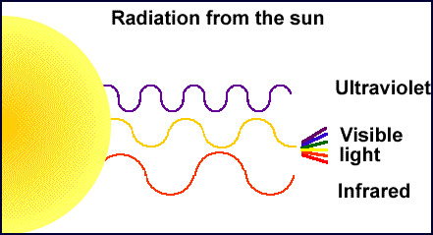
The sun's waves of energy are not all the same.
- Ultraviolet waves are shorter, invisible and cause sunburn.
- We can detect visible light with our eyes as different colours. Each colour has a different wave length, a bit less than one thousandth of a millimetre. When we look at a rainbow the red and yellow waves are longer than the blue and violet ones.
- We detect (feel) infrared waves as heat when we stand in sunlight.

The Earth also gives off longer waves of radiation. The wave length is a bit over ten times longer than visible light and it is called longwave radiation. Hot objects like the sun give off shorter waves of radiation than cooler objects like the Earth.
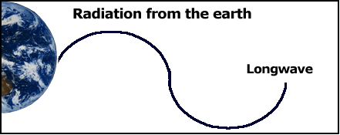
- Research why the sky is blue.
- Try to make or see a rainbow. Sometimes light passing through a window or fish tank will form a rainbow. Draw a rainbow and indicate which colours have longer wave lengths and which have shorter wave lengths.
Newton's colour wheel
Sir Isaac Newton, a famous scientist around 300 years ago, looked at light passing through a prism and saw that it divided into different colours.
He realised that normal white light was made of these different colours and if we put the colours back together we would get white light again. Newton is given the credit for inventing the colour wheel. By spinning the wheel, the colours appear to combine again.
Click for a black line master of a colour wheel to colour in (Word doc).

QUIZ
What type of radiation does the Earth give off?

9. World temperature
Most solar radiation goes through the atmosphere to the Earth's surface where it is absorbed. It is changed to heat and warms the Earth's surface. This warms the air next to the surface.
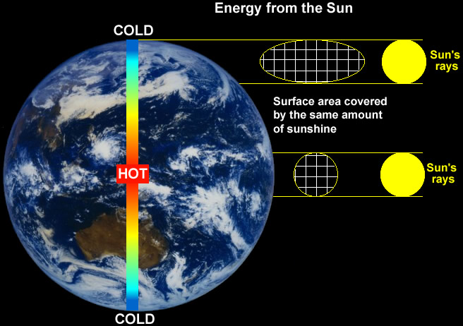
- Count the number of squares in the surface area diagrams. Now explain why the poles are colder than the equator.
- What would happen to global temperatures if the earth's orbit took it closer or further from the sun?
- What would happen to global temperatures if the sun gave off less or more radiation?
- Why does the air get colder, the higher you go, even though this is closer to the sun?

10. Why do we have seasons?
- The Earth orbits the sun.
- It takes one year or 365 1/4 days to orbit the sun.
- During this orbit, our climate changes. In most of Australia we have four seasons: summer, autumn, winter and spring.
- The seasons are caused by the tilt of the Earth.
- The Earth's axis has a tilt of 23 1/2 degrees and as it orbits the sun, the tilt always faces the same direction.
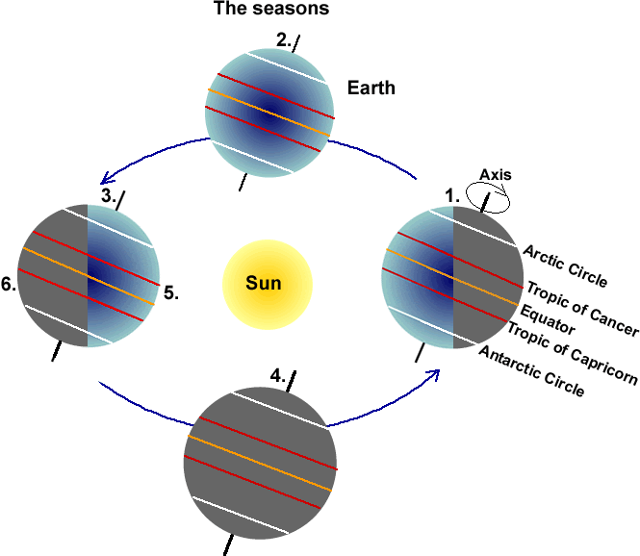
- Look at the diagram above.
- At position 1, is the South Pole having summer or winter?
- At position 2, would Australia be having autumn or spring?
- At position 3, would Australia be having summer or winter?
- At position 3, would the South Pole be having a season of permanent light or permanent dark?
- Why are some parts of the Earth coloured grey?
- What would happen to the seasons if the Earth had no tilt?

QUIZ

What is the imaginary circle around the Earth equidistant from the poles?

11. The atmosphere
- Earth is the only planet with an atmosphere which supports life.
- Look up at the sky on a clear day and the 'blue' atmosphere seems to go on for ever. It is a mixture of gases we call air.
- Scientists divide the atmosphere into four layers depending on temperature.
- Weather occurs in the lowest layer, the Troposphere. Large jets fly at about the top of the Troposphere called the Tropopause. Nearly all air pollution is trapped in this layer.
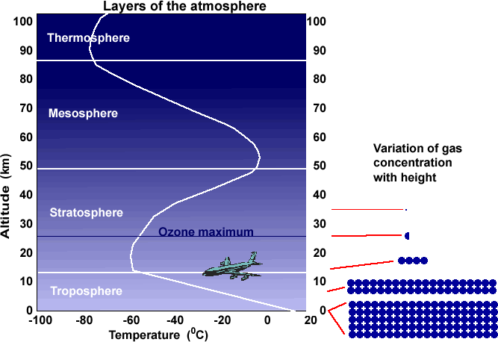
In the diagram above, the left side shows the altitude and the right side shows how the concentration of gas in the air varies with height. The concentration at the surface is 100%.
- What is the concentration of gas (%) in the air at about 8 km altitude?
- What is the concentration at about 12 km?
- Go outside and estimate where the Tropopause is (about 12 km) by looking for a cruising jet or a contrail.
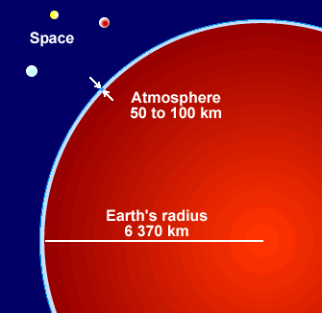
99.9% of the gas in the air is in the first 42 km because gravity causes most air molecules to settle near the surface.
The ozone layer in the stratosphere protects us from the sun's harmful ultraviolet rays. Ozone is made up of three oxygen atoms, O₃. Ozone blocks ultraviolet rays while allowing longer wavelengths to travel through.
Go outside and look at the sky:
- Does it go on for ever?
- Do you think it would be possible to fill it up with pollution from cars, factories and power stations or is it too big for this?
QUIZ

Nearly all of the gas in the atmosphere occurs in which layer?

12. Atoms and molecules
If we could shrink and get right inside substances such as air or water or even people and see the smallest parts that they are made of we would find tiny particles called atoms.
Atoms are the smallest part of any substance.
 |  |  | 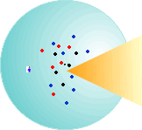 |  | Nitrogen molecule, N₂
 |  |  |  |  | Oxygen molecule,O₂
 |  |  |  |  | Carbon dioxide molecule, CO₂
When different atoms join together in a group we call it a molecule, a bit like making things with a Lego set.
Air is made of two main gases:
- Nitrogen which combines with itself to form a nitrogen molecule (N₂).
- Oxygen which combines with itself to form an oxygen molecule (O₂).
Air also has small amounts of many other gases:
- Carbon dioxide which consists of molecules of carbon atoms joined to two oxygen atoms (CO₂).
Atoms and molecules are so small there are 25,000,000,000,000,000,000 molecules in every cubic centimetre (cm³) of air near sea level.
- Take a deep breath. How many molecules of air did you just breathe in? Most adults have a lung capacity of about 6,000 cm³ so multiply this by the number of molecules of gas in air (above).
QUIZ

The main gas you breathe in is?

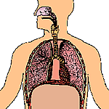
13. The air we breathe

Earth is the only planet with an atmosphere (air) which supports life.
- On the count of three take a really deep breath. One, two, three, breathe in. What gasses were in the air you just breathed in?
- In the diagram below, each dot represents one percent of the air we breathe in. What is the main gas?
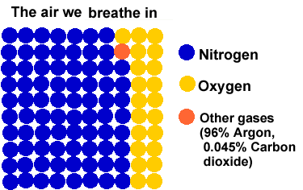
- How much oxygen did you breathe in?
- How much carbon dioxide?

Take a guess at what we breathe out. The amount of oxygen and carbon dioxide we breathe out varies from person to person depending on fitness.
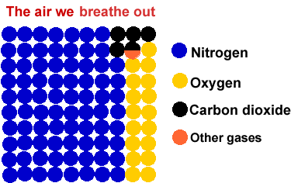
- How much oxygen do we breathe out?
- How much carbon dioxide do we breathe out? Did the amount of nitrogen vary?
- Why does mouth-to-mouth resuscitation work.

QUIZ

The gas we breathe out which is the second highest by volume is?

14. How greenhouses work
People in cool climates grow plants in glass greenhouses because the air inside heats up in the sun. There are two main ways this occurs.
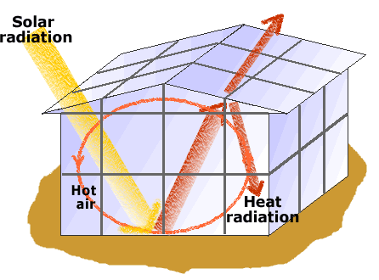
1. Radiation from the sun (solar) passes through the glass and is absorbed by the ground which heats up. The warm ground then gives off heat radiation.This has a longer wavelength (from 5/1000 mm to 1/100 mm long compared to shorter visible solar radiation (about 1/1000 mm long). Only some of this heat manages to pass through the glass, the rest is trapped inside the greenhouse.
2. The air next to the hot ground warms up by conduction. The same as if you put your hand on a hot stove, your hand gets hot. The air is trapped in the greenhouse and keeps heating up by being in contact with the hot ground.
- Sit inside a house or classroom near a window where the sun is shining on you then sit nearby but out of the sun. Which is warmer?
- Place a thermometer inside a room where the sun can shine on it and nearby where it cannot. What happened? To make this a 'fair test', place the thermometer on the same type of surface or hold it for the same length of time.

15. The natural greenhouse effect
The natural greenhouse effect explains how some gases in the Earth's atmosphere reduce the amount of heat escaping from the Earth into space.
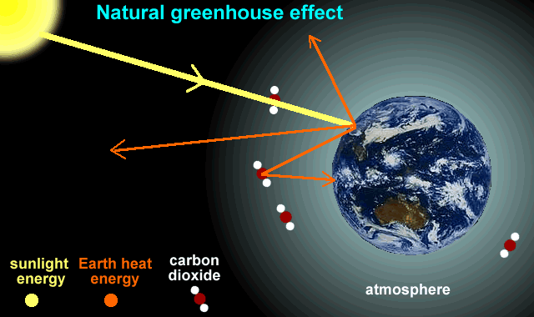
Greenhouse gases such as water vapour, methane and carbon dioxide allow shortwave solar radiation to pass through the atmosphere but prevent much of the Earth's longwave radiation (heat energy) escaping into space.
The natural greenhouse effect of these gases is very important because without it, the Earth's temperature would be minus 18 degrees. The problem is people are putting more of these gases into the atmosphere.
- Explain why the natural greenhouse effect is very important.

16. Human enhanced greenhouse effect

Human actions, particularly the burning of fossil fuels (coal, oil and natural gas) and the clearing of land (burning vegetation), are increasing the quantity of some greenhouse gases in the atmosphere, particularly carbon dioxide (CO₂).

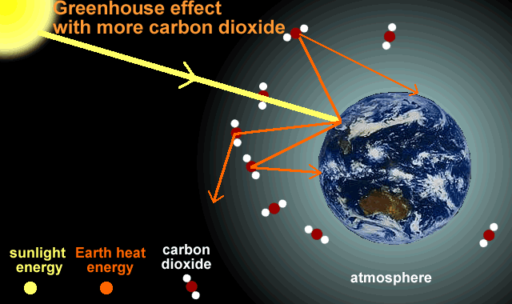

As more of the Earth's longwave radiation is trapped, global temperatures are rising causing global warming.

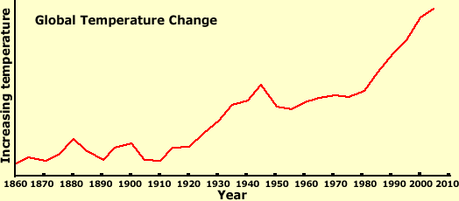
- The temperature line in the graph is not smooth; it has an upward trend but is 'bumpy'. Think of reasons to explain the bumps.
- In your own words, explain why the earth is getting warmer. Draw a diagram to show this.
QUIZ
The term for coal, oil and gas?

17. Water and climate change
Water is a very special substance and plays a big part in clmate change in many different ways.
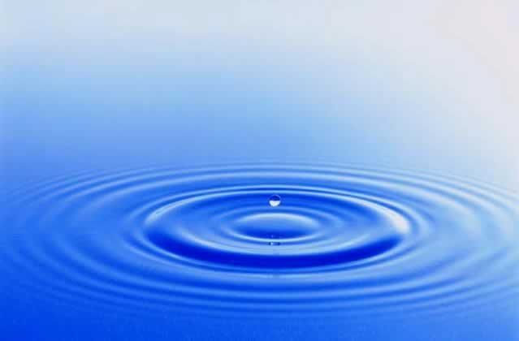
- Water vapour, a gas, is an important greenhouse gas.
- It takes a lot of heat energy to raise the temperature of water so the oceans have stopped global warming from being much greater.
- It takes a lot of heat energy to evaporate water. This heat is released when water condenses from a gas back to a liquid such as when a cloud forms.
- Ocean currents transport a lot of heat (remember it takes a lot of heat energy to increase the temperature of water) from the hotter regions near the Equator to the cooler areas near the poles.
- Explain why water has an important role in climate change.

18. Water and heat energy
It takes a lot of heat energy to raise the temperature of water.
If we apply 42 kilojoules (10 calories) of heat energy to one gram of the following substances their temperature increases by the amounts in the graph. (One gram of water is one millilitre or about 10 drops)
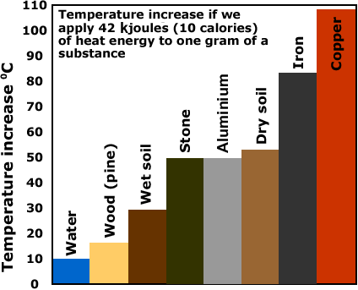
This is also why hot water bottles work well. They keep warm during the night because water can store a lot of heat energy with only a small rise in temperature compared to other substances.
The oceans have absorbed about half the heat energy from global warming.
- Explain why standing under a hot shower to wash in wastes a lot of energy and causes the production of a lot of greenhouse gas if fossil fuels are used to make the electricity.
QUIZ
Energy is measured in ______________

19. Ocean currents
The water in oceans is always moving because of waves and currents. Connecting the world's oceans is a large current, often called the ocean conveyor belt.
The conveyor belt (thermohaline circulation) takes warm surface water from the Pacific Ocean to the Atlantic and returns cold water from the Atlantic to the Pacific as a deep current.
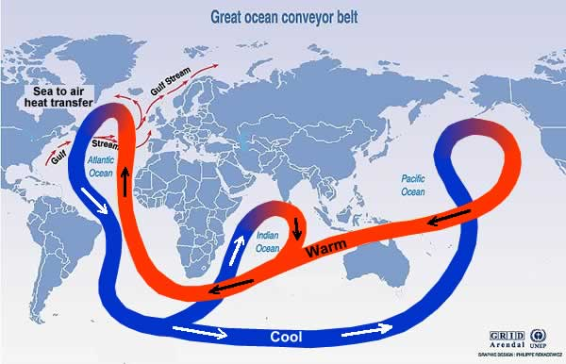
Warm water from the equator moves to the Arctic where it releases heat to the atmosphere. As the water cools it becomes denser and sinks to the deep ocean. This deep water travels along the ocean bottom, eventually coming back to the surface as much as 1000 to 2000 years later.
The Gulf Stream takes warm tropical water from near the Equator to the Arctic. It warms Western European countries such as Great Britain by 9⁰C above what it would be without it.
Recent studies show global warming has caused the speed of the Gulf Stream to slow by 30% and carry 30% less water. Next time you have a shower turn the hot water down by one third and see what happens to the temperature.
- Explain what will happen to the climate of Great Britain if the Gulf Stream slows or has less water?
QUIZ- Name of the ocean current which warms Great Britain and Europe?

20. The East Australia Current
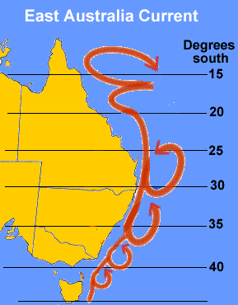
The East Australia Current is similar to a river in the ocean.
It flows at up to 9km/h, is up to 100 km wide and can transport 30,000,000 cubic metres of water per second.
It starts in the Coral Sea off northern Queensland where water temperatures are approximately 30⁰C.
It transports warm tropical water down the east coast and impacts on the climate along the coast.
The CSIRO have reported that the waters off the east coast of Tasmania have warmed over the past 50 years as the current has moved further south.
Water off the east coast has been warmed by 2.28⁰C which is much higher than the climate change global average of less than one degree.
Climate change is also impacting on other important world currents such as the Gulf Stream which starts in tropical waters and transports warm water to Europe which is thought to be 9⁰C warmer because of it.

- Pour a glass of water from the tap and measure its temperature with a thermometer. Put your finger in to feel it, then put warm water in it until it is 9⁰C warmer and feel it again.
- How would the East Australia Current effect fish, people swimming, shipping and the climate along the coast?

21. Water as a solvent
If we put sugar in water it appears to disappear. It dissolves in the water forming a solution.
The liquid in which a solid dissolves is called a solvent. Water is an extremely good solvent; it dissolves more substances than anything else.

Sugar in water  time 0 min. | Time 10 min. | Time 30 min.
Nearly half the carbon dioxide released into the atmosphere is dissolved in the oceans. This reduces the greenhouse effect and slows climate change.
Carbon dioxide and water form a very weak acid, carbonic acid and ocean acidity has increased by about 30%. This is starting to have an impact on the ability of marine organisms such as corals to make shells.
As more carbon dioxide enters the oceans, their ability to take up more will decline, leaving more in the atmosphere.
- Put a teaspoon of sugar in water and stir. What happens?
- Why do we wash clothes and dishes in water?
QUIZ

When substances such as sugar 'disappear' in water they are said to have _______

22. Evaporation
If you stand in a breeze in wet clothes or a wet swimming costume you feel much colder than if you were dry. Heat energy is taken from your body to evaporate the water.
Evaporation is the changing of water from a liquid to a gas and this takes a lot of heat energy. People in wet clothes have a far greater risk of suffering from exposure or hypothermia than those in dry clothes.
The heat necessary to change water to water vapour (gas) is called latent heat. It takes about 2,436 kilojoules (580 calories) of heat energy to evaporate one gram of water which is a lot of heat for a small amount of water.
One gram of water is one millilitre. There are 5 millilitres in a teaspoon. That is a lot of energy for a tiny amount of water. (A muesli bar has about 600 kilojoules of energy.)
When the reverse happens and water vapour condenses to form a liquid (water) such as when a cloud forms, 2,436 kilojoules of heat energy are released into the air.
- Wet your hand then move it around slowly to increase the rate of evaporation. Does it feel cooler, warmer or the same?
- Why do we sweat in hot weather?
QUIZ

The word for when water changes from a liquid to a gas ________________

23. Condensation
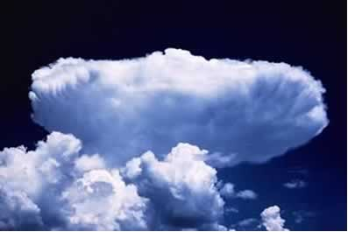
- Watch a big, puffy cloud on a warm day. Does it stay the same shape or is it constantly changing?
When water changes from water vapour, an invisible gas, to a cloud droplet (liquid) it is called condensation and heat energy stored in the water molecule is given off to the surrounding air. This warmer air is lighter than the surrounding air so it bubbles up through it. (Hot air rises.) When it rises, it cools again and so more condensation occurs and the cloud keeps forming and bubbling up.
When water changes from a gas to a liquid it is called condensation and a lot of heat energy is released, 2,436 kilojoules for each millilitre of water.
- Go outside when there are cumulus clouds (puffy) around and watch one closely for 5 minutes. What happens?
We have been having more severe storms. The oceans are now slightly warmer which causes more evaporation. When this extra water vapour condenses into clouds we can get a lot more energy released into the air causing violent winds and big hail stones.
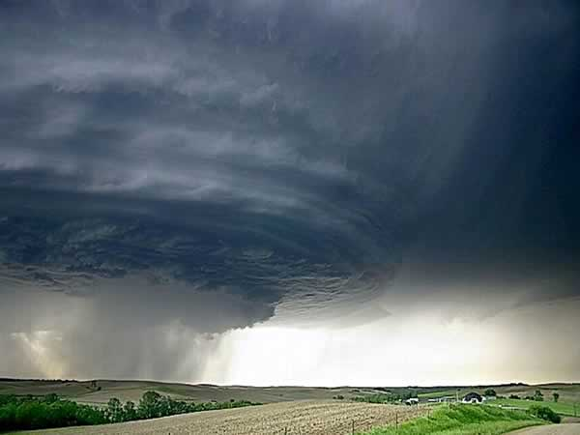

24. The water cycle
The water cycle describes the movement of water between the different states (solid, liquid, gas) and between different places (oceans/rivers, atmosphere and land).
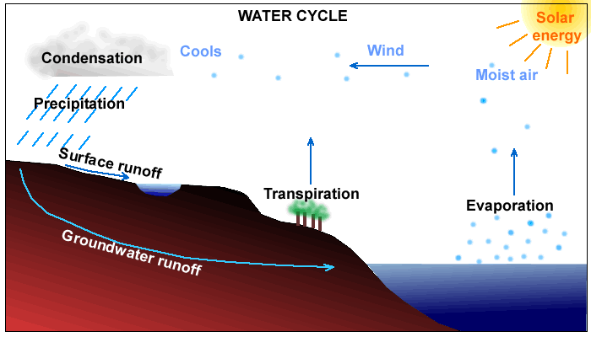

- When water evaporates it changes from a liquid to a gas.
- When it reverses or condenses back from the gas to the liquid form it releases the heat energy that was used to evaporate it.
- So the water cycle moves lots of energy as well as water.
- The water cycle can transport huge amounts of energy into the atmosphere.
Most of the extra heat from climate change has been absorbed by the oceans. As the oceans become a little bit warmer, the amount of evaporation increases, the amount of energy transferred to the atmosphere increases and extreme weather events such as tropical cyclones form.
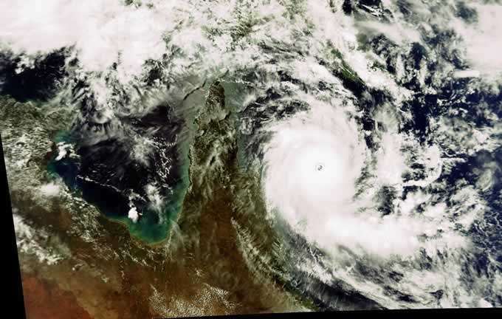
An average tropical cyclone generates enough energy in one day, about 300-400 billion kilowatt hours, to provide Australia's electricity needs for 18 months.
- Look outside on a cloudy day and imagine where the moisture for the clouds came from.
- Look at a cloud and imagine it as a big bundle of energy, it not only rains water it also "rains" heat energy to the surrounding air.
QUIZ
What is the movement of water between places called?

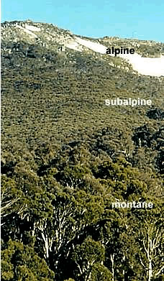
25. Temperature and plants and animals
All organisms have an upper and lower temperature which will kill them. In between these two extremes they can survive. A place which is not too cold nor too hot but just right. This is called the organisms habitat, the area where it can live.
The photo of the Thredbo valley shows three vegetation zones, montane of several tree types below 1350 metres in altitude, sub-alpine of just snow gum trees between about 1350 and 1800 metres and alpine, above the treeline at approximately 1800 metres where no trees can grow.
Trees have difficulty surviving as it gets colder by going up mountains or near the poles.
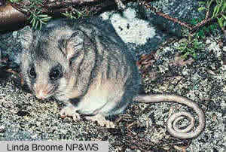
- Describe what happens to trees as the temperature gets colder.
The Mountain Pygmy-possum (Burramys) lives among granite boulders above an altitude of 1600 metres in alpine areas of Australia. The females live in the better, cooler habitat near the tops of mountains, while the males live in poorer habitat lower down.
Look at the diagram below.
If the climate gets warmer:
- What will happen to the three vegetation zones?
- Will the area with snow gums get wider, narrower, move up or move down?
- What will happen to the alpine zone with no trees?
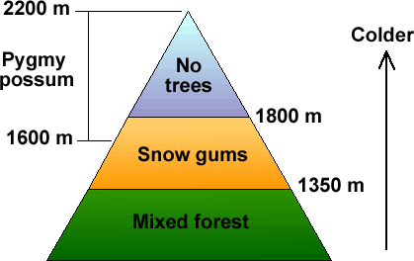
- Will the habitat of the pygmy possum get bigger, smaller, move up or move down the mountain?

26. Past changes in climate

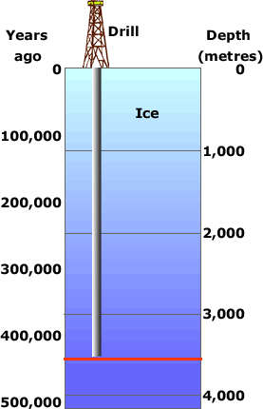
Russian scientists drilled 3,623 metres into the Antarctic ice cap at their Vostok base and took cores of ice to study.
By studying the ice and the air bubbles trapped in it they were able to estimate the age of the ice and global temperatures at that time.
The ice at the bottom had been undisturbed for nearly half a million years.
Below is a graph showing how the temperature changed over that time. There were four ice ages when much of the world was covered in thick sheets of ice.
The most recent ice age ended about 12,000 years ago.
When looking at the graph below, scientists compare past temperatures to the average global temperature from 1961 to 1990 which was about 15⁰C. This average temperature is 0⁰C on the graph. So -2 on the graph is really 13⁰C.
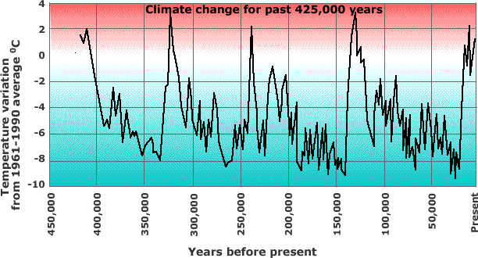
- Where is the older ice, at the surface or deep down?
- Estimate the approximate dates in years before present of the four ice ages over the past 400,000 years.
- How much colder than now were the ice ages?
- How much warmer than now were the warmest periods of the 'interglacials', the periods between ice ages such as now?
- Why do scientists report temperature change as being warmer or cooler than the 1961-1990 average instead of giving the actual temperature?

27. Tree ring evidence
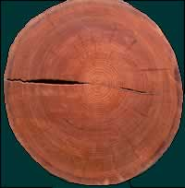
The Earth's temperature change is not just measured with thermometers. There are natural indicators including tree rings. They show how much a tree has grown in width each year. In wetter years, trees grow more so the growth ring will be wider than for drier years.
This field of scientific study is called dendrochronology. Scientists can use tree ring patterns to reconstruct patterns of drought and climate change. Scientists have used Siberian pines from Mongolia which indicate yearly temperatures dating back to the year 262, over 1,700 years ago.
Each yearly tree ring has two layers, a light coloured layer which grows in good seasons such as spring and a dark coloured layer which grows in difficult seasons such as late summer or during droughts. Tree rings of a similar width each year indicate the climate did not vary.
The section of tree below is from a mountain ash at Batlow.
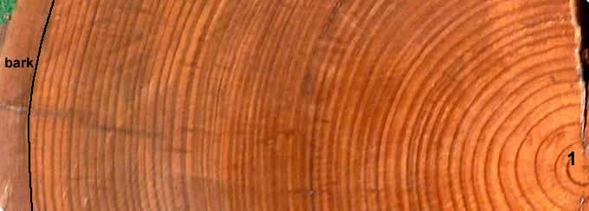
- Count just the dark rings to find how old the tree was when it was cut down. The first ring has been numbered 1. The last ring is next to the bark.
- The tree was logged in 1992. In which year did it start growing?
- In which three years of its life did the tree grow most?
- In which years of its life did it grow least?
- Ignore the first few years of life when the tree was young. When were the most favourable conditions for growth?

28. How is our climate changing?
The maps below are based on data produced by the CSIRO for the New South Wales Government Greenhouse Office.
Map showing how maximum temperatures have changed since 1950. | 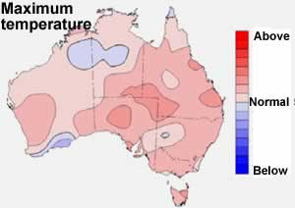
Map showing how minimum temperatures have changed since 1950. | 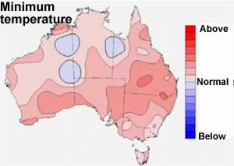
Map showing how rainfall patterns have changed since 1950. | 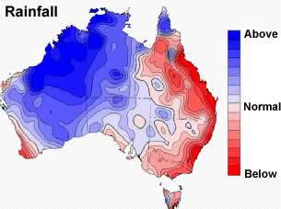
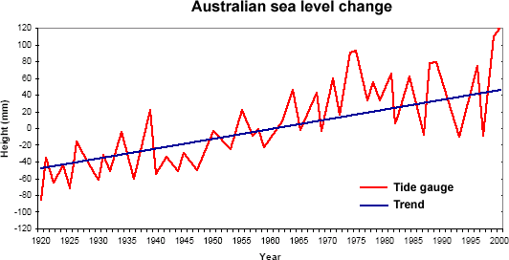
There has been a rise in sea level of about 1.2 mm per year from 1920 to 2000 which is a little bit below the global average.
Predictions for the Riverina | Days Below 0⁰C |  | Days Above 35⁰C
 | Present | Year 2030 | Present | Year 2030
Wagga Wagga  Deniliquin  Wyalong | 26  10  9 | 10-23  2-8  2-7 | 20  24  26 | 21-34  25-37  27-42
Note: the predictions for the Riverina are based on climatic models; the figures are what scientists think will happen by the Year 2030. They are not sure so they have given two figures, a low and a high one. Scientists estimate Wagga Wagga will have somewhere between 10 and 23 days each year with temperatures below zero degrees.
- Have the maximum temperatures increased evenly over Australia?
- Have minimum temperatures increased or decreased? Describe where?
- Has all of Australia become drier since 1950?
- How might the change in temperature effect where plants and animals might live?
- How would the change in temperature impact on farmers?
- How would these climate changes impact on you?

