March 2014
Riverina Environmental Education Centre

Water

Table of Contents
Important information
1. Water: the issue
2. What happened to the Aral Sea?
3. Why does Adelaide have a problem?
4. River health in the Murray-Darling Basin
5. Many uses of water
6. Population growth
7. The water cycle
8. All the water in the world
9. Rainfall in Australia
The Murrumbidgee catchment
The remainder of this study guide is a case study of the Murrumbidgee Catchment
10. Murrumbidgee catchment overview
11. Griffith and the MIA
12. Water use by irrigated crops
13. Changes down the catchment
14. Murrumbidgee water cycle
15. Aquifers
16. Groundwater
17. Murrumbidgee long profile
18. Rainfall variation
19. River regulation
20. River flow Variability
21. The Snowy Mountains Scheme
Table of Contents- Continued
22. Regulated flow in the Murrumbidgee
44. Testing water
45. River red gum forests
46. Water birds
Management
47. Climate change
48. Groundwater
49. Groundwater management
50. Afforestation
51. Government water policy

23. Regulated flow January
24. Regulation and seasonal flow
Allocation of water
25. Murrumbidgee water Sharing Plan
26. Water allocation history
27. Crop water requirements
28. Rice
29. Rice and seasonal river flow changes
30. Rice: water efficiency
31. Triple bottom line accounting and rice
Water and the environment
32. Environmental water
33. Gundagai Choke
34. Environmental flow and frogs
35.River health: fish
36. Wetland fish investigation
37. River health: macroinvertebrates
38. Pollution
39. Salinity
40. Wetland salinity problems
41. Phosphorus
42. Blue-green algae
43. Turbidity

Important information
- Water is a renewable but also a scarce resource. Water is a renewable or replaceable resource because it is replaced by movement through the water cycle. But it is also scarce, we can still run out of water if people use it faster than it is replaced by rainfall or if we pollute it and cannot use it.
- Apart from Antarctica, Australia is the driest continent in the world. 70 per cent of the mainland receives less than 500mm of rain annually and is classified as arid or semi-arid.
- Many of the world's rivers flow through a number of countries creating problems on how the water is shared between countries and who is polluting it.
- There are approximately 500 cities and towns in Australia that depend upon groundwater for drinking purposes.
- 17 of 20 rivers assessed for 'River Health' in the Murray-Darling Basin were classified as poor to very poor. The Sustainable Rivers Report (MDBC), 2008 found the Murrumbidgee River to have the worst river health in the Murray-Darling Basin.
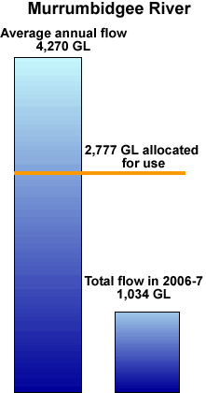
- Much of Australia's fresh water supplies are in north-western Australia away from population centres.
- Population increase, especially in coastal urban areas, is placing further pressure on water supplies.
- Groundwater is a very important source of water in the Murrumbidgee catchment making up approximately 20% of total water used.
- Rainfall and river flow are very variable in Australia, both seasonally and from year-to-year.
- Large irrigation schemes including the MIA depend on reliable supplies of water.
- The Murrumbidgee is a 'working river'. It is regulated by dams in the headwaters to supply water when people need it.
- The Water Sharing Plan for the Regulated Murrumbidgee determines who gets the water. The main licence categories are general and high security water. The quantity of water allocated is determined by the long term average annual flow of 4,270 gigalitres (GL). The Water Sharing Plan allocated 2,777 GL or 65% to people which is very high.
- In dry years such as 2003 the annual flow in the Murrumbidgee was 2,053 GL, someone has to miss out and this is not taking into account water needed for the environment so the river does not dry up.
- In 1994 the Australian Government enacted the National Water Commission Act which included the notion of environmental water to preserve the health of Australian rivers.
- The main water pollution issues in Australian rivers are: salinity, turbidity and nutrients.
- Future risks to water supply include:
  - climate change with less rainfall and much less runoff
  - over use of groundwater
  - afforestation

1. Water: the issue
Water is a big issue to the safety of this person but it is not our issue.
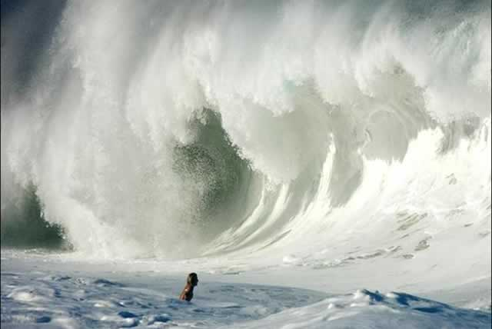
The dry irrigation canal is our issue. How should the community care for and share water?
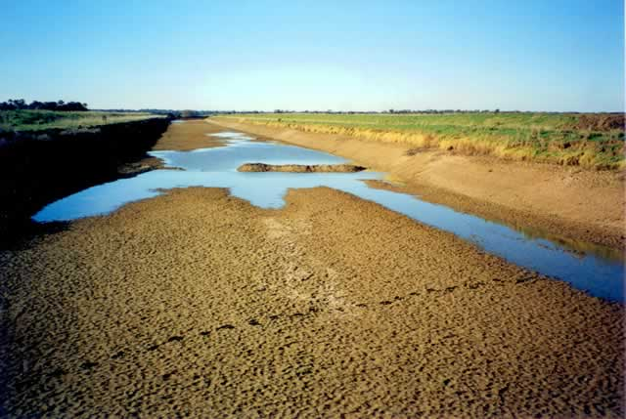
Water is a scarce resource. Some of Australia's major water issues are.
- Availability: Rainfall determines the volume of water available. This impacts on river flow and groundwater. Water storage in dams secures water for human use but creates environmental issues.
- Consumption: Water consumed for home use makes up 11% of total water use. Agriculture uses 65%.
- River health: Water quality is related to river and wetland health. Major issues include salinity, turbidity and blue-green algae. Reduced flows impacts on agriculture, tourism and aquatic ecosystems.
- Management: Mandatory household water restrictions apply to many parts of Australia and many irrigation farmers do not receive their licence entitlement.
Source Issue: Water, ABS, Australia's Environment, Issues and Trends, 4613.0, 2007. This is a highly recommended resource of 19 pages available by downloading for free from the Australian Bureau of Statistics web site. Google abs 4613.0 (Important to type the full number)
QUIZ

Water is an issue because it is a _______________________ (two words)?

2. What happened to the Aral Sea?
The Aral Sea was once the fourth largest inland body of water on earth with a surface area of 66,000 km². The main volume of water comes from glaciers feeding into the two main rivers, the Syr Darya and the Amu Darya. In ancient times the Aral Sea region was an oasis, where thousands of people lived as fishermen, farmers, merchants, hunters and craftsmen. It was once an important area that connected Europe and Asia as part of the Great Silk Road.
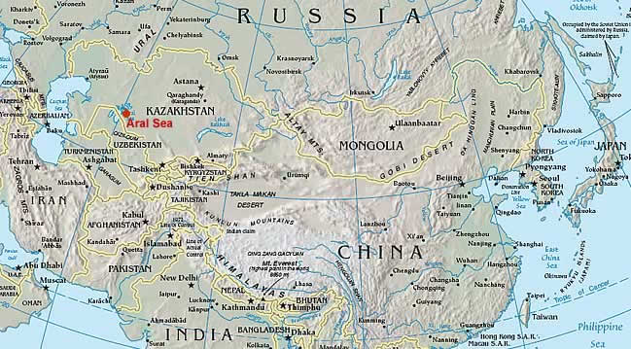

Soon after the creation of the Soviet Union, its leaders made plans to increase the production of cotton (often referred to as white gold) and rice in Central Asia by expanding irrigation. This led to massive irrigation projects in the Aral Sea Basin commencing in the 1950's. The scale of the irrigation projects was enormous and little thought was given to the Aral Sea downstream. Irrigation techniques were inefficient with open waterways causing much waste. By the 1980's, during dry or average years no river water reached the sea at all. Its surface level shrunk by half and in some sites the sea's edge is over 100 km from its former shore. To improve crop yields, fertiliser and pesticides were applied and were washed into the sea. The exposed former seabed consists of lifeless, salt encrusted sands contaminated by pesticides. Large dust storms, which can occur ten times annually scour the seabed and transport tens of millions of tons of dust per year to be dumped on the surrounding land and its inhabitants causing the health of the population to decrease greatly. Journal of Rural and Remote Environmental Health 1(2): 29-34 (2002) The Aral Sea environmental health crisis. Phillip Whish-Wilson
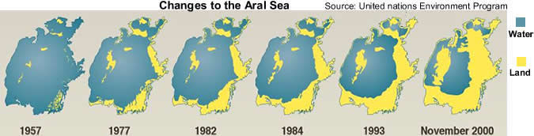
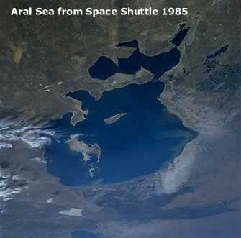 | 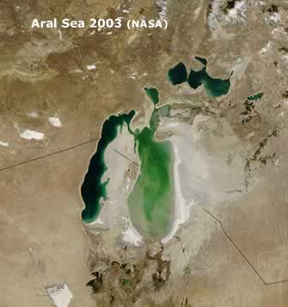
In the 2003 satellite image above the remaining water of the Aral Sea is a green colour. Compare the two images above to the maps above of a similar date. (Images: NASA)

- Explain why the size of the Aral Sea decreased.
- Describe the problems associated with the decline in the size of the Aral Sea.

3. Why does Adelaide have water problems?
Adelaide receives about 42% of its water from the Murray in normal rainfall years and up to 90% in drought years. The Murray is over 2,500 km long from its headwaters in the Snowy Mountains to where it enters the sea in South Australia and has a catchment area of over 1,060,000 square kilometres when the Darling River is included. This is about one-seventh of the total area of Australia. This means a lot of people up catchment get to use the water first and a lot of pollution can enter the river before Adelaide.
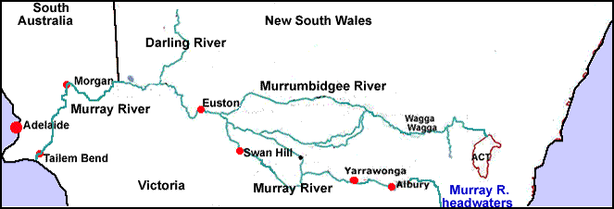
The average annual flow is the amount of water flowing down the Murray in a year. It is recorded in GL's (gigalitres), 1 GL = 1 thousand million litres or about one thousand swimming pools 50 metres long by 20 metres wide and 1 metre deep.  The green line shows the flow before people changed it. The orange line shows the normal flow that occurs now. | 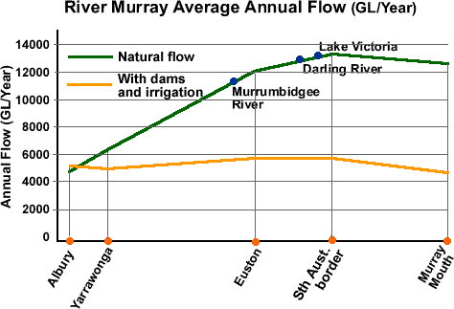
Salt is a natural part of Australia's environment and has accumulated in the soil from rainfall, the weathering of rock and old sea deposits.  People have now changed the land and salt accumulated in the soil is dissolving in groundwater and washed into the river system. The desirable limit for humans is 830 EC's. | 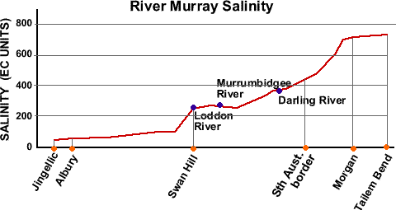
Phosphorus is essential for plant growth and is not poisonous to people. It becomes a serious pollutant when there is enough to cause increased growth of algae and other aquatic plants.  Blue green algae can be highly toxic to livestock and humans and is a serious problem considering the number of towns using the river for their water supply.  Large amounts of phosphorus enter the river from the house - sewage treatment plant - river link. The desirable upper limit is 0.05 mg/L. | 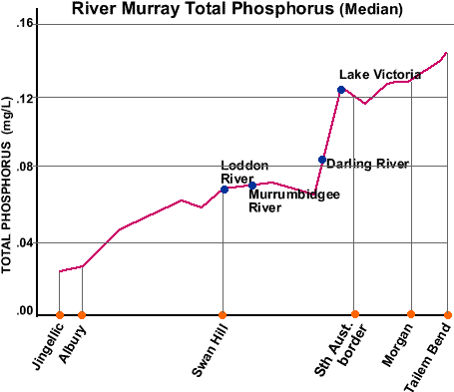
Turbidity or muddiness of the water is caused by fine particles such as clay and plankton (microscopic plants and animals) suspended (floating) in the water.  Turbidity increases when there is a lot of soil erosion in the catchment from storms or when the river is high and erodes its own banks.  Lake Hume at Albury traps 800,000 cubic metres of sediment each year. | 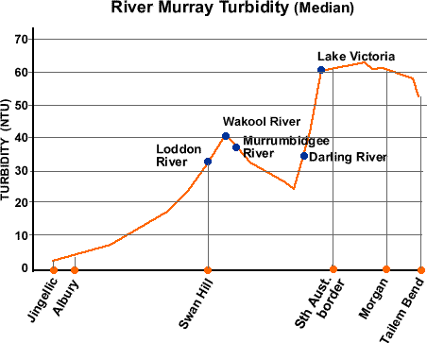

- Explain why Adelaide's water issues need to be solved on a whole of catchment basis?

4. River health in the Murray-Darling Basin

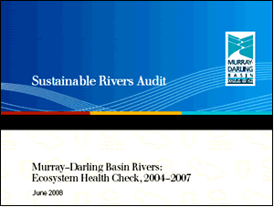
A wide variety of measurements can indicate river health. Information on algae, fish, invertebrates, water plants, birds and many other things give a ‘window' on the river. The Murray-Darling Basin Commission in its Sustainable Rivers Audit released in 2008 chose fish, macro invertebrates and river hydrology. Data collected on these was compared to Reference Condition assessments, what they would be like in a natural river, not changed by people.
The Ecosystem Health assessment shows the Paroo to be the best in 2004-2007 but an article in The Weekend Australian newspaper August 16 2008 states, "the Queensland government came under fire for permitting the construction of a large dam and diversion channels along the Paroo River, regarded as the Murray-Darling Basin's last free-flowing river."
- Which two rivers have the worst health?
- Explain what you think the term 'river health' means.
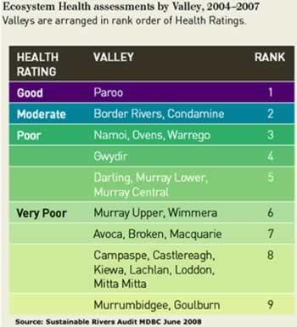
- Most of the rivers above are on the map below (some of the Victorian rivers are missing). Can you locate them?
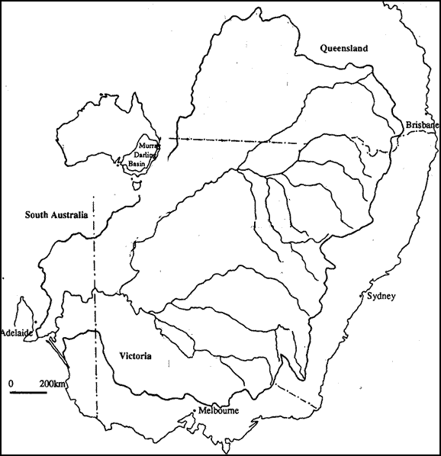

5. Many uses
We need water for many different uses. There is not enough for all and the community is presently deciding how to share this scarce resource.
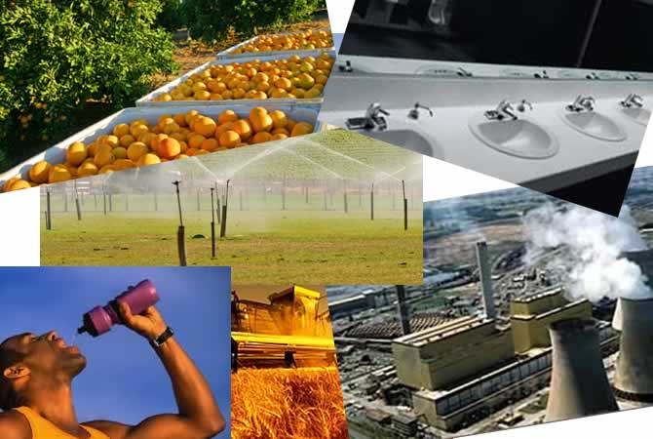
- Explain why water can be scarce if it is a renewable resource?
- List 5 things you use water for in a day?

6. Population growth
“Population increase, especially in coastal urban areas, is placing further pressure on water supplies.” ABS Australia's Environment: Issues and Trends 2007

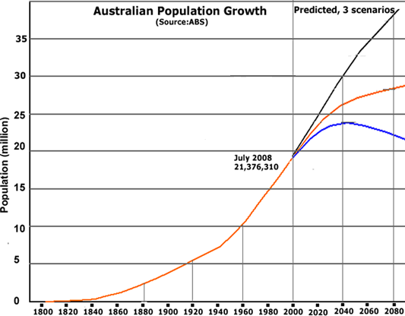
Three different scenarios are given for population growth depending on birth and death rates and migration.
- Has water always been an issue in large urban areas such as Sydney? How would community attitudes to water use such as watering gardens and washing cars have changed? What would they be like in 2040?

7. The water cycle
A typical water cycle diagram. It shows that water is a renewable resource.
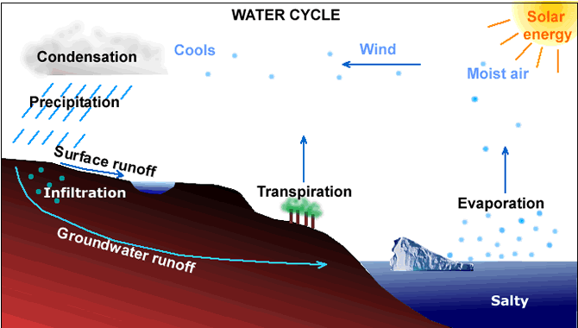
- List the parts of the water cycle?
- Which part of the water cycle determines the upper limit on how much we have?
- Explain the statement: "water is a renewable resource"?
- Have a look outside. Make a water cycle diagram for your school area and present weather conditions? Many scientists are now investigating the water balance (water cycle) of catchments in Australia.

QUIZ

What is term for the change of state of water from a gas to a liquid?

8. All the water in the world
The previous water cycle diagram showed water to be a renewable resource. This diagram shows it is a scarce resource.
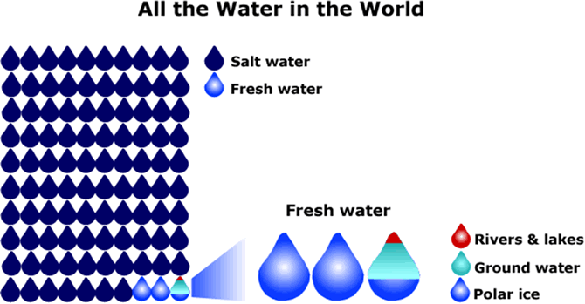
- Make a bar graph from this diagram?
- How can we get more fresh water? For each idea, give the good points and the bad points. Would there be an environmental cost in implementing your idea?

9. Rainfall in Australia
Population map underneath.
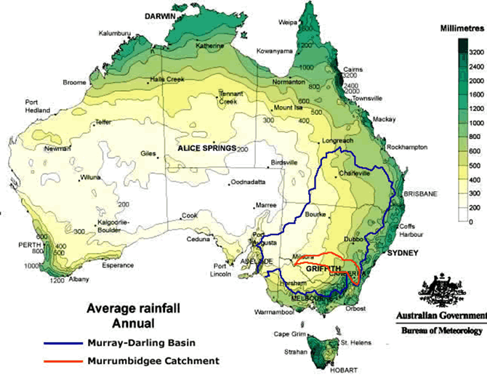
- Areas with an annual rainfall below 500 mm are classified as arid to semi-arid. Estimate the proportion of Australia in this classification.
- The Murray-Darling Basin and Murrumbidgee catchment have been outlined. What proportion of these catchments are arid to semi-arid?
- Which region in Australia has the most rainfall? Compare this to the map of population density. Which areas receive a lot of rainfall but have a very low population density? To see the population map place your mouse on the rainfall map.
- Explain why South Australia relies so much on the Murray River for water?

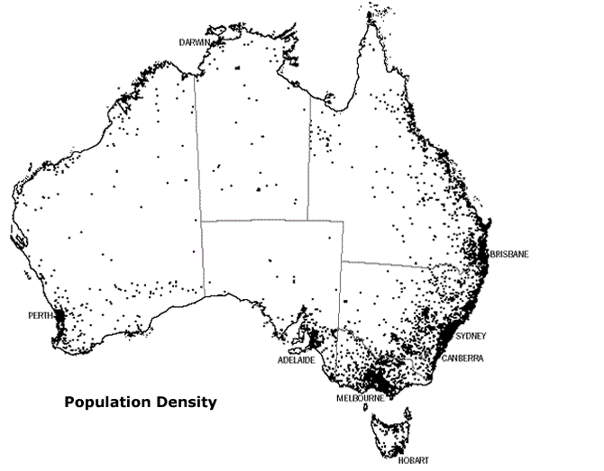
QUIZ

Most rainfall in Australia occurs close to the?

10. The Murrumbidgee catchment
The Sustainable Rivers Report (MDBC), 2008 found the Murrumbidgee River to have the worst river health in the Murray-Darling Basin. The rest of this study guide investigates this issue.
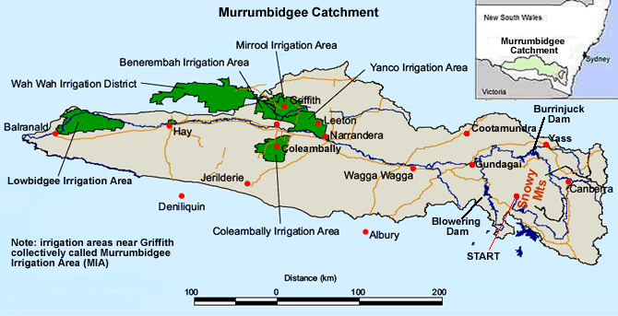
- Draw a sketch map showing the Murrumbidgee River, major towns and irrigation areas?

QUIZ

What is term for the combined irrigation areas of Yanco, Mirrool, Benerembah and Wah Wah? (3 letters)

11. Griffith and the Murrumbidgee Irrigation Area (MIA)
The first waves of European inhabitants of the Griffith area were the squatters who took up large parcels of land, thousands of hectares, and grazed herds of cattle and flocks of sheep. Much of the land carried only one sheep to two hectares and there were no more than 100 people living in the area.
Now Griffith is a large regional city with a population of 24,867 in 2006. Irrigation has allowed very productive, intensive agriculture. Griffith was first settled in 1912 and irrigation water became available in 1913. Water Burly Griffin designed Griffith for a population of 30,000 and planned it around a one and a half mile radius circle. Like Canberra, the urban design featured a radial pattern with wide tree lined streets, ring-roads and parks. The focal point was to be a grand circle with the Town Hall, court house and other government buildings.
Source: Walter Burley Griffin Society - Lives and Works, Web based www.griffinsociety.org
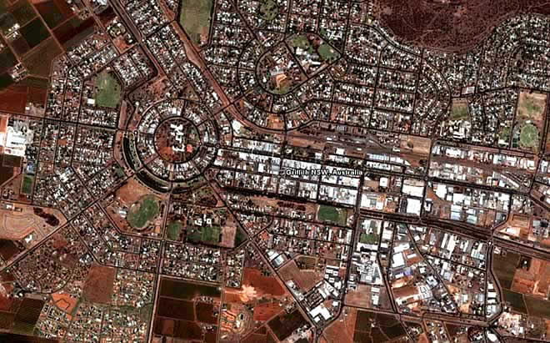
The image above shows the city of Griffith. Larger, commercial (retail and industrial) buildings are surrounded by smaller residential blocks which are surrounded by horticultural farms.
There are two main types of agriculture in the MIA:
- Large area farms in the MIA have a typical size of 220 ha. They grow a combination of rice, corn, wheat, vegetables and pasture and graze beef cattle. These farms generally rely on general security irrigation water which varies greatly from year-to-year.
- Horticultural farms are typically 20 ha in size. They grow a combination of permanent crops that may include wine grapes, peaches, plums and citrus fruit such as oranges. Because the plants are long living, not seasonal like rice, they rely on high security water which is guaranteed except in the worst droughts.
The value of farm production in the MIA varies from year-to-year but is generally around $700,000,000. The MIA produces 90% of the NSW citrus crop. Around 150 000 ha of rice are sown each year in Australia producing 1.3 million tonnes at a yield of 8-9 tonnes per hectare and a total crop value of $800 million. Nearly all Australian rice is grown in the Murrumbidgee Irrigation Area, Coleambally Irrigation Area and Murray Irrigation Areas.
Source: Murrumbidgee Irrigation www.mirrigation.com.au
- Draw a sketch map of Griffith and label the main land use areas and the main parts from Griffin's original plan?
- Describe the difference between large area and horticultural irrigation farms?
- Explain why large area farms have general security water and horticultural farms have high security water?
- Describe what this area would be like if there was no irrigation?
The false colour satellite image below shows the Griffith and Coleambally irrigation areas and the surrounding dryland farming areas. Prior to European settlement most of the image would have been a dark colour indicating bushland, then a mix of browns and greys as extensive grazing took place and now we have the bright green of intensive horticulture and agriculture as well.
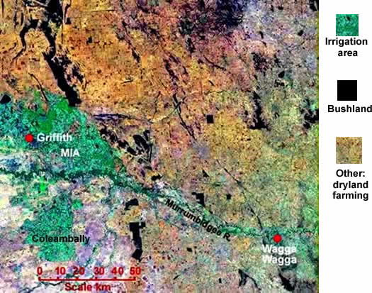
- Describe the sequence of vegetation and land use changes to this area since European settlement?
- Draw a sketch map of this region showing remnant bushland, dryland and irrigation farming?

12. Water use by irrigated crops
Water use by crops in the Murrumbidgee Irrigation Area for a "normal" pre-drought irrigation season in 2000/2001 (Irrigation water years are from July to June, not January to December.)
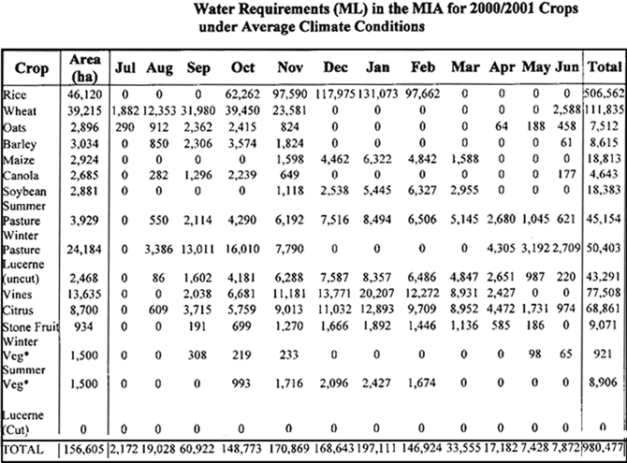
Source of table: "Whole of catchment water and salt balance to identify potential water saving options in the Murrumbidgee catchment", CSIRO 2004
- Which crop used the most water and in what months of the year?
- Make a graph of the bottom line showing total monthly water use. Which months had the greatest water demand?

Water use by crops in the Coleambally Irrigation Area, CIA.
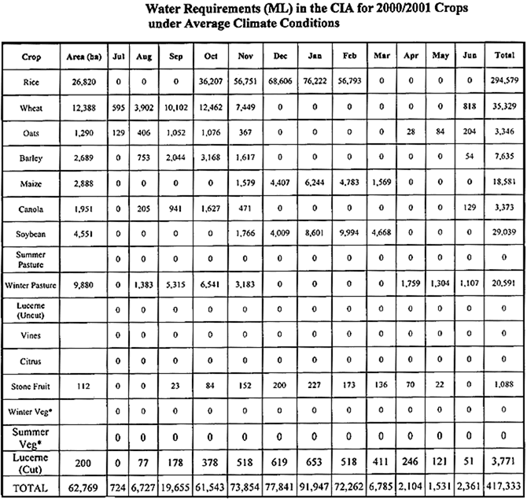
- Which crop used the most water and in what months of the year?
- Make a graph of the bottom line showing total monthly water use. Which months had the greatest water demand?

13. River changes down the catchment

The Murrumbidgee River a few kilometres from its start at Long Plain near Kiandra in the Snowy Mountains

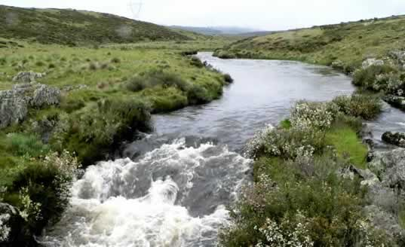

The Murrumbidgee near Wagga Wagga
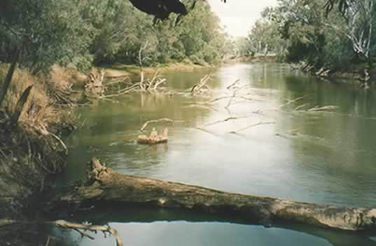

The Murrumbidgee at Darlington Point
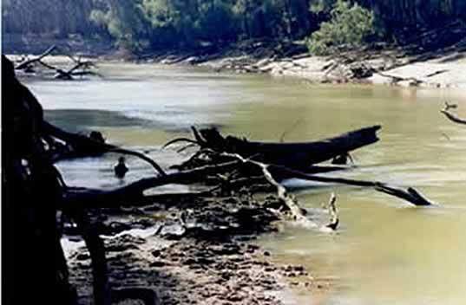
Snags or fallen timber are very important habitat for native fish and invertebrates. Snags were removed in the past for paddle steamers and assist flood flows but now scientists are putting snags back in the river for habitat to improve river health.
- Compare the width, volume, water colour and banks at the three locations.
- Make annotated line drawings of the three photos.
- Make a fourth drawing of what you think the river would like further downstream just before it enters the Murray River past Balranald.

14. Murrumbidgee water cycle
The fate of rainfall for 2004-2005 in the regulated catchment- below the major dams.
(Source: www.water.gov.au)
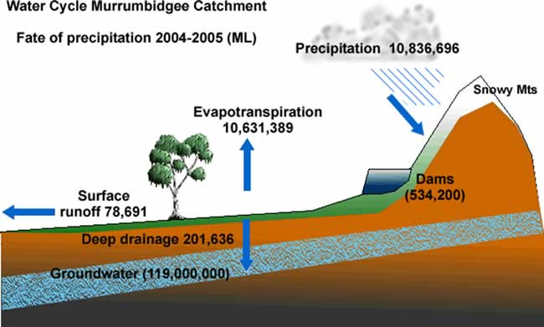
- At the start of the irrigation year in 2004, the dams (Burrinjuck and Blowering) and groundwater already had a store of water.
- Deep drainage is water that gets past the roots of plants and joins the groundwater. Surface runoff is the flow in rivers.
- Evapotranspiration is the evaporation from lakes, wetlands and rivers and the transpiration from plants such as native woodlands, dryland farming crops such as wheat and irrigated crops such as rice.
- The total water in evapotranspiration, deep drainage and runoff do not equal precipitation. Some water stays in the soil profile and the science is not that accurate for measuring what happens to the water.
- Draw a water cycle diagram for the Murrumbidgee catchment using the quantities for 2004/5.

QUIZ
Which component of the water cycle shown has by far the largest store of water?

15. Aquifers
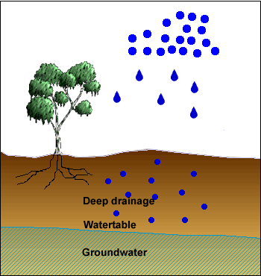
Diagrams of groundwater often look like this one with rainfall, deep drainage of some water below the root zone, a water table at the top of the groundwater and the groundwater itself filling pores in the soil and rock.
Soil and rock are rarely uniform. There is often a variety of different rock and sediment types deposited by rivers over perhaps millions of years and under very different climates. Some deposits may be impermeable clays which have no or very slow groundwater movement, other deposits consist of sands which are porous (air spaces) and permeable (allow the movement of water). These deposits or layers are called aquifers.
Below is a cross-section of part of the Murrumbidgee floodplain at Collingullie between Wagga Wagga and Narrandera showing a number of aquifers.
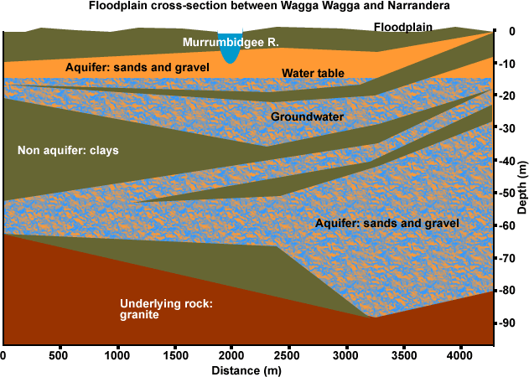
The aquifer between Gundagai and Narrandera is well-connected to the river, meaning that water leaks out the bottom of the river and tops up the aquifer. Much of the groundwater pumped for farm and town use is actually river water replacing used groundwater.
The Mid-Murrumbidgee Alluvium between Gundagai and Narrandera has two major aquifers, the upper Corowa Formation and the lower Lachlan Formation which is less salty and from which many town supplies are taken. As groundwater is pumped out, the water table drops then leakage from the river causes it to rise again.

QUIZ

A rock or deposit which is both porous and permeable is called an?

16. Groundwater
The total groundwater use for the catchment in 2004/5 was 407 GL. This represents 17% of total water use. In dry years when there is less surface water, this would represent 26% of total water use so groundwater is a very important source of water. The catchment is divided into three major groundwater units.
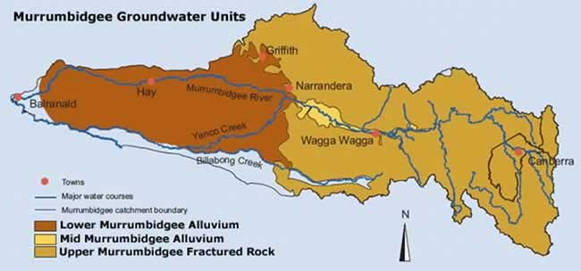
The Upper Murrumbidgee Fractured Rock unit consists of hard rock with limited groundwater pumping ability. This area provides base flows to local streams (groundwater seepage into streams keeps them flowing) and are called gaining streams.

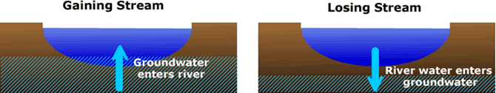

The Mid-Murrumbidgee Alluvium is a deep V-shaped aquifer from Gundagai to Narrandera. It depends on seepage from the river to maintain watertable height and is a losing stream for much of this unit.
The river and tributaries in the Lower Murrumbidgee Groundwater Management Unit are losing streams, water moves from the river into the groundwater. As more groundwater is pumped out, more river water can move in.
This has become a major issue with water allocation and licensing. In the Mid and Lower Groundwater Units, the Murrumbidgee River is highly connected to the groundwater so when groundwater is pumped out, it is replaced by river water so we need to manage both together. We could think of groundwater as an underground tributary of the river. If we take 10 ML of water from the groundwater, we lose approximately 10 ML from the river as it leaks through the bottom of the river to replace the groundwater.
- Explain the difference between a gaining and losing stream.
- Why do we need to be very careful about letting people use groundwater when it is highly connected to a river?

17. Murrumbidgee long profile
The river passes through three landform areas: 1. the Snowy Mountains, 2. a hill/valley area from Burrinjuck Dam to Wagga Wagga and 3. the Riverina Plain from Wagga Wagga to the end of the river.
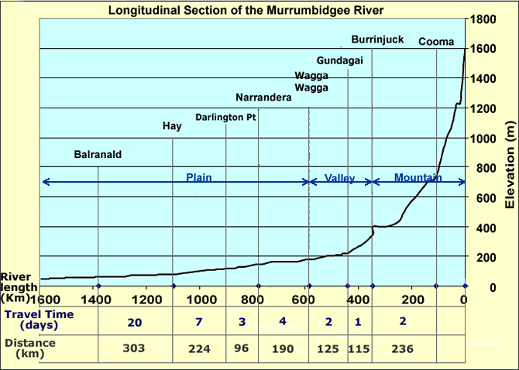
- Describe how the elevation of the catchment varies between Cooma and Balranald.
- Calculate the average speed of the water from Cooma to Burrinjuck Dam in km/hr (2 days = 48hrs) and from Hay to Balranald. Why does it vary?
- If an irrigation farmer in Hay placed an order for water with the Department of Water and Energy, which then releases it from Burrinjuck Dam, how long will it take to arrive?

18. Rainfall variation
The graph shows how rainfall has varied down the catchment, from Cabramurra in the Snowy Mountains to Wagga Wagga in the hill/valley area to Hay on the plains. (Technically Cabramurra is just outside of the Murrumbidgee catchment but is the closest location to the river's starting point with rainfall data.)
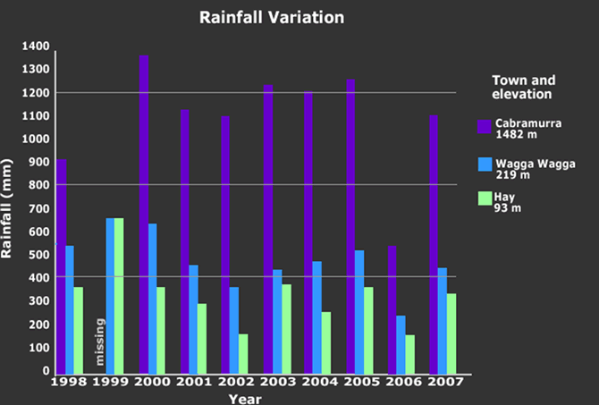
- Rainfall varies spatially, as you travel down the catchment and over time. Explain this statement.
- Comment on the reliability of rainfall. How would this impact on towns and farmers?

19. Dams and river regulation
In 1895-1903 nearly the whole of Australia was affected by drought. This was probably Australia's worst drought to date in terms of severity and area. (Data for Wagga 1895-1897 - not available.)

Year  Rainfall mm | 1898 | 1899 | 1900 | 1901 | 1902 | 1903 | 1904 | 1905 | Long term mean
Wagga Wagga | 364 | 404 | 625 | 456 | 304 | 493 | 410 | 494 | 526
Hay | 279 | 258 | 363 | 225 | 219 | 376 | 333 | 433 | 364

Following the drought the State Government passed legislation in 1906 which made it possible to buy land for irrigation farms, establish associated towns and construct dams and canals. Work began in 1907 on Burrinjuck Dam and in 1912 it was ready to store water. In 1912 the Yanco Irrigation Area was established to use water from Burrinjuck Dam. By 1914 there were 677 irrigation farms.
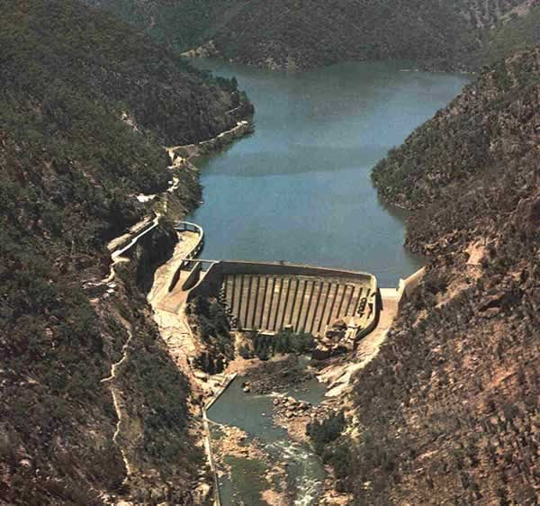
River regulation is the building of dams to store water and release it when it is needed down river. Much of the flow down the Murrumbidgee pre-dam occurred as spring floods when winter snow melted in the Snowy Mountains. This water is now trapped by Burrinjuck and Blowering Dams and released for summer irrigation. Photo of Burrinjuck Dam courtesy Richard Woodward
- Comment on the reliability of rainfall between 1898 to 1905.
- The building of what item of infrastructure allowed the establishment of irrigation farms?
QUIZ

Burrinjuck dam was built to regulate the Murrumbidgee River because of sever?

20. River flow variability
The graph shows river flow variability at Wagga Wagga. Wagga was chosen because it is the point where the highest flow occurs. Upstream there are a number of tributaries contributing water to the river, downstream there are very few and water is taken for the major irrigation schemes.
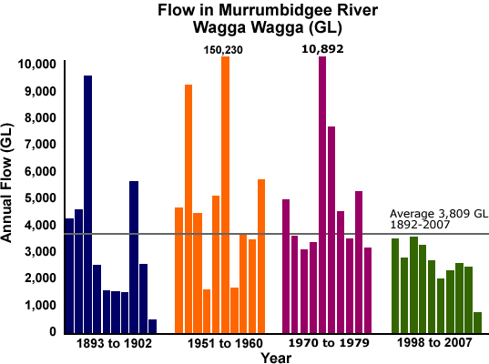
Source of data: Dept. Water & Energy NSW Pinneena DVD
Burrinjuck Dam was started in 1907, so the period 1893-1902 is prior to river regulation. After about 1912 irrigation schemes started to expand. Blowering Dam was completed in 1968 after which the Coleambally Irrigation Area was established in 1969 and the river became highly regulated.
Large volumes of water are recorded in kilolitres, megalitres and gigalitres (kilolitres, KL = 1,000 L; megalitres, ML = 1,000,000 L = Olympic swimming pool and gigalitres, GL = 1,000,000,000).
Click for Murrumbidgee River annual flow data for Wagga Wagga 1892-2007.
- Describe how river flow varied at Wagga Wagga for the period 1893 to 1902.
- How would flow variability impact on irrigation farmers downstream?
- Compare the two periods 1893/1902 and 1951/1960 to the two periods 1970/1979 and 1998/2007.

21. The Snowy Mountains Scheme
Blowering Dam was constructed (1963-68) on the Tumut River to regulate additional water from the Snowy Mountains Scheme. About 500,000 ML or 10% of the water in the Murrumbidgee River is diverted from the Snowy River via the Snowy Mountains Scheme.
In the past this has been a very reliable source of water and formed a critical part when allocating water in the Murrumbidgee Water Sharing Plan. The allocation of High Security water to farmers and town water depended on this reliable supply.
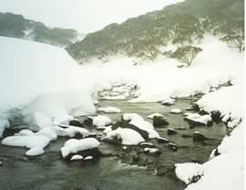
In 1998 the Snowy Agreement (NSW/Vic.) determined that 294,000 ML of water would be returned to the Snowy after lobbying by environmental groups. This would return the Snowy River to 28% of its original flow.

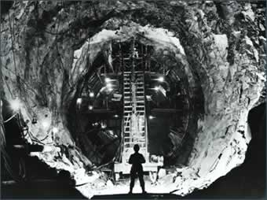
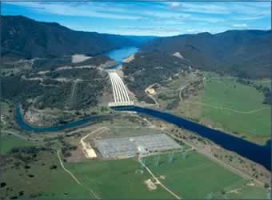
Photos below: courtesy Snowy Hydro

- Discuss the good points and bad points about the decision to return water to the Snowy River which had been put in the Murrumbidgee. Include the impact on farmers, towns and the environment.

22. Regulated flow in the Murrumbidgee
Flow in the Murrumbidgee in the year 2000. This year was chosen because it was very close to the historic average flow in the river.
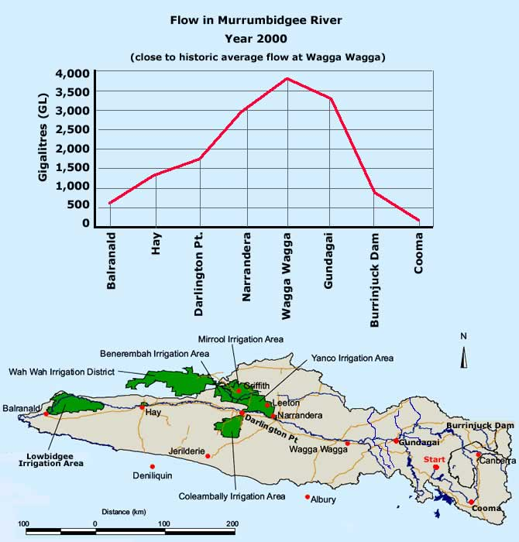
Note: the Murrumbidgee Irrigation Area (MIA) is a collection of smaller irrigation areas (Way Wah, Benerembah, Mirrool and Yanco).
- Describe how the flow varies from the headwaters near Cooma to Balranald where the Murrumbidgee enters the Murray.
- Explain why the highest flow occurs at Wagga Wagga and why it decreases after this.

23. Regulated flow in January
The previous graph showed the yearly flow in the year 2000 and the volume was in gigalitres. This graph is for just one month, January, the peak of the irrigation season and the volume is measured in megalitres. The ‘normal' rainfall years of 1982-2000 are compared to the drought years of 2001-2007. Data for both the Murray and Murrumbidgee is given.

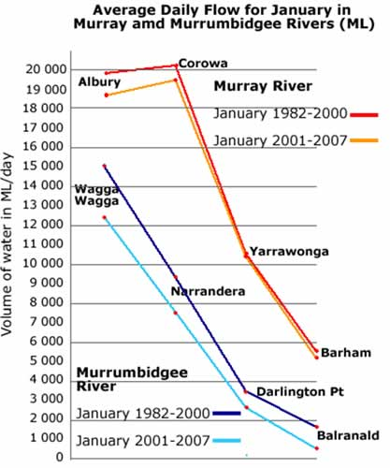
- Describe how flow varies in both the Murray and Murrumbidgee.
- Explain why there is not a bigger difference between drought and non-drought years.
- Go back to page 2 on the Aral Sea. Could this situation happen in the lower Murray or Murrumbidgee Rivers?

24. Regulation and seasonal flow
The impact of river regulation on seasonal flow: 1892-1912 shows flow before the major dams were built, 1980-2006 shows flow after both Burrinjuck and Blowering were built.

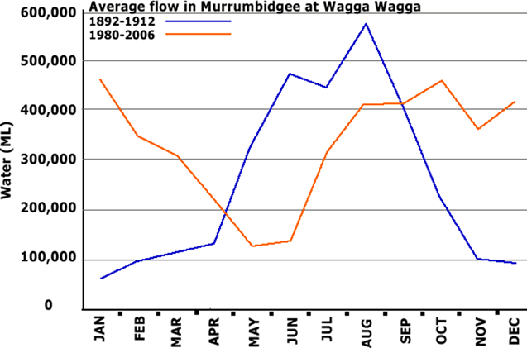
Prior to regulation, the highest flows occurred in spring when the snow melted in the Snowy Mountains.
- Compare the seasonal flow in the river under regulated and pre-regulation conditions.
- What impact may regulation have on native fish, water birds and river red gum forests which evolved over a long time to the natural seasonal river flow cycle?

25. Murrumbidgee Water Sharing Plan
The Water Sharing Plan for the Regulated Murrumbidgee determines who gets the water. It was developed by the Murrumbidgee River Management Committee consisting of representatives from local councils, farmers, irrigation industry, National Parks and Wildlife Service and others. (The regulated Murrumbidgee occurs below Burrinjuck Dam.)
Plan Vision
To provide the equitable sharing of limited water resources to sustain a healthy and productive river and the welfare and well-being of Murrumbidgee regional communities.
Water allocation
Water is allocated according to the following hierarchy numbered 1-7.
1. Environmental water
On a long-term basis, 56% of annual river flow should be protected for environmental health. This is a target and at the discretion of the government and may not happen. (The long term average annual river flow is 4,270 GL/yr.)
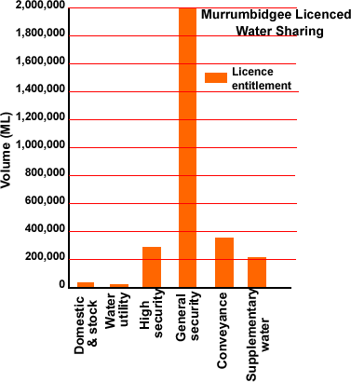
2. Basic landholder rights of 4,560 ML per year. This water is used by farmers living beside the river for stock and household use. All other users must have a water licence.
Licenced water use
3. Domestic and stock (farms not on the river but nearby) 35,572 ML.
4. Water utilities (supply to towns)
23,403 ML.
5. High security irrigation 298,021 ML.
6. General security irrigation 2,043,432 ML.
Conveyance (allowance for loss in delivery of irrigation water by evaporation and channel leakage) 373,000 ML.
7. Supplementary water 220,000 ML. When surplus water is available, this amount may be sold for irrigation, any other water left over will be kept for the environment.
Although someone may have a water licence for a particular volume of water, they may not get this each year, it depends on the volume of water available and where they are in the priority ranking above. Available water determinations are made at the start of the water year (1 July – 30 June) then modified as more or less water enters Burrinjuck and Blowering dams.
The high reliability of inflows from the Snowy Mountains Scheme meant the water determinations for basic landholder rights and local water utility licences provide 100% of their allocation in all years except in extreme droughts.
The high reliability of Snowy water also meant high security licences would get at least 95% of their licence amount in all but extreme drought years.
General security allocation varies from year-to-year depending on the amount of water held in Burrinjuck and Blowering Dams, they are allocated what is left and in drought years this may be extremely low.
Water licence trading
Until the 1990s, supplies of irrigation water were considered to be plentiful, and expansion of irrigation agriculture was encouraged. However, the last few years has seen increased demand for water, together with seven years of drought and has prompted changes to the management of water. Australia is one of the few countries where water can be traded (licences bought and sold). Farmers can choose to sell their water or use it on their crops. The government sees water trading as an efficient means of allocating water to the best use for licence holders.
Trading allows:
- the sale of a licence;
- a change in the location where a licence can be used;
- the sale of a volume of water that has been allocated but not the licence; and
- a change in the category of a licence – conversion e.g. low to high security and from high to low. When general security was converted to high security there was a decrease in the amount of water e.g. 100 ML of GS converts to 55 ML of HS but an embargo has been placed on this with the current drought.
- What is the vision of the Murrumbidgee Water Sharing Plan?
- What does the government think of water trading?
- Some farmers think water trading is bad because of what might happen if many farmers in their area/town sold their water licences. List good and bad points about water trading.

The largest licence category is?

26. Water allocation history
Licence holders with high security water receive their full allocation in all but the worst droughts. High security licences have lower priority than local water utilities which supply water to towns and farmers who live near the river and have a licence for domestic and stock needs.
The Water Act 1912 allocated high security water to horticulture, mining and industrial users. This was carried over in the new Water Management Act 2000. Horticultural users need a reliable supply of water to keep their permanent plantings of fruit trees and grape vines alive. Some irrigation users can adjust their needs form year-to-year such as the annual cropping of rice and can cope better with general security licences.
From the available water resource each year (water in storage and river flows), water is set aside for high security (HS) users, evaporation, environment, river transmission loss, stock and domestic needs and end-of-year carry over (a proportion of water allocated to a farmer but not used). The remainder is shared among general security (GS) users in proportion to their entitlement. This varies as the water resource varies.
Murrumbidgee Valley Water Allocation History (% licenced amount)
Year | Gen. Security | High Security |  | Year | Gen. Security | High Security
1980-1 | 100 | 100 |  | 1995-6 | 105 | 100
1981-2 |  |  |  | 1996-7 | 100 | 100
1982-3 | 100 | 100 |  | 1997-8 | 90 | 100
1983-4 | 120 | 100 |  | 1998-9 | 85 | 100
1984-5 | 140 | 100 |  | 1999-2000 | 78 | 100
1985-6 | 120 | 100 |  | 2000-1 | 90 | 100
1986-7 | 120 | 100 |  | 2001-2 | 72 | 100
1987-8 | 120 | 100 |  | 2002-3 | 38 | 100
1988-9 | 120 | 100 |  | 2003-4 | 41 | 95
1989-1990 | 120 | 100 |  | 2004-5 | 40 | 95
1990-1 | 120 | 100 |  | 2005-6 | 54 | 95
1991-2 | 120 | 100 |  | 2006-7 | 10 | 90
1992-3 | 120 | 100 |  | 2007-8 | 13 | 90
1993-4 | 120 | 100 |  | 2008-9 | 21 | 95
1994-5 | 100 | 100 |  | 2009-2010 | 27 | 95
 |  |  |  | 2010-11  (1.12.2010) | 64 | 95

- Describe the allocation of general security water from 1980 to 2010.
- What impact would this have on farmers of annual irrigated crops such as rice? What impact would this have on employment and towns?
- Explain why high security water originally used for fruit trees and grape vines and not rice and wheat crops.
- Compare the allocation of general security water to high security water from 1995 to 2010.
Murrumbidgee Water Sharing Plan licenced entitlement compared to the actual allocation in the drought year of 2006-7.
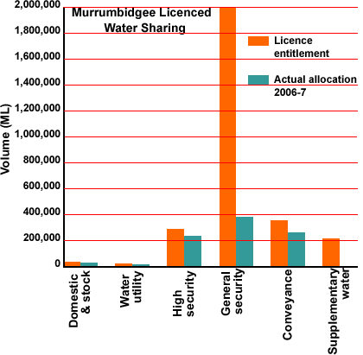
The graph above compares the entitlement of licenced water according to the Murrumbidgee Water Sharing Plan to the actual allocation which occurred in the 2006-7 water year.
- Which three areas are entitled to most of the water under the water sharing plan?
- Compare the actual allocation of water between high and general security water in 2006-7 and the entitlement under the water sharing plan.
- Compare the proportion of water set aside for conveyance in the plan to the amount allocated in 2006-7. Conveyance is the amount of water set aside for evaporation and channel leakage so when a farmer orders 100 ML of water, about 115 ML is released from the dams (15 ML for conveyance) so 100 ML is received.
- Explain why the proportion of conveyance water is so high in 2006-7 compared to the amount of general security water released?

27. Crop water requirements
Water requirements for crops in the Murrumbidgee Irrigation Area 2000/2001:
This was the most recent, nearly 'normal' year when high security received 100% and general security received 90% allocation. Source: Murrumbidgee Catchment Irrigation Profile, M. Hope and M. Wright 2003
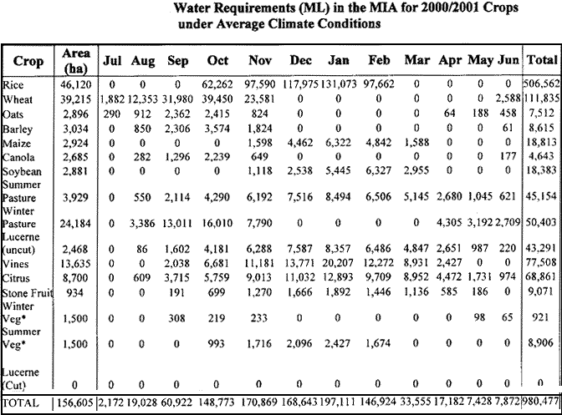
- Which crop used the most water and in what months of the year?
- Make a graph of the bottom line showing total monthly water use.
- Which months had the greatest water demand?

Water requirements for crops in the Coleambally Irrigation Area (CIA) 2000/2001
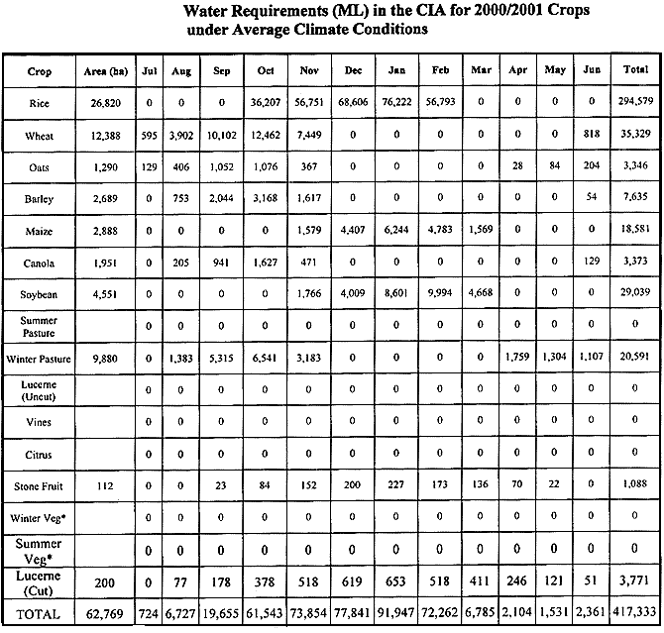
- Which crop used the most water and in what months of the year?
- Make a graph of the bottom line showing total monthly water use.
- Which months had the greatest water demand?
QUIZ

Which crop used the most water?

28. Rice

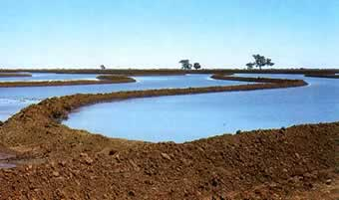 | 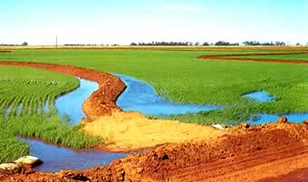
Rice is a semi-aquatic plant. It has an ability to grow under waterlogged or submerged conditions and is grown under flooded conditions for most of its production season from October to April.
Around 150 000 ha of rice are sown each year in Australia producing 1.3 million tonnes at a yield of 8-9 tonnes per hectare and a total crop value of $800 million. Nearly all Australian rice is grown in the Murrumbidgee Irrigation Area, Coleambally Irrigation Area and Murray Irrigation Areas. World production is 600 million tonnes per year. The industry exports 85% of production worth $500 million in trade revenue.
Source: Balancing Act, A Triple Bottom Line Analysis of the Australian Economy, Uni. Sydney and CSIRO 2005 Vol. 2 p14
Excerpts from a newspaper article, ‘Rice farmers live in hope of heavy rain'
Source: The Weekend Australian July 5-6 2008, Ray Brindal, Dow Jones Newswires
“Despite a startling decline in Australian rice output in 2008, ongoing dry weather and zero official irrigation water allocation growers are hoping …………
Yield from a crop harvested in April hit an 80 year low in 2008, with just 19,000 tonnes produced, down 99 percent from the peak output of 1.64 million tonnes in 2001. Output in 2006 was 1.05 million tonnes.
For the 2008 crop, only 2,100 ha was planted, down from 177,000 ha for the 2001 crop. The rice industry, which depends on irrigation water………"
- Outline the impact of the lack of general security irrigation water on farmers, the towns of Coleambally and Griffith and the Australian economy. Include income, employment, rice mills, retail and farm supply shops in towns, schools and the general welfare of farming families.
- Would rain in the rice farming districts solve the problem?

29. Seasonal river flow changes with river regulation
The Murrumbidgee is a working river because it is managed to support human use.
(Murrumbidgee Wetlands Resource Book, Pat Murray, Murrumbidgee CMA, 2008 p19)
The graph shows monthly flow for a typical period before river regulation (1892-1912) with a typical period after regulation (1980-2006). The green line at the bottom shows the water requirements for rice in the Coleambally Irrigation Area.
A major issue with river regulation has been the change in the seasonal flow pattern. This has disrupted breeding cycles of many native fish, water birds and other animals and plants which have evolved to suit the pre regulation river flows.

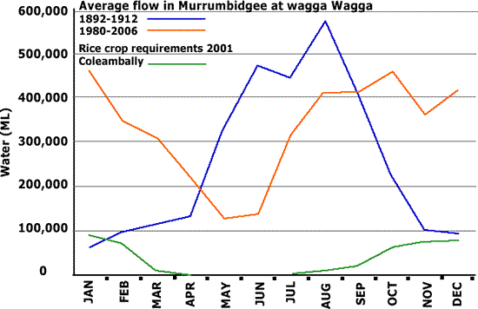

- Describe how the seasonal flow has changed with river regulation.
Source of table: "Whole of catchment Water and salt Balance to Identify Potential Water saving Options in the Murrumbidgee Catchment", CSIRO 2004
- Compare the seasonal water use by crops in the table with the graph. Note the graph starts with January and the table with July, the irrigation water year.
- Which crops have been the major cause of the change in seasonal flow in the river?
- Which crops suit the unregulated river i.e. require water when it was normally available before regulation.
- Explain how we could change our use of the river to suit it's natural flow pattern and hence the requirements of the environment.
QUIZ

A major issue with river regulation has been the change in?

30. Rice: water efficiency
Compare how water use and yield have changed over the 19 year period given in the table.
Source: Murrumbidgee Catchment Irrigation Profile, Hope and Wright NSW Agriculture 2003
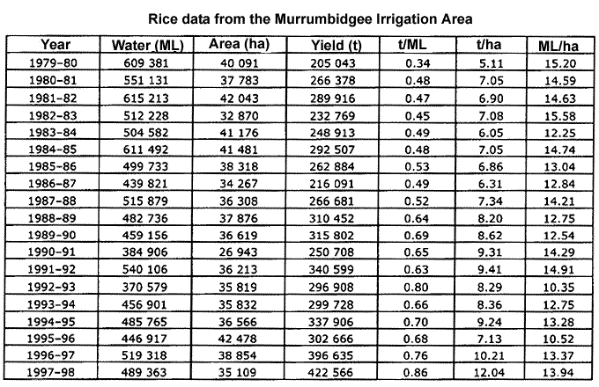

- How did the quantity of rice produced from each megalitre of water (t/ML) change?
- How did the quantity of rice produced from each hectare of land (t/ha) change?
- Comment on how the efficiency of rice growing changed during this period.
Have I enough water to finish my rice crop?
Source: Primefact 406, Nov. 2006 Dept. Primary Industries, Rachel Whitworth, District Agronomist Griffith
To plant and grow a rice crop the farmers must know how much water they need and how much they have been allocated. If the farmer does not have enough water they need to decide whether to buy more (if possible) or reduce the area of rice being grown by draining rice bays (fields).

Calculating rice crop water needs.
1. Duration of crop growth to drainage of bay for harvest (days bays needed to be flooded).
Rice variety | Medium grain (Amaroo etc) | Long grain (Langi etc) | Short season (Jarrah etc)
Growth time (days) | 70-80 | 65-75 | 60-70
2. Estimate rice water use
The main component is evapotranspiration, water transpired through the leaves and evaporated from the surface of bays. This varies greatly within and between seasons.
Deep percolation (water passing below the root zone) and drainage losses are minor components. The Department of Primary Industries uses a figure of 1 mm/day when estimating crop water use.
Rice Water Use ML/ha (This depends on the stage of crop growth)
Early Oct. | Mid Oct. | Late Oct. | Early Nov. | Mid Nov. | Late Nov.
0.59 | 0.64 | 0.72 | 0.76 | 0.85 | 0.94
Early Dec. | Mid Dec. | Late Dec. | Early Jan. | Mid Jan. | Late Jan.
0.94 | 0.97 | 1.00 | 0.99 | 1.00 | 0.98
Early Feb. | Mid Feb. | Late Feb. | Early Mar. | Mid Mar. | Late Mar.
0.96 | 0.91 | 0.83 | 0.80 | 0.71 | 0.62
Note: these are average figures based on evapotranspiration and include 1 mm/day deep percolation and drainage losses.
If a farmer plants the crop and runs out of irrigation water half way through the season they will lose the whole crop. But if they calculate how much water they need and know how much they have left from their irrigation licence allocation they can decide how many bays to drain (abandon) and how many to keep.
A 40 ML deficit on the 1st January may mean 7 ha needs to be drained. Delaying the decision to 1st February may mean 15 ha is lost. If you wait to the end of the season, the crop could run out of water 10 days too early which could result in a 33% loss in yield and a big drop in grain quality.
Example
You are going to plant Amaroo rice in early January. It takes about 70 days, so total water use from early January to early March is:
0.99 + 1.00 +0.98 + 0.96 + 0.91 + 0.83 + 0.80 = 6.47 ML/ha
You want to plant 30 ha so you require 194.1 ML of water. Unfortunately there is a drought and although you have a licence for 200 ML of General Security water, this year the Department of Water and Energy has announced General Security holders will only be allocated 60% of their licence. This means you will get 120 ML of water or enough for 18.5 ha.
- Comment on this statement: A rice farmer’s life is not an easy one in Australia where rainfall is so variable.

31. Triple bottom line accounting and rice

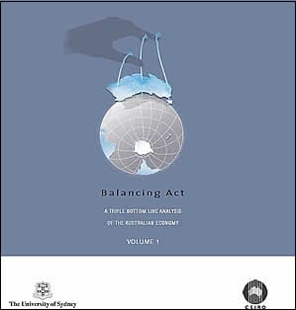
The CSIRO and Sydney University produced a report, Balancing Act, A triple bottom line analysis of the Australian economy in 2005. This report looked at the Australian economy using financial, social and environmental indicators. 135 economic areas such as wheat growing were assessed and the results referenced against one dollar of final demand e.g. how much water was used to produce a dollars’ worth of wheat.
“Governments at all levels, corporations, non-government organisations and the general public are all engaging with the concept of sustainability………. Practices and development that meet the needs of the current generation without compromising the ability of future generations to meet their needs.” Balancing Act Vol.1, p15
Corporations are beginning to apply the concept of sustainability in terms of corporate citizenship. This is dominated by the notion of the triple bottom line. Instead of just reporting on financial performance, sustainability has three areas, financial, social and environmental.
Financial indicators used were:
Gross operating surplus; exports and imports.
Social indicators used were:
Employment; income and government revenue (taxes).
Environmental indicators used were:
- water use, litres of water used per dollar value of item produced;
- energy use, Megajoules (MJ, one million Joules) of energy used per dollar value of item produced;
- greenhouse gas emissions, kilograms of CO₂ produced per dollar value of item produced; and
- land disturbance, square metres of land disturbed per dollar value of item produced.
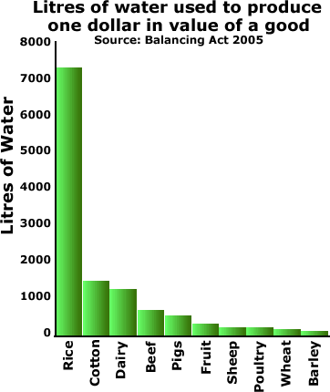
- Explain why corporations are starting to report their performance using a triple bottom line approach instead of just how much profit they made.
The graph shows water use of selected industries. This is the quantity of water use per dollar value of the product to the farmer e.g. for the farmer to produce one dollars’ worth of rice which they sold for processing, over 7,000 litres of irrigation water was used.
When rice is compared to the average for the other 135 industries studied:
- Water use is 200 times more per dollar value at 7,342 litres per dollar value.
- Greenhouse gas production is 4 times due to methane production at 3.66kg CO2 per dollar value.
- Land disturbance (degradation) is 40% above average.
Source: Balancing Act Vol.2, pp 14-17
Note: the water accounted for here is irrigation water, it does not include rainfall and the figures are for Australia, including both irrigation and dryland farming. Some sheep would be grazed on hillside paddocks where the pasture relies solely on rainfall. Other sheep are grazed on irrigated pasture. Only the irrigation water is shown on the graph so this amount of water has been divided by the dollar value of all sheep, both dryland and irrigation produced.
- Give the good points and bad points of growing rice.
QUIZ

Practices that meet the needs of the current generation without compromising the ability of future generations to meet their needs is called?

32. Environmental water
In 1994 the Australian Government enacted the National Water Commission Act which included the notion of environmental water to preserve the health of Australian rivers (Murrumbidgee Wetlands Resource Book, Pat Murray, 2008). The Murrumbidgee Water Sharing Plan includes five types of planned environmental water:
1. It is planned that 56% of the long term average Murrumbidgee flow will be protected for the environment. The long term average surface water is 4,270 GL/yr. This does not occur each year, it is a target.
2. The dam transparency rule. If inflow to Burrinjuck Dam is less than 615 ML per day then the outflow from the dam must equal the inflow into it. If the inflow is above this, the outflow will be 615 ML per day. Blowering Dam is similar but the amount is 560 ML per day. This rule ensures the river does not dry up below the dam, the river will continue to flow, it will stay connected above and below the dam.
3. Base flow at the end of the system. When general security water allocations are above 80%, the flow past Balranald must be at least 300 ML per day. When the general security allocation is below 80% the flow must be at least 200 ML per day. This rule ensures the Murrumbidgee does not dry up at the end; the river will always flow into the Murray River just past Balranald. It is important these river ecosystems stay connected.
4. Dam translucency. Natural flow variability is mimicked by making releases from Blowering Dam in winter and spring based on the amount of water entering the dams. This rule tries to ensure there is some seasonal variation in the flow of the river.
5. Three Environmental Water Allowance (EWA) accounts are kept for wetland inundation, fish or bird breeding events and the management of water quality. The EWAs are used to put minor floods down the river. (Photo: Lorraine Hardwick) 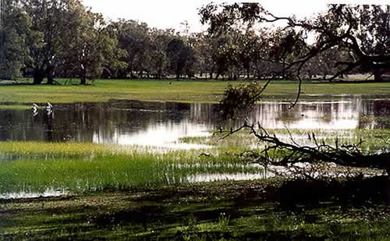
- Explain why dam transparency and base flow rules are important to river health.
- The Murrumbidgee is one of the most regulated rivers in Australia; it is a working river, supplying water for human use. Should water be allocated to the environment? Give your reasons.
EWA operation since 1998
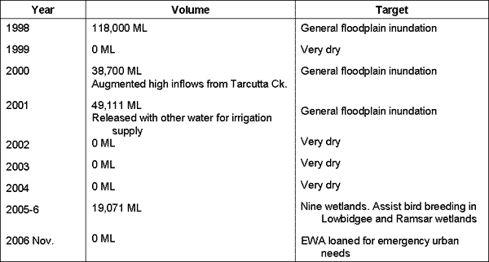
QUIZ

Initials of type of environmental water kept for creating minor floods?

33. Gundagai choke
Under river regulation, wetlands which normally would have been filled by river flood events every four years, now only receive water once every nine years placing significant stress on them and the ecological communities they support. (Source: "The Business of Saving Water", Pratt Water, 2004)
The Gundagai choke, a natural restriction in the river valley between Gundagai and Wagga Wagga, near Wantabagery, restricts the river flow to 32,000 ML per day. At flows above this the Mundarlo Bridge and private farmland is flooded. This constraint does not allow enough water to be released to achieve the river height for wetland inundation. Sufficient water can be obtained when an environment flow is combined with a natural flood in downstream tributaries such as Tarcutta Creek, which enter the Murrumbidgee below the Choke. A critical environmental flow target of 50,000 ML per day at Wagga Wagga is believed to provide the best extent of wetland flooding (Murrumbidgee Wetlands Resource Book, Pat Murray, 2008, p21).
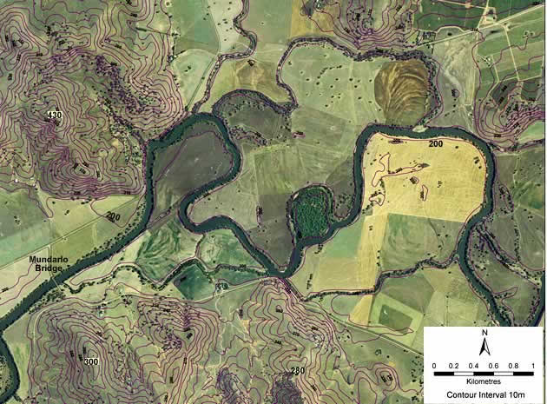
The map shows the Murrumbidgee River and the constriction in the valley known as the Gundagai choke near the Mundarlo Bridge.
- Draw a sketch map of the air photo above showing the river, floodplain, hilly areas and a likely billabong wetland. Indicate where the 'choke' is.
- Explain why it is not just a simple matter of releasing water from dams to inundate the wetlands along the river.

34. Environmental flow
"Water surge encourages vital frog breeding", article in Weekend Advertiser newspaper, Wagga Wagga, April 19 and 20, 2008
“A crucial Southern Bell frog breeding event is under way on the Lowbidgee floodplain with hundreds of young frogs observed. Young frogs have been monitored at Yanga National Park and on private property near Maude following targeted environmental water releases.
The lower Murrumbidgee wetlands received 8,300 ML of environmental water between December and March, which created and sustained the necessary habitat for Southern Bell frog breeding."

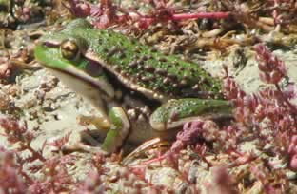 | 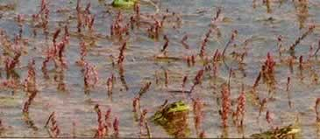  Photos courtesy Sky Wassens, Charles Sturt University, Wagga Wagga.

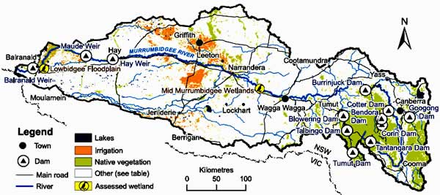
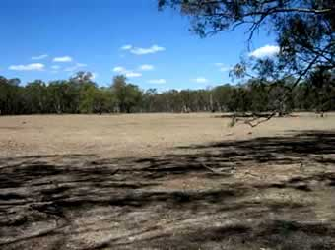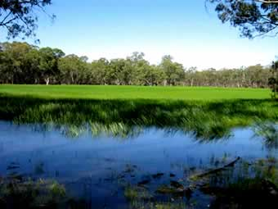
Mercedes Lagoon on the Lowbidgee floodplain before and after the 2008 environmental flow where frog breeding occurred. Photos and research courtesy Sky Wassens, Charles Sturt University, Wagga Wagga.
- Discuss some of the problems in delivering this quantity of water to this location at this particular time. Include distance, water travel time, exact quantity of water, length of time wetlands needed to be wet, frog breeding cycle and frog habitat (look at the photos).
QUIZ

Name of the floodplain where the frog breeding where the environmental water was delivered?

35. River health: fish
A wide variety of measurements can indicate river health. Information on algae, fish, invertebrates, water plants, birds and many other things give a ‘window' on the river. The Sustainable Rivers Audit by the Murray-Darling Basin Commission in 2008 chose fish, macro invertebrates and hydrology.
Data collected on these indicators was compared to Reference Condition assessments, what they would be like in a natural river, not changed by people.
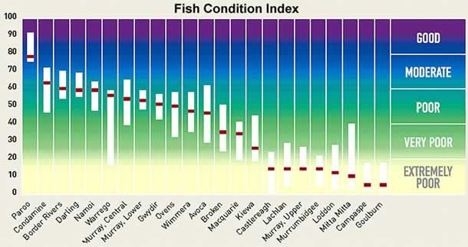
Twenty eight sites in the Murrumbidgee catchment were sampled with 1,536 fish caught. Thirteen of 22 expected native species were caught but introduced fish made up 87% of biomass (weight). The main introduced species were Rainbow trout, carp and redfin. Introduced fish made up 71% of abundance (number) with Gambusia (mosquito fish), Rainbow trout, Redfin and Goldfish dominating.
Native catfish, Silver perch and Macquarie perch were not caught at any sites, although they were expected to be common.
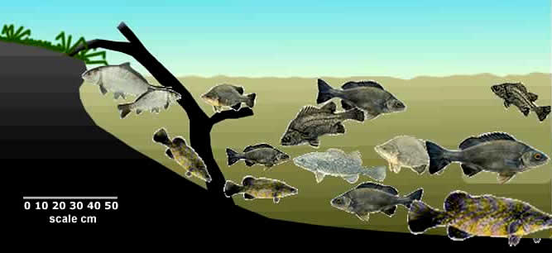
Native fish species such as golden perch and Murray cod use the floodplains as a fish nursery where there is food and shelter for juveniles. The fish spawn during rising floodwaters. The mouth gape of some juvenile fish is only 4 microns which is ideal to eat the zooplankton blooming in the water on the floodplain. As the floodwaters receded after 2-3 months (natural winter/spring floods lasted a long time), the fingerling size fish entered the river and had a much greater chance of survival.
- Explain why biological indicators such as fish populations are used to indicate river health and not just measurements on pollution.
- Explain the term 'Reference Condition'.
- You know a bit about the impact of people on the Murrumbidgee now. With this knowledge, explain why the fish condition assessment for the Murrumbidgee is so poor.
- Explain how would a change in flood frequency, duration, depth and timing impact on the breeding cycle of native fish?
- Research the Paroo River. Explain why it has the highest river health ranking.

36. River health: wetland fish investigation
Below is an example of a wetland fish investigation to see how this research was done. It was not part of the Sustainable Rivers Audit.
'Fish communities in floodplain wetlands of the mid-Murrumbidgee River',
R Watts and C Budd pp 96-116, in Wetlands of the Murrumbidgee River Catchment Ed. I Taylor, S Taylor and P Murray 2006
Summary
Four permanent and four temporary billabongs on the floodplain of the mid-Murrumbidgee River were surveyed in 2004-5. Of the 23 species of fish previously recorded, only eight species including 3 exotic species were caught.
Methods
Eight billabongs between Wagga Wagga and Darlington Point were selected. Four were classified as permanent as they had been wet for over 20 years. The other four billabongs filled between one and 16 months prior to the study. Sampling was done in spring and summer.
Fish were caught in nets, traps and by electrofishing. Nets were checked twice a day to remove air breathing vertebrates such as tortoises. Bait traps were left unbaited because the bait attracts yabbies which eat any fish in the traps. All native fish were kept alive in buckets for identification, counting and measuring then released back into the billabongs. Unbaited traps caught 91% of all fish.
Results
3,754 fish were caught, 5 native and 3 exotic species.
Species | Total | % Total abundance | % Total biomass
Bony Bream  Aust. Smelt  Western Carp Gudgeon  Midgley's Carp Gudgeon  Lake 's Carp Gudgeon  Midgley's/ Lake 's Carp Gudgeon*  Goldfish  Carp  Gambusia  Total Native  Total Exotic  Total Fish | 2  1  96  55  1534  1589  7  22  113  1688  142  1830 | 0.1  0.1  5.2  3.0  83.8  86.8  0.4  1.2  6.2 | 2.2  0  1.2  0.7  20.0  20.7  0.8  74.9  0.2
Note: In the spring survey Midgley's and Lake 's Carp Gudgeon were not separated, they were counted as the same species. Nearly all fish were caught in the permanent billabongs. The four temporary billabongs had only 176 carp, one goldfish and 20 native fish.
Several small native fish have apparently become extinct, or very rare, in recent times. The dominance of one common species confirms the wetland ecosystems are degraded.
Reasons include:
- Reduced flooding.
- Altered flooding regimes (time, duration, depth) altering conditions for cues for fish breeding.
- Pollution caused by urban and agricultural activity.
- Damage caused by livestock around wetlands.
- Displacement of native fish by exotic fish.
Comments: The coordinated inundation of floodplain wetlands is a large scale solution.
- Explain why carp made up 74.9% of the biomass but only 1.2% of the abundance (number of fish).
- Explain the statement, "The dominance of one common species confirms the wetland ecosystems are degraded".

37. River health: macro-invertebrates

The Sustainable Rivers Audit by the Murray-Darling Basin Commission in 2008 used macro-invertebrates as an indicator of river health. Macro-invertebrates are small animals without backbones and are visible with the naked eye. Different species have different sensitivity to pollution, so some are found in polluted waters and others are found only in clean water. The health of the river was determined by:
- the number of species found;
- the proportion found compared to those expected to be found in a natural river, not changed by people; and
- their sensitivity to pollution.

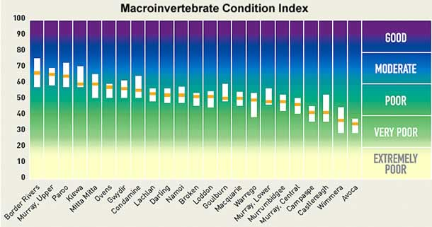

Thirty five sites were sampled. The number of macro-invertebrates families was less than Reference Condition at over 40% of sites. Some typical macro-invertebrates found in the Murrumbidgee catchment are below.

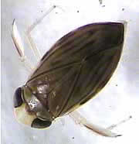  water boatman | 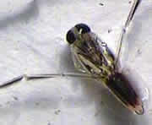  backswimmer | beetle larva
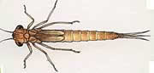  damselfly nymph | 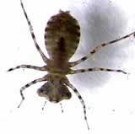  dragonfly nymph | 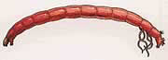  midge larva

- Give some advantages in using macro-invertebrates as indicators of river health.

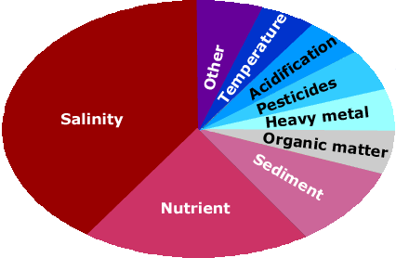

38. What is water pollution?

We often think of water pollution as plastic bags and toxic waste but water pollution occurs when something is added to water which makes it unsuitable for use. The Australian National River Contaminants Program interviewed catchment and river managers about what they thought the most important river pollution issues were. The results are shown in the pie (circle) graph.
Salinity is mainly caused by salt in the soil dissolving in water and being carried into rivers from their catchments.
Nutrients include phosphorus and nitrogen and are not a threat to our health directly but they impact on aquatic ecosystems. Nutrients help plants and algae grow. Large aquatic plants can block irrigation canals. Algal blooms are a problem for drinking supplies and can cause low oxygen levels in the water. The major sources of nutrients are from town sewage treatment plants which often release the effluent into rivers and fertiliser from farmland.
Sediment is the solid material washed into rivers from soil erosion. This includes pebbles, sand and clay. The heavier particles settle on the bottom. Fine sediment such as clay takes a long time to sink and makes the water turbid (muddy). Excess sediment fills deeper parts of the river bed and can cause rivers to become wide and shallow. Many nutrients and chemicals attach to clay particles and are washed into rivers with it.
Water quality varies down rivers as pollutants enter from different parts of the catchment and as non-polluted water enters, diluting the polluted water.
QUIZ

Something added to water which makes it unsuitable for use is called a?

39. Salinity
Over 1,000,000 tonnes of salt pass Wagga Wagga each day, dissolved in the water of the Murrumbidgee. (The amount of salt dissolved in water is often measured in electrical conductivity units, EC, since salty water conducts electricity. Sea water is about 50,000 EC)

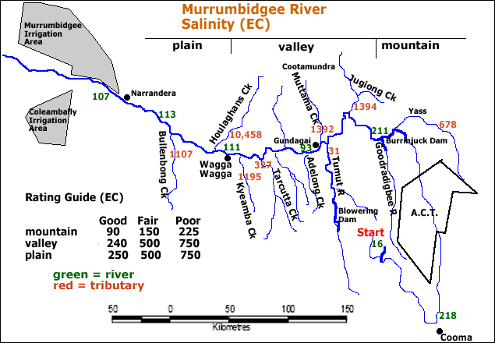

- Which part of the catchment, mountain, valley or plain contributes the most salt to the river?
- Land use in this area is dominated by dryland farming such as grazing and broad acre crops such as wheat. Explain why this might contribute to salinity.
- Explain why river salinity does not increase even more after the high salt load tributaries enter it.

The Murrumbidgee is a major contributor of salt to the Murray River. Adelaide takes about half of its drinking water from the Murray. The World Health Organisation has placed the desirable limit for humans at 830 EC units.
- Describe the change in salinity of the Murray from its headwaters near Jingellic to where it enters the sea near Tailem Bend. Use the Rating Guide given in the map of the Murrumbidgee, the Murray would be classified as a plain below Albury.
Salinity and Irrigation
"Around 140,000 tonnes of salts were exported from the Murrumbidgee to farmer’s fields in the MIA and CIA in 1992. Amounts will increase, with increasing river salinity and will need to be managed .......... if sustainable irrigated agriculture is to be achieved.....
Most salts are derived from small tributaries of the Murrumbidgee ....... between Burrinjuck Dam and Wagga Wagga. Management of dryland salinity would have the greatest effect ......."
Source: Whole-of-Catchment Water and Salt Balance, p7, S. Khan et al, CSIRO 2005
- Use data from the Murrumbidgee map to justify the paragraph above.
- Discuss how salinity problems caused by salt in the river water farmers are using could be managed on a catchment basis.
QUIZ
Which tributary entering the Murrumbidgee caused the Bidgee's salinity to decrease?

40. Wetland salinity problems

From D. Nielsen and M Brock in Wetland of the Murrumbidgee Catchment 2006 Ed. I. Taylor, S. Taylor and P. Murray
Many wetlands are becoming more saline because of:
- rising salty groundwater entering the wetland; and
- wetting and drying of the wetland without flushing.
Salt are building up in wetland sediments as water enters the wetland and evaporates, leaving the salt behind. If floods do not flush the salts from the wetland they accumulate over time.

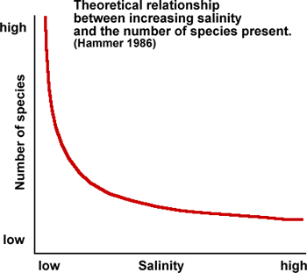

Different organisms can tolerate different salinity levels.
- Describe the relationship between salinity and the number of species.
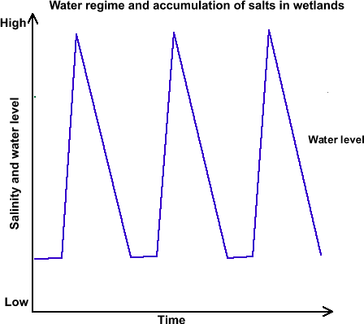
- The graph above shows a series of three fill events (floods) in a wetland over time. Describe how water levels in the wetland changed over time.
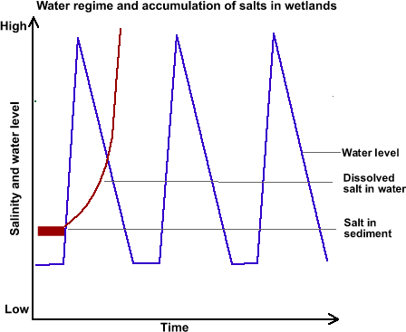
- Analyse the graph above. What happens to the salinity level of the water in the wetland as it dries out?
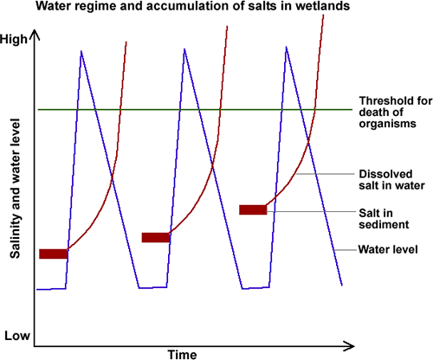

- This graph shows three fill events followed by drying each time. Explain why the salt level in the sediment increases each time.
- Describe what happens to the organisms in the wetland when the salt level gets high?
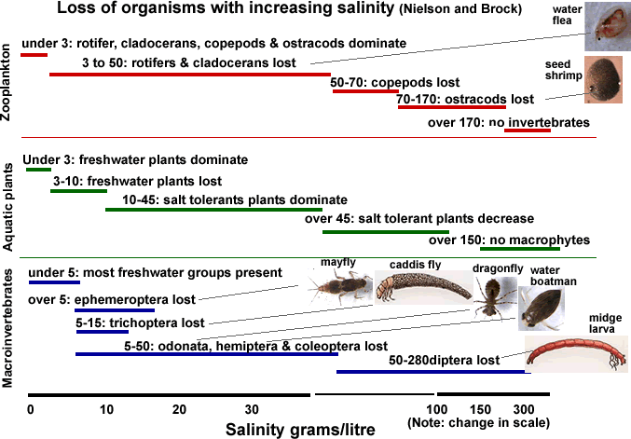
Zooplankton (microscopic animals) and macroinvertebrates (animals without a backbone and visible to the naked eye) such as insects and water plants are all impacted by increasing salinity levels in water.
Apart from the loss of species at different salinity levels there are indirect impacts:
- The loss of food in the food chain of organisms.
- Many species can survive high salt levels when in egg or adult stages of life cycles but these need to coincide. Timing of high salinity and particular life stages is important and has implications for the release of environmental flows to flood wetlands.
- Explain why different organisms die at different salinity levels.
- Could this be useful to someone investigating wetland health?

41. Phosphorus
Phosphorus is a nutrient that occurs naturally at low concentrations in water. Increases in levels may result from erosion, discharge of sewage or detergents, urban stormwater and rural runoff containing fertilisers and animal and plant material. When phosphorus concentrations become too high they cause problems such as algal blooms (including blue-green algae) and excessive growth of aquatic weeds which block irrigation channels. (Source: A Community Water Quality Monitoring Manual for Victoria)
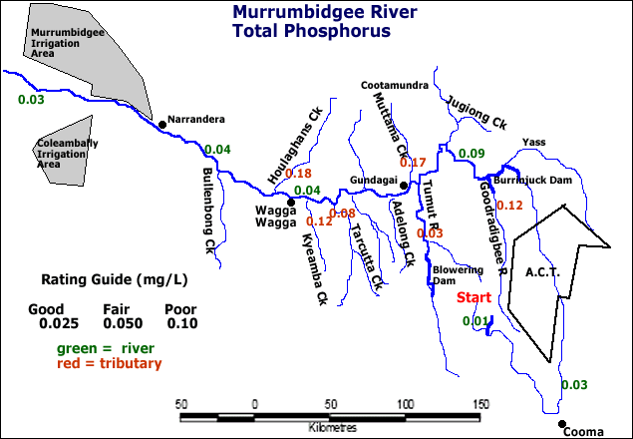
Source of data: David Honberg, monitoring period 2001-2004
- Explain why the river has lower phosphorus levels than many of the tributaries.
- You are a member of the phosphorus reduction team for the Murrumbidgee Catchment Management Authority and your task is to provide phosphorus reduction plan. Outline your plan or research you would need to do before making your plan.
QUIZ

Which tributary has the highest phosphorus levels?

42. What is blue-green algae?

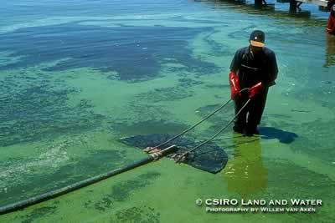 | 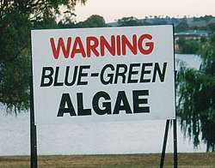
Blue-green algae are microscopic cells which group together. They are really bacteria but act a bit like plants because they use sunlight to make food by photosynthesis. When they grow in large numbers they form blooms which may be seen as scums on the surface. Blue-green algae can produce poisons which have killed stock. They cause unpleasant smells and tastes in water and clog water treatment filters.
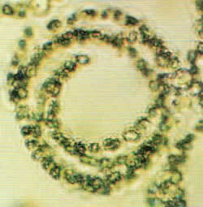 | 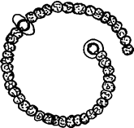 | If each red dot represents 10 algal cells, the number of red dots is the number of cells recommended as safe to drink in each millilitre (ml) of water. A teaspoon has 5 mls.

The photo below shows a type of blue-green algae called Anabaena magnified 400 times (Photo: 'What scum is that?', Simon Mitrovic). Individual cells have joined to form chains. Blue-green algae cells are tiny and exist in low numbers in most bodies of water. The highest concentration deemed safe to drink in untreated water is 2,000 cells per millilitre (mL) of water (5 mL = one teaspoon). For non-drinking purposes it is recommended to have less than 15,000 cells/mL.
A number of things affect algal growth including river speed, amount of sunlight, temperature, nutrients such as phosphorus and turbidity. The main sources of phosphorus to the river are sewage treatment plants and irrigation drainage. Household laundry detergents contribute between 30% and 50% of phosphorus to sewage treatment works.
- What are the main sources of phosphorus in the river?
- Design a poster to encourage people to use phosphorus free laundry detergents.

43. Turbidity
Turbidity is the cloudiness of water and is the result of suspend material such as clay in it. Suspended material decreases the ability of light to pass through it which reduces photosynthesis by water plants which reduces oxygen levels. This also decreases the amount energy for plants and the food chain. The most frequent cause is algae and eroded soil particles.
(Source: A Community Water Quality Monitoring Manual for Victoria)
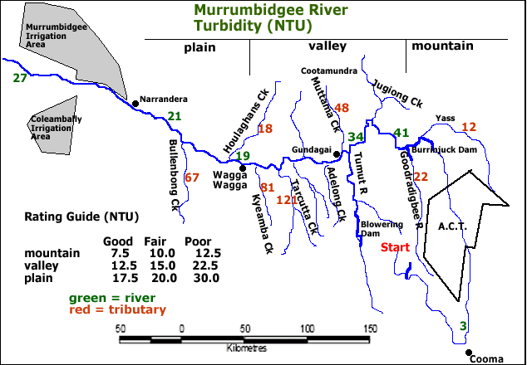
Source of data: David Honberg, monitoring period 2001-2004
- Use the data from the map to explain why turbidity levels are so variable along the river.
- Explain the impact on the food chain of the river from high levels of turbidity.
- Explain why taking only one water sample at one time along the river would be poor scientific method.
QUIZ

The cloudiness of water caused by suspended material in it is called?

44. Testing water in the Murrumbidgee River
The Murrumbidgee River starts in the Snowy Mountains near Kiandra then flows near Canberra and heads west to Wagga Wagga and Hay before entering the Murray River past Balranald. Two important water pollution issues are turbidity, how muddy the water is, and phosphorus, a nutrient. Turbidity is caused by erosion of the river banks and eroded soil being washed in from the catchment. Phosphorus is washed in from fertiliser used on home gardens and farms. It is also in treated sewage released into the river from town sewage works.
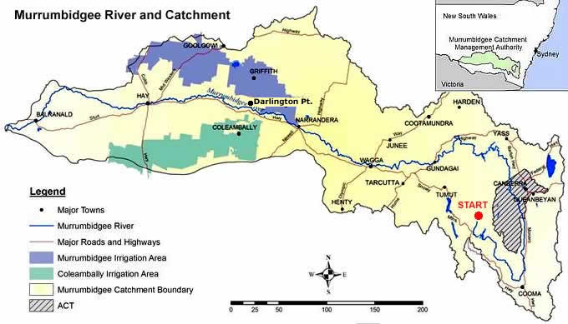

45. River red gum forests
River red gum forests require the equivalent of 1,100 mm of rainfall each year to remain healthy, yet they grow in areas with under 400 mm. The remainder of their moisture requirements came from the annual winter-spring snow melt floods which lasted for two to three months under natural conditions.
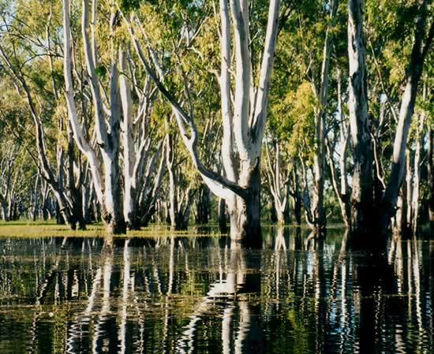

The floodwaters in the image below are coloured olive green because of the high turbidity. The floodwaters replenished the groundwater below the forests, helping them survive the dry summers.
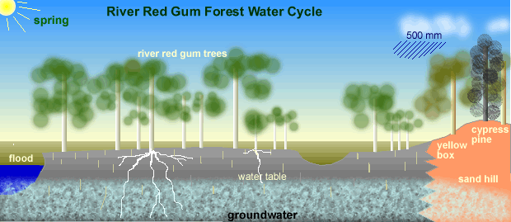
Flooding is critical to successful germination of river red gums and survival of seedlings. The seedlings have a very long root length allowing them to follow the water table as it gets lower in summer.
- Explain why river red gum forests rely on long lasting floods.
- Explain the consequences if the long floods were replaced with floods of shorter duration.
- Draw a water cycle diagram for a river red gum forest. Use the diagram above as a start.

QUIZ

Annual winter spring floods were caused by?

46. Water birds
Many water birds depend on wetlands for breeding purposes. It takes about 2 months from courtship to when the chicks leave the nest. If the wetland does not fill, no breeding takes place. If it dries out early the adults abandon the nest because they cannot collect the food from the floodwater to feed the chicks.
"The extent of reduction of water for natural systems (such as wetlands) is illustrated by the size of the average annual allocation of water for urban ... and ... agricultural purposes...... The average annual allocation of 2,500 GL is slightly over 50% of the Mean Annual Natural Flow of the Murrumbidgee River, 4,400 GL." (Source: Murrumbidgee Wetlands Resource Book, Pat Murray, p 21 2008)
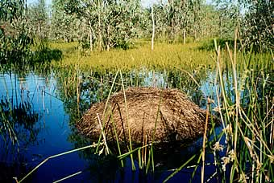
Swan Nest
With river regulation, in the section of river between Gundagai and Narrandera, the period of 'dry spell' between billabong fill events for when the river is flowing at 30,000 ML/day, has increased from four to nine years. In the river section between Narrandera and Hay, wetland fill events of over 20,000 ML/day and lasting more than 15 days occurred annually prior to regulation. Now these events occur once every two to ten years. (Source: The Business of Saving Water, Pratt Water, p 19 2004)
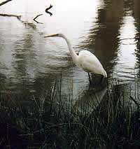
Wading birds have very specific adaptations to collect food in water. Their legs, neck and bill are a specific length to wade through shallow water to collect their food, if the water is deeper or shallower, they have difficulty feeding. River regulation has changed the depth characteristics of the floodwaters the birds are adapted to.
- Describe how river regulation has altered the natural flow of the Murrumbidgee River.
- Describe how river regulation has impacted on wetlands such as billabongs.
- Explain how river regulation has impacted on water birds.

47. Future risks: climate change
Temperature
Mean temperatures have increased across the Basin at a rate of 0.17⁰C per ten years since 1950. This is similar to global average temperature increases. The 1961-1990 average temperature is used as the zero line and is 15⁰C. To understand the graph, ignore the red bars and look at the black line.
Source: Risks to the Shared Water Resource of the MDB, p 9, CSIRO 2006
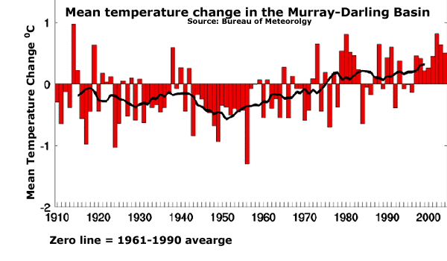
“Dr Craik (head of MDBC) said recent research by the CSIRO under the South-Eastern Australian Climate Initiative has shown a rise of 1⁰C leads to a 4% increase in evaporation and a reduction in (river) inflows of about 15%.” The Weekend Australian, May 3-4 2008
Rainfall
For the Murrumbidgee catchment, over the ten year period 1997 to 2006, average rainfall has decreased by 11% and and runoff (river flow) has decreased by 31%. Source: Water Availability in the Murrumbidgee, p 4, CSIRO 2008. Kath Bowmer, Professor of Water Policy at Charles Sturt University, Wagga Wagga, puts the runoff figure as high as 50%. A similar situation has occurred in Western Australia shown in the graph below. When rainfall decreases, river flow decreases much more, less of the rainfall makes it to the river.
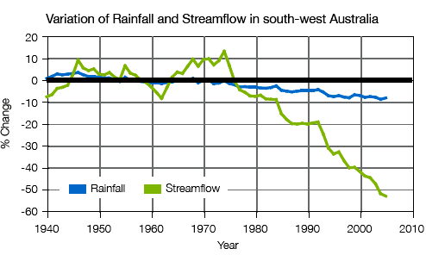
With increasing temperature and lower rainfall, flow in the Murrumbidgee will decline. Estimates vary between 1,100 and 4,400 GL in 20 years. This will be amplified because much of the existing stream flow is used by people and they will be directly affected.
Predictions include a 23% reduction in flows into Burrinjuck and Blowering Dams and 36% of inflows below the dams. This will result in flow reductions of 52% in the lower Murrumbidgee below the irrigation areas.
The impact on agriculture will be significant. Reduced on-farm rainfall and increased crop water use will increase the demand for irrigation water while dams will lose more water through evaporation.
Source: Water Availability in the Murrumbidgee, CSIRO 2008.
- Describe how temperature is changing in the region and the impact this will have on evaporation and river flow.
- Describe how rainfall and river flow in the Murrumbidgee area have changed lately.
- Draw a typical water cycle diagram to show and explain why a decrease in rainfall of 11% results in a decrease in river flow of 31%. Which parts of the water cycle are getting the 31% not going into the rivers?
- Explain the implications for towns and farmers if rainfall declines in the future.

48. Future risks: groundwater
Groundwater extraction in the Murrumbidgee catchment has increased in recent years. Apart from depleting aquifers, it can also reduce stream flow. Total groundwater extraction for 2004/5 was 407 GL. This represents 17% of total water use and in dry years when there is less surface water this would represent 26% of total water use.
Source: Water Availability in the Murrumbidgee, CSIRO 2008
If groundwater is extracted faster than it is recharged the following scenario occurs.
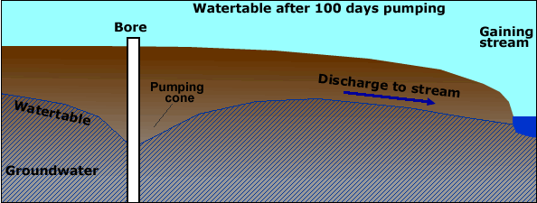
After 100 days of groundwater extraction, the pumping cone or lowered watertable near the bore is quite large but the water table near the river is still high enough for groundwater to still enter, it is still a gaining stream.
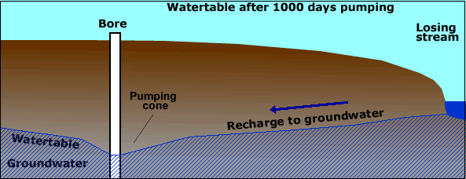
After 1,000 days of extraction, the pumping cone has lowered the whole watertable so much that water now discharges from the river into the groundwater, reducing river flow and it becomes a losing stream.
The regions in the MDB at highest risk are those with high and future extraction rates and where the aquifer and stream are strongly connected such as the Mid-Murrumbidgee River valley and lower Murrumbidgee region.
Extraction from the Lower Murrumbidgee Groundwater Unit was 324 GL in 2004/5. At this rate groundwater levels would be eventually lowered by 8 metres near the pumping area. Extraction at this level will decrease flow in the Murrumbidgee River by 53 GL/year.
Extraction in the Mid-Murrumbidgee Groundwater Unit was 48 GL/year in 2004/05. At this level of extraction groundwater levels near the extraction zone would fall by 10 metres. The eventual impact on the Murrumbidgee would be a loss of flow of 31 GL/year.
Lower watertables may dry out groundwater dependent ecosystems in lakes and wetlands.
- Explain how groundwater extraction can also reduce the amount of water in the Murrumbidgee River.
- "There are some tough decisions to be made with groundwater use in the Murrumbidgee catchment." Explain this statement.

QUIZ
When water moves from the river to the groundwater it is termed a ........................ stream.

49. Groundwater management
The Lower Murrumbidgee Groundwater Unit provides water to major irrigation districts including the MIA, Coleambally and Hay. Below is a summary diagram showing the two major aquifers and recharge rates. The deep aquifer has better quality water and is used for irrigation and town supplies. The shallow aquifer has a higher salt content and is used for farm household and stock use with minor irrigation where quality permits.
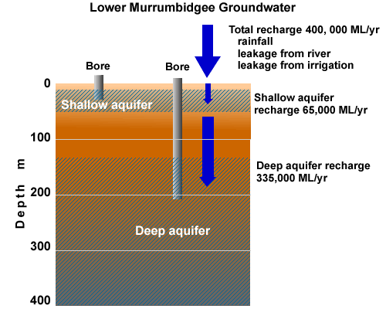
Groundwater licences (entitlements) in this area rapidly increased since 1994/5. See graph below.
Source of graph: Dept. Water and Energy
- Draw a sketch of the groundwater summary diagram.
- Explain how the shallow and deep aquifers differ.
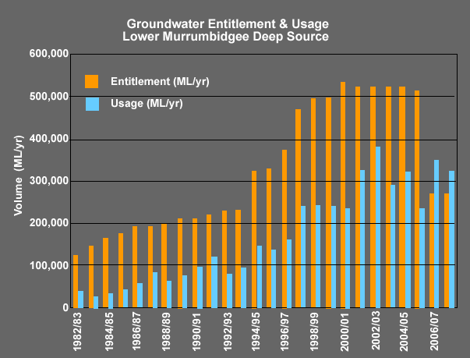
- Describe how entitlements varied between 1982 and 2007
- Describe how use as a proportion of entitlement varied over the same period.
- Explain the dramatic change in 2006.
- Explain why groundwater was being used unsustainably until 2006. Include the following terms in your answer: recharge rate, entitlement and use.
It was realised that entitlements were greater than aquifer recharge, they were at unsustainable levels. The Groundwater Sharing Plan for the Lower Murrumbidgee Groundwater Unit was developed and implemented in October 2006. The plan was developed so groundwater use was sustainable and is summarised below.
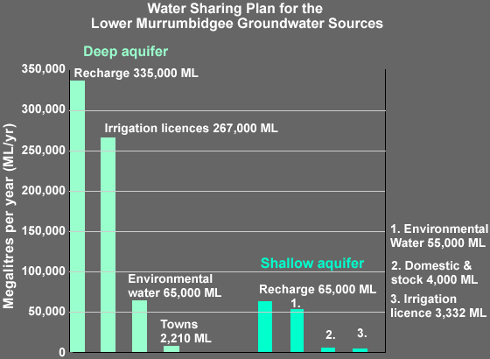
Irrigation entitlements from the deep aquifer had to be reduced and this was a dilemma for the plan developers. How do you fairly reduce a farmer’s entitlement to water? Some farmers had spent a lot of money investing in infrastructure such as bores, pumps and ground preparation while others had an entitlement but were not using much water. It was decided to use each farmer’s previous history of extraction for between the past five to seven years depending on circumstances to determine their entitlement.
Note: environmental water is water left in the ground and not available for human use.
- Calculate the percentage of the deep aquifer recharge used by people.
- Calculate the percentage of the shallow aquifer recharge used by people.

QUIZ

What is the term for managing a resource so it is there in the future?

50. Future risks: afforestation

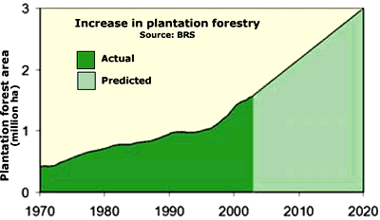
Australian industry and government have committed to establishing new plantations across land currently used for agriculture with a target of 3 million hectares by 2020. In addition there are tree plantings for farm forestry and environmental reasons such as biodiversity and salinity control.
Trees use more water than unirrigated pastures or crops. Converting an area from pasture to forest will reduce water yield (run off into streams).
Areas suitable for plantation forestry in the Murray-Darling Basin have a rainfall of 800 mm/year. When pasture is converted to forestry in these areas there is a reduction in water yield (stream flow) of about 1.5 ML per hectare of forest planted.
If the current plantation area of 460,000 ha is doubled, the reduction in river flow could be 550-700 GL per year or about 10%.
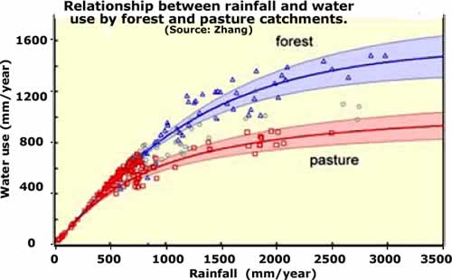
The map below shows the impact of converting land to forests on water yield (how much water enters the streams) e.g. the water yield in the red area will be 100 to 456 mm less if current land use is replaced by forests.
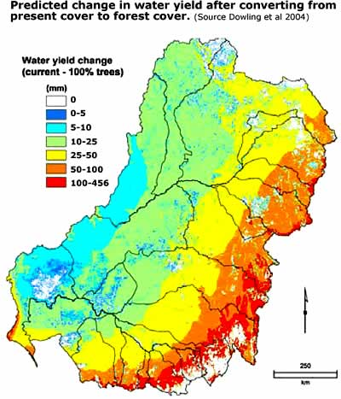
Data and images from: 'Risks to the Shared Water Resource of the MDB', CSIRO 2006
- We would like to plant more trees as carbon sinks to combat climate change. Explain the problem this will cause for our rivers.
- Our major rivers and the downstream users rely on the high rainfall Great Dividing Range for much of their water. What is the conflict with plantation forestry?

51. Water management policies
A summary of recent water policies by Brian Pink, Australian Statistician, Australian Bureau Statistics
The National Water Initiative
ln 2004, the National Water Initiative (NWI) was signed by all state and territory governments. The NWI is the overarching policy framework that guides current water management in Australia. It represents the Commonwealth, state and territory governments' shared commitment to water reform (NWC 2008).
The overall objective of the NWI is to achieve a national system of managing surface and groundwater resources for rural and urban use that optimises economic, social and environmental outcomes (NWC 2008).
One of the key objectives of the NWI is to facilitate the operation of efficient water markets (and the trading of water within and between jurisdictions. Another objective is to establish best practice pricing and institutional arrangements to promote economically efficient and sustainable use of water resources, infrastructure and government water management resources (NWC 2008).
The purpose of implementing these measures is to:
- reduce barriers to water trade;
- effectively allocate water between competing users;
- improve water efficiency; and
- ensure that water is allocated to its highest value use (Grafton and Peterson 2007, Wong 2008).
The National Plan for Water Security
The National Plan for Water Security seeks to facilitate the modernisation of Australian irrigation, helping to put it on a more sustainable footing at a time of declining water resources. It seeks to address over-allocation in the MDB, to improve the health of rivers and wetlands of the MDB, and to benefit irrigators and the community (Australian Government 2007).
Under the National Plan for Water Security, the Commonwealth Government will invest up to $3 billion over ten years to address over-allocation of water in the MDB. Planned in conjunction with the modernisation programme, this will be achieved by providing assistance to irrigation districts to reconfigure irrigation systems and retire non-viable areas, such as those at the end of isolated channels or in salt-affected areas. Assistance will be provided to help relocate non-viable or inefficient irrigators, or help them exit the industry. Where necessary, water entitlements will also be purchased on the market (Australian Government 2007).
The National Plan for Water Security is a document of the former Australian Government.
The current Australian Government's new national water plan, Water for the Future, incorporates elements of the earlier plan.
Water for the Future
Water for the Future is a national strategy to secure Australia 's long term water supply. It is built on four key priorities:
- taking action on climate change,
- using water wisely,
- securing water supplies; and
- supporting healthy rivers (Wong 2008).
Water reforms will include:
- removing barriers to trade in water, allowing markets to operate more effectively in allocating water between competing uses, improving water use efficiency, and delivering water to its highest value uses;
- ensuring that economic settings work to promote affordable and timely investment in secure water supplies, and ensuring that alternative water supplies and water efficient technologies can compete on a level playing field;
- improving water security in remote communities, including remote Indigenous communities; and
- making sure water planners have the best information on available water resources and the likely impacts of climate change (Wong 2008).
Water for the Future includes a commitment to a National Greywater and Rainwater Initiative. This provides direct incentives for household rainwater and greywater use, recognising the importance of water conservation and water efficiency to water planning.
The Water Act 2007
The Commonwealth Water Act was initiated by the previous Australian Government in 2007 and commenced on 3 March, 2008 under the new government. The Water Act will "enable water resources in the MDB to be managed in the national interest, optimising environmental, economic and social outcomes" (DEWHA 2008c). The Act establishes the MDBA to manage water resources in the MDB in an integrated and sustainable way. The MDBA's functions include preparing a Basin Plan that sets sustainable limits on surface and groundwater that can be taken across the Basin. The MDBA will develop systems that facilitate water trading, and will be responsible for measuring and monitoring water resources in the MDB (DEWHA 2008c).
POLICY INITIATIVES SPECIFIC TO THE MURRAY-DARLING BASIN
Management of the Murray-Darling Basin
Murray-Darling Basin Authority
In July 2008, the Council of Australian Governments agreed to changes in the Water Act 2007 to establish the independent Murray-Darling Basin Authority (MDBA) with the functions and powers needed to ensure that the Basin's water resources are managed in an integrated and sustainable way (DEWHA 2008c).
The key functions of the MDBA include preparing a Basin Plan, including setting sustainable limits on water that can be taken from surface and ground water systems across the Basin. The Basin Plan will address the following range of issues:
- limits to the amounts of water (both surface and ground water) that can be taken from Basin water resources on a sustainable basis - known as long-term average sustainable diversion limits;
- identification of risks to Basin water resources, such as climate change, and strategies to manage those risks;
- the requirements that state water resource plans will need to comply with in order to be accredited under the Water Act;
- an environmental watering plan to optimise environmental outcomes for the Basin by specifying environmental objectives, watering priorities and targets for MOB water resources;
- a water quality and salinity management plan which may include targets; and
- rules about trading of water rights in relation to Basin water resources (OEWHA 2008d).
Water management policies
The Murray-Darling Cap on diversions
Because of concerns about the quantity of water being removed from the MDB for consumption, and the subsequent impact on flow regimes and river health, the NRM Ministerial Council initiated an audit of water use in the MDB in 1993. The outcome of the audit demonstrated that if the volume of water diversion continued to increase, river health would decline, and water security for irrigators and other water users in the Basin would be reduced (MDBC 2008a).
This resulted in a limit on the volume of water that could be diverted from rivers for use this is called the Cap. For further information about the Cap agreement see http://www.mdbc.gov.au/nrm/the_cap.
The Living Murray Initiative
The Living Murray Initiative was launched in 2004. The aim of the initiative is to recover annual average of 500 GL of water for environmental use at six icon sites:
- Barmah-Millewa forest;
- Gunbower and Koondrook-Perricoota Forests ;
- Hattah Lakes ;
- Chowilla Floodplain (including Lindsay-Wallpolla);
- Lower Lakes , Coorong and Murray Mouth; and
- River Murray Channel.
APPENDIX POLICIES AND PROGRAMS RELEVANT TO THE MURRAY DARLING BASIN
4610.0.55.007 - Water and the Murray-Darling Basin - A Statistical Profile, 2000-01 to 2006
The full article is available on the Australian Bureau of Statitics web site using the above address.
Congratulations, this is the last page.

