The following pages introduce you to several scientists and their work.

There are investigations and experiments for students to complete

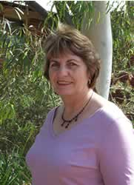**Cereal Chemist: Helen Allen**

**Background information on wheat**

**Cracker biscuit investigation**

**Student investigation: self-raising flour**

**Student investigation: cracker biscuit flour**

**Student investigation: how suitable is flour for bread making**

## 1. Cereal Chemist

Wheat is our most important grain crop, being grown on over 25 000 farms. About 80% is exported to over 40 countries and it is worth   
approximately 2.3 billion dollars per year to our economy. The export market is very competitive and it is important we develop wheat varieties with characteristics to meet the cultural needs of our customers.

Helen Allen is a Cereal Chemist at the Wagga Wagga Agricultural Institute working for the New South Wales Department of Primary Industries. Helen leads a team of ten scientists researching wheat for Australian farmers. The aims of the wheat improvement program are to develop new varieties that will:

* have high yield and disease resistance desired by farmers; and
* have grain quality that suits both the domestic and export markets.

Helen's qualifications:

* Bachelor of Applied Science, Charles Sturt University;
* Master of Agriculture (Cereal Chemistry) University of Sydney.

Below is an outline of one of the many research projects Helen has 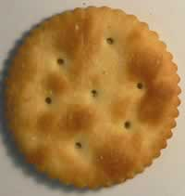undertaken.

Note: special thanks to Helen Allen for her assistance, research and photos.

**Cracker biscuits**Australian farmers had a problem, they were not growing enough soft wheat to satisfy demand by the cracker biscuit industry, there was a shortage of soft wheat. The farmers needed help to see if they could use other wheat varieties for the cracker biscuit market. We are talking of a huge global market worth millions of dollars. The farmers needed a cereal chemist to research wheat types for cracker biscuits. Hard wheat, as it name implies, is hard when bitten and soft wheat breaks more easily when bitten.

Cracker biscuits have been commercially produced for over one hundred years. They started in Britain under the name of cream crackers and later in America as soda crackers. In many countries, cracker type biscuits replace bread because the shelf life of crackers is far greater than bread. A simple recipe for cracker biscuits would be flour, fat, baking soda and salt.

## 2. Background information on wheat

A grain of wheat

|  |  |  |
| --- | --- | --- |
| http://www.reec.nsw.edu.au/geo/scient/image/rscc3c.jpg | http://www.reec.nsw.edu.au/geo/scient/image/rscc3a.gif | Bran is the hard, brownish outer protective skin of the grain and makes up about 16% of the grain. The bran layers are a source of dietary fibre.  The germ becomes the new plant if the seed is grown. It includes the embryo and contains most of the kernel's fat and vitamin E.  Endosperm makes up 80% of the grain. It provides the sprouting seed with food. The main nutrients in the endosperm are protein and carbohydrates. |

|  |  |
| --- | --- |
| http://www.reec.nsw.edu.au/geo/scient/image/rscc3b.gif | When milling hard wheat, the contents of the endosperm break along the lines of the cell wall and protein. The flour particles are large, have sharp edges and the flour feels gritty, like fine sand. The milled particles flow freely through a sieve to produce a very clean flour.  When soft wheat is crushed at the mill, the endosperm contents burst out in very fine rounded cells. The flour clumps together like fine powder and is difficult to sieve. |

**Hard and soft wheat**

**Strong and weak wheat**

* Strong wheat has a high protein content which makes an elastic dough needed for products like bread.
* Weak wheat has a lower protein content which makes a "breaking" dough suitable for products like biscuits.

**Wheat types used in the cracker biscuit investigation**

|  |  |  |  |  |  |  |  |
| --- | --- | --- | --- | --- | --- | --- | --- |
| Diamond | **Whistler** | Lorikeet | Sunsoft | Thornbill | Snipe | Bowie | Qal2000 |
| strong hard | weak hard | strong soft | strong soft | medium strong soft | weak soft | weak soft | weak soft |
| bread baking | general purpose | soft cracker biscuits | soft cracker biscuits | pastries cracker biscuits | sweet biscuits | sweet biscuits | sweet biscuits |

## 3. Cracker biscuit investigation

Helen's research report below shows how the team investigated different wheat types for cracker biscuits. To have confidence in the collected data, she need to be sure the tests were fair and that sources of error were minimised. Check the methods used below to see how it was a "fair" test.

Characteristics of a good cracker biscuit are:

* Crisp and crunchy with a good feel in the mouth when eaten with a soft centre, not too tough.
* Golden colour.
* Uniform outside appearance, no burnt or over cooked spots.
* Even inside texture. The internal stucture of biscuit and air spaces forms even flakes.
* Not too hard, chewy, firm or tough when eaten.

Use the above characteristics to evaluate the biscuite below. The cross-section shows the internal texture: even flakes apart from one large air space. Outside colour is not golden and varies from brown to white.

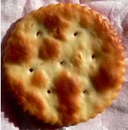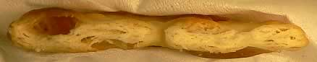

**MATERIALS AND METHODS**

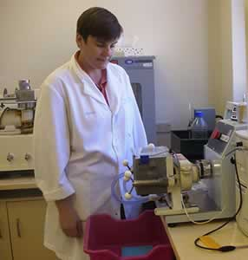Recipe  
Plain flour 220g, 1.5g sodium hydrogen carbonate (NaHC03, baking soda), 26g fat (Frymaster Solid Vegetable Oil) and 3.Og salt (NaCl) into a plastic jar. The liquid ingredient is made by dissolving 2.Og malt extract in 65g warm distilled water in a beaker.

The dough was mixed by machine then rolled to a thickness of 2 mm. A 60 mm biscuit cutter was used to cut the biscuits. Wire baking trays were used for baking at a temperature of 1800C.

The mixer was set to automatically stop after mixing for 5 minutes at 160 rpm; temperature was recorded by inserting a temperature probe into the dough. Dough temperature should be 350C or higher.

Each sheet of dough was placed on a greased baking tray, covered with a tea towel and rested in an oven at 300C for 3 minutes. After 3 minutes, as many biscuits were cut as possible for baking.

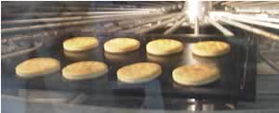The biscuits were baked in an oven for 8 minutes at 2150C.

After baking, the biscuits were covered with a tea towel, and placed into a cabinet to cool for 20 minutes. The biscuits were stored in a plastic container with the lid on, and judged the day after baking. Measurements taken to judge the biscuits were packet length (stack height), packet width, weight of 10 crackers, colour, texture and appearance.

This procedure was repeated for each type of wheat tested so the "test was fair". The only change, variable, was the type of wheat used.

**RESULTS**

|  |  |  |  |  |  |  |  |
| --- | --- | --- | --- | --- | --- | --- | --- |
| **Sample** | **Diamondbird** | **Lorikeet** | **Snipe** | **Sunsoft** | **Thornbill** | **QAL2000** | **Bowie** |
| **Height** of a stack of 10 (cm) | 8.1 | 7.2 | 6.8 | 7.8 | 7.2 | 6.4 | 7.0 |
| **Weight** of stack of 10 (g) | 71 | 58 | 57 | 58 | 59 | 56 | 57 |
| **Colour** | brown | golden | golden | yellow | golden | golden | golden |
| **Appearance** (outside) | dry, thick | OK, streaky | uniform | uniform | uniform | flat | uniform |
| **Texture** (inside) | hard,  chewy | even, crisp | even, crisp | thick, chewy | even, crisp | firm, tough | crisp, flaky |
| **Final Bake Score** | 37 | 56 | 54.5 | 50.5 | 59.5 | 35 | 56.5 |

**CONCLUSION**Strong hard varieties were totally unsuitable for this product as the texture was hard, and biscuits were hard and chewy. Weak soft wheat was also unsuitable as the biscuits were thin, flat and have a tough inside texture.

**Wheat type characteristics again**

|  |  |  |  |  |  |  |
| --- | --- | --- | --- | --- | --- | --- |
| Diamond | Lorikeet | Snipe | Sunsoft | Thornbill | Qal2000 | Bowie |
| strong hard | strong soft | weak soft | strong soft | medium strong soft | weak soft | weak soft |
| bread baking | soft cracker biscuits | sweet biscuits | soft cracker biscuits | pastries, cracker biscuits | sweet biscuits | sweet biscuits |

## 4. Student investigation: self-raising flour

You are a chemist working with Helen. Occasionally supermarkets complain that their self-raising flour does not rise when used. You know the baking powder in self raising flour produces carbon dioxide gas bubbles when mixed with water to produce dough.

You devise a simple test which can be used on the spot in the supermarket to test the alleged faulty flour. Mix 15 ml (3 teaspoons) of flour with 5 ml (one teaspoon) of water to produce a dough ball. Drop this in a cup of warm water (50 degrees Celsius) and wait one minute. If it rises to the surface, the flour is good. If it sinks it is bad. (Thanks to John Oliver, DPI for this test.)

You have a bad day and there are complaints from two supermarkets.

Write a report on your investigation using the following headings. Part 5 has the results of your investigation

1. What do we want to investigate?

2. What do we already know?

3. What do we think will happen?

4. Why do we think this will happen?

5. What are we going to do to find out more?

|  |
| --- |
| **Control**  You do the test with plain flour so you have something to compare the self-raising flour to. You repeat the test 3 times with flour from 3 different packets of the same brand and use-by-date. |

|  |
| --- |
| **Supermarket 1.**  You repeat the test 3 times with flour from 3 different packets of the same brand and use-by-date. |

|  |
| --- |
| **Supermarket 2.**  You repeat the test 3 times with flour from 3 different packets of the same brand and use-by-date. |

6. How will we make this a fair (controlled experiment) and reliable test?

7. What do we need?

8. What data did we collect from our observations?

|  |  |  |
| --- | --- | --- |
|  | **Sinkers** | **Floaters** |
| **Control** |  |  |
| **Supermarket 1** |  |  |
| **Supermarket 2** |  |  |

9. What does our data tell us? Can we analyse our data to find any relationships, patterns or trends?

10. What did we conclude?

11. Is this what we expected?

12. How are we going to report?

## 5. Student investigation: cracker biscuit flour

A current affairs television show has asked you to investigate different brands of plain flour available at supermarkets. They are looking at an angle to see if dearer brands are really better than cheaper "no name" brands. You are one of Helen's research assistants and she has asked you to do the investigation. You decide you will compare the flour by baking cracker biscuits. Your hypothesis is that dearer flour will make better crackers. Brand A is the cheapest flour and you will use this as your control to compare the dearer brands to.

Write a report on your investigation using the following headings to assist you. Part 5 has your results.

1. What do we want to investigate?

2. What do we already know?

3. What do we think will happen?

4. Why do we think this will happen?

http://www.reec.nsw.edu.au/geo/scient/image/rscc6b.gif5. What are we going to do to find out more?   
You bake a batch of biscuits with the following results.

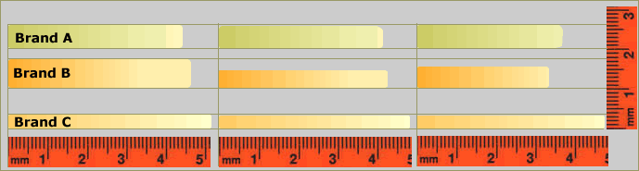

6. How will we make this a fair (controlled experiment) and reliable test?

7. What do we need?

8. What data did we collect from our observations?

|  |  |  |  |  |  |
| --- | --- | --- | --- | --- | --- |
|  | **Width** | **Height** | **Colour/Appearance** | **Texture** | **Taste** |
| **Brand A** |  |  |  | even, crisp | slight buttery flavour |
| **Brand B** |  |  |  | firm, tough | like old sardines |
| **Brand C** |  |  |  | hard, chewy | like strong cheese |

Did the width and thickness of crackers vary within brands?

9. What does our data tell us? Can we analyse our data to find any relationships, patterns or trends?

10. What did we conclude?

11. Is this what we expected?

12. How are we going to report?

## 6. Student investigation: how suitable is flour for bread making?

Wheat contains four different proteins: albumins, globulins, gliadians and glutenins. Two of these proteins when mixed with water form gluten. The unique properties of gluten are responsible for the structure of bread. Only hard wheat flour with a protein content of around 11% (strong) is suitable for baking bread. Gluten washing was first developed as a test of the baking quality of flour over 100 years ago and is still used to determine gluten content.

**Try this investigation yourself using real flour.**

Use the following headings to assist you to do your investigation.

1. What do we want to investigate?

2. What do we already know?

3. What do we think will happen?

4. Why do we think this will happen?

5. What are we going to do to find out more?

**Gluten Washing**

**Materials**

Strong Flour (Bakers - bread making)

General Purpose flour (plain flour)

Water 250C

* Baker’s flour is available from either the supermarket or health food shop. Baker’s flour is Australian hard wheat flour of 11% + protein content.
* General purpose flour from the supermarket, sold as plain flour, is usually a blend of low protein hard wheat and Australian Standard White soft wheat.

**Method**

100g flour - Bakers 50 – 55 mL of water and   
100g flour – General Purpose plain flour 40- 45 mL of water

**Procedure**

In a small container add 100g flour, take 50 mL water for baker’s flour or 40 mL for general purpose flour.

Mix into a dough ball approximately 1 minute. If the dough is too dry add a little more water just a small amount at a time, if too wet add a little flour a small amount at a time. When a nice even ball is achieved and the dough ball can be worked run a tap with slow trickle of cold water. Work the dough under the water, moving it between the thumb and fingers, trying to keep the dough mass together.

As the dough is worked the starch will be washed out, starch makes up about 65-70% of the flour, while protein can be 8-24%.

Strong gluten mass not unlike chewing gum will form with hard flour, the higher the protein content, the greater the gluten ball. At the end of washing the gluten will stick together, will have a glassy appearance that is slightly yellowish - grey in colour.

In general purpose flour or soft wheat flour this gluten formation will be weak, the ball will fragment very easily and will not have the same glassy appearance.

6. How will we make this a fair (controlled experiment) and reliable test?

7. What do we need?

8. What data did we collect from our observations?

9. What does our data tell us? Can we analyse our data to find any relationships, patterns or trends?

10. What did we conclude?

11. Is this what we expected?

12. How are we going to report?

http://www.reec.nsw.edu.au/geo/scient/image/rscc2b.gif[**Agricultural Protection Officer**](http://www.reec.nsw.edu.au/geo/scient/text/rsap1.htm)

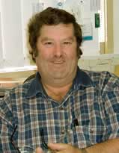[**Mouse monitoring**](http://www.reec.nsw.edu.au/geo/scient/text/rsap2.htm)

**Background: mice**

**Mouse investigation: Murrumbidgee Irrigation Area**

**Student Investigation: where are the mice?**

**Locust swarms**

**Locust life cycle**

**Student investigation: locust survey**

## 1. Agricultural Protection Officer

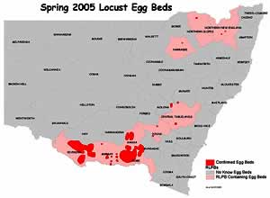In the summer of 2004/5 scientists saved the economy over four billion dollars in damage to crops and pasture from a locust plague. The map at right will save millions of dollars more if farmers are ready for the next one.

"This summer, Australian farmers are bracing themselves for a locust plague of biblical proportion that has the potential to cause $500 million  
damage in crops alone." Landline, ABC TV 2000

David Croft is the Agricultural Protection Officer for the Murray, Murrumbidgee & Riverina based at the Wagga Wagga Agricultural Institute with the Department of Primary Industries.

David's qualifications include:

* Certificate in Animal Husbandry, Queensland;
* Bachelor of Arts (zoology/environmental studies), University of New England; and
* Master of Science; University of New South Wales.

For many years David was involved in research on foxes, rabbits, feral pigs, wild dogs, feral goats and rodents until 1987 when he was appointed as the Agricultural Protection Officer.

David has over thirty five years’ experience with locusts and vertebrate pests and has been involved with exotic disease management for over twenty years.

More recently he has been recognised as an authority on rabbits, mice and plague locusts and conducts regular workshops principally to promote effective control of vertebrate pests and noxious insects by providing advice and training to land managers and Rural Lands Protection Board staff.

Note: special thanks to David for his assistance, research and photos.

## 2. Mouse monitoring

"With the current mouse problems being experienced by many farmers, there is an urgent need to get a picture of the current and potential mouse problem on a Board by Board basis.

The best way to coordinate the baiting requirements and to determine the distribution of mice throughout the state is by monitoring and reporting.

Each Rural Lands Protection Board in the grain growing areas of NSW are asked to do some in-crop monitoring using census cards.”

David Croft  
Agricultural Protection Officer  
Murray/Murrumbidgee Region  
13 September, 1999

**Census cards for assessing the possible presence of mice in the field.**

Where pests pose a problem there is always a need to maintain some form of monitoring or observation that can relate to changing population densities. Mice are present all the time in the field living in holes (photo) and under cover from predators.

There is no truly accurate way to count mice, except for extensive trapping. However, the use of census cards can provide an indication of mouse activity and whether they are increasing or declining.

Cards are put out in the afternoon and retrieve the following morning. Record the number of squares chewed from individual cards and the location of those cards along the transect. If only 5–10% of cards are chewed, then the problem might not need much action apart from regular checks. If there is an average of 15% chewed then there is an increasing mouse problem and action needs to be taken. Greater than an average of 20% indicates there could be a major mouse problem or a potential for the mouse population to increase rapidly and cause serious economic damage.

Preparing census cards

1. Cut sufficient cards to do each nights count. You need at least 10 cards per transect.
2. Each card is 10 cm x 10 cm cut from white (photocopy etc.) paper. A 10x10 grid pattern 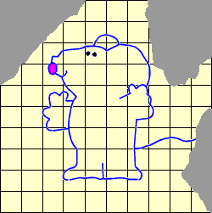may be printed on it for measuring percentage chewed.
3. Soak cards in canola or similar vegetable oil for at least an hour then drain cards for 10 minutes.
4. Cards are put out in the afternoon (the later the better).
5. Each monitoring line should be marked and noted (recording type of vegetation).
6. Place 10 cards in a row in the paddock at 10 metre (10 - 12 paces) intervals.
7. Fix cards to the ground using wire spikes (not clods of dirt) to prevent cards being carried off or blown away.
8. Retrieve cards the following morning.
9. Record the number of squares chewed from individual cards and the location of cards within the transect

**If you were doing a mouse census on two different farms, how would you make it a "fair" test?**  
Start with the census cards. Would you use the same vegetable oil, make the cards from the same paper, the same size, leave them out for the same length of time, have the same number per area on each farm? Where and how would you place cards in the field?

## 3. Background information: Mice

Mice can breed at an alarming rate with litters of 2-11 young every three weeks. If conditions are right, plague proportions can be reached after only 4-5 generations. Because of the potential for rapid population increases, early detection of potential mouse plagues is essential if effective control is to be implemented.

Mice are present throughout nearly all grain growing areas of Australia at all times of the year. Numbers depend on many factors but the most important is between non-breeding winter populations and breeding populations of spring and summer.

Mice are not long lived and the size of the over-wintering population is usually small and unnoticeable. Weather and food supply trigger the commencement of breeding in spring and determine if a population develops into a plague. Breeding usually commences around October and continues through to the following June.

The earlier breeding commences and the sizes of the over-wintering population are important factors in predicting the likelihood of a plague. Peak numbers can be expected by early autumn with numbers then declining due to colder temperatures, lack of food and stress related diseases.

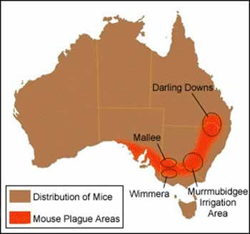

## 4. Mouse investigation: Murrumbidgee Irrigation Area

Mouse plagues occur somewhere in Australia every 4 years. Management has been reactive with large amounts of poisons used by farmers once a plague has erupted. In one instance over 500 000 hectares of land was baited. This investigation is aimed at determining whether the extensive use of poison can be prevented through early preventative actions.

Fencelines and adjacent non-crop areas are a stable habitat for mice through providing cover and food from grasses and weeds. Reducing these non-crop habitats can reduce the abundance of mice in adjacent crops.

The study was undertaken on farms in the Murrumbidgee Irrigation Area. Twelve experimental sites were randomly selected on seven farms near the town of Coleambally. Farm management actions were developed for each major crop type (winter cereal, irrigated rice and summer crop). Actions included weed control, stubble management and sowing depth and timing.

Response to the practices were evaluated by comparing six treated and six untreated (control) sites for abundance of mice, damage to crops by mice and estimates of yield loss from mice. Below is a graph of the results estimating mouse abundance using census cards. The seasonal overlap of winter cereal and rice crops means mice have a continuous supply of food.

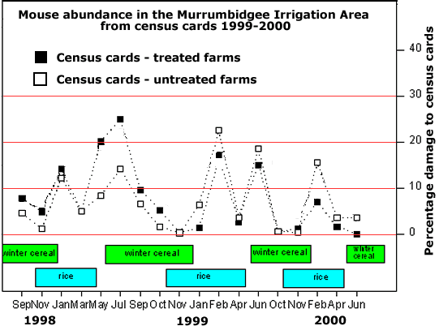

**Student Activity**

Describe how mouse populations vary seasonally on both treated and untreated farms.

What is the most likely cause of this natural seasonal variation?

What was the general population trend for mice on both the treated and untreated farms between 1998 and 2000?

Compare the mouse populations on the treated and untreated farms.

* When the investigation started, which farm type had higher mouse populations?
* When the investigation finished, which farm type had higher mouse populations?

Name benefits to farmers in following preventative management practices on farms in this area.

Give reasons why this was a "fair" test.

## 5. Student investigation: where are the mice?

Are there mice in your backyard, vacant lot or 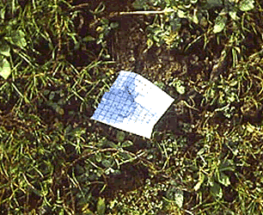school grounds? Where do they prefer to live? You can find if mice are present and where they prefer to live by doing a mouse census.

Prepare mouse census cards as described in page 2 on Mouse Monitoring and place them randomly in your study area.

Use the following headings to assist you to do your investigation.

1. What do we want to investigate?

2. What do we already know?

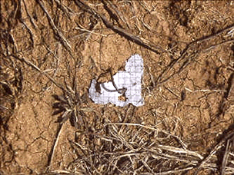3. What do we think will happen? Do you think the mice will be evenly distributed around the grounds or concentrated in particular places?

4. Why do we think this will happen?

5. What are we going to do to find out more?

6. How will we make this a fair and reliable test?

* How many cards will you use?
* When will you place and collect them (time)?
* Will all cards be exactly the same: size; paper; colour; oil etc?
* What else may eat the cards and give false readings?

7. What do we need?

8. What data did we collect from our observations?

9. What does our data tell us? Can we analyse our data to find any relationships, patterns or trends?

10. What did we conclude?

11. Is this what we expected?

12. How are we going to report?

## 6. Locust swarms

The swarm of locusts below occurred in the summer of 2004/5 and was over 50 km long, 20 km wide and 300 meters deep with a density of 100 to 150 locusts per cubic metre. The direction and distance covered during migration depends on temperature, wind-speed and wind direction. Migrations of 500–600 km overnight are not uncommon and this behaviour can lead to the sudden appearance of large numbers of locusts in previously un-infested areas.

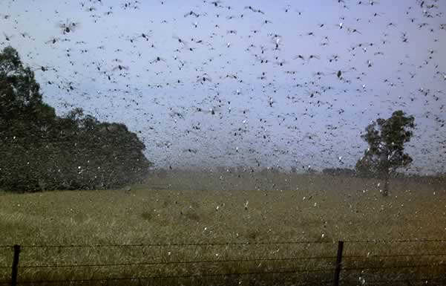

Photo: locust swarm approaching Wagga Wagga, Riverina region NSW 2004

Tiny locusts, about the size of a grain of wheat, will grow 10 times bigger in five weeks, after eating five times their body weight a day. A dense 250 acre swarm of 40 million insects can eat 10 tons of grains a day." Photo at right: overnight crop damage in the Riverina region of New South Wales, 2004.

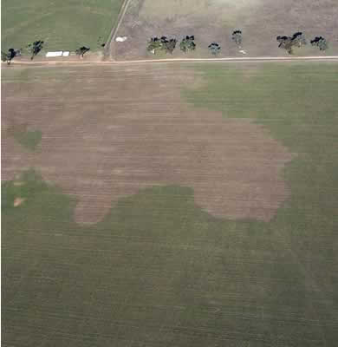

## 7. Locust life cycle

|  |  |  |
| --- | --- | --- |
| http://www.reec.nsw.edu.au/geo/scient/image/rsap6b.jpg | http://www.reec.nsw.edu.au/geo/scient/image/rsap6a.jpg | Female locusts prefer to lay eggs in hard soil and often congregate on tar roads trying to drill into the tar to lay eggs. |
| http://www.reec.nsw.edu.au/geo/scient/image/rsap6c.jpg | Female locusts lay eggs in batches called pods, usually at a depth of 2–10 cm. Each pod will contain 30–60 pale yellow banana shaped eggs 5–6 mm long and an individual female may lay up to three pods. A collection of egg pods laid by a number of locusts is termed an egg bed.  Eggs need warmth and moisture to develop and will suspend development if these needs are not met. In summer, eggs may hatch within 14–16 days. | |
| http://www.reec.nsw.edu.au/geo/scient/image/rsap6e.jpg | An immature locust is called a nymph or hopper. After hatching from the egg, a locust goes through five growth stages called instars, moulting at each stage. At each stage, the developing wings become more noticeable until the locust becomes a fledgling adult and then a mature adult capable of sustained flight. Normally, the nymphs take 4–8 weeks to complete this development.  When the population is large and at the second and third instar, nymphs will often concentrate into dense aggregations called bands. These bands will vary in size but can extend over several kilometres and can move over 1 km from the egg bed before the nymphs fledge and can consume or damage all vegetation in its path. | |
| http://www.reec.nsw.edu.au/geo/scient/image/rsap6f.jpg | After the final moult, the adult locust emerges with fully-formed wings. At first the body and wings of the locust are still soft and, until they harden after about a week, sustained flight is not possible. Green feed is required to provide fuel for flight and egg development. | |
| http://www.reec.nsw.edu.au/geo/scient/image/rsap6g.jpg | If numbers are sufficient, adult locusts may concentrate into dense groups called swarms. These infest areas usually less than 5 Km2 but which can be up to 50 Km2. If sufficient green feed is available to enable flight but conditions are drying off, migration of locusts may occur. | |

## 8. Student investigation: locust survey

Increasing numbers of locust have been reported near your property and the Agricultural Protection Officer for your Rural Lands Protection Board has asked all farmers to do daily surveys of locusts and report back so they can monitor locust density and coordinate aerial spraying.

How should you do this survey? Do you drive through the paddocks looking for locusts flying out of the path of your vehicle and then count the highest concentration or do you randomly survey your paddocks?

Below is a small portion, 4 metres by 10 metres, of a paddock. The black squares are quadrats you have put down to count locusts in the highest concentrations near the vehicle. The yellow quadrats have been randomly placed in the area.

|  |  |  |
| --- | --- | --- |
| Comment on your results using the two different methods and the implications for the Agricultural Protection Officers when they receive your report. The descriptors at right should be used to describe locust infestations. | **Density** | **No. per m2** |
| Isolated | 0.02 |
| Scattered | 0.02–0.1 |
| Numerous | 0.1–0.5 |
| High concentration | 0.5–3 |

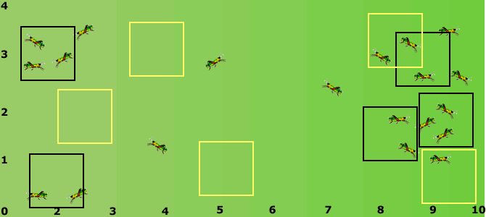

Use the following headings to assist you to report on your investigation using the above data.

1. What do we want to investigate?   
What is the density of locusts in the sample area?

2. What do we already know?

3. What do we think will happen?

4. Why do we think this will happen?

5. What are we going to do to find out more?

6. How will we make this a fair and reliable test?

7. What do we need?

8. What data did we collect from our observations?

9. What does our data tell us? Can we analyse our data to find any relationships, patterns or trends?

10. What did we conclude?

11. Is this what we expected?

12. How are we going to report?

http://www.reec.nsw.edu.au/geo/scient/image/rscc2b.gif**Weed Educator Officer : Annabel Bowcher**

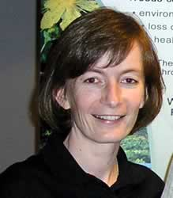**Background information on weeds**

**Weed management research paper - background**

**Weed management research paper - short version**

**Weed management research paper - long version**

**Student investigation: competition**

**Student investigation: seed dispersal**

**Student investigation: germination**

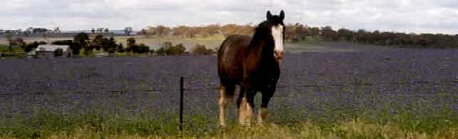

Pasture dominated by Paterson's Curse (purple)

*Much of the information in this section on weeds is from the* education resource, "Ghastly Guests"*, produced by the* Weeds Cooperative Research Centre (Weeds CRC). This excellent resource and other information is available at: www.weeds.crc.org.au

## 1. Weed Education Officer

**Science writer, communicator or educator**

Just because it's green and growing doesn't mean it should be there – it could be a weed. More than two thirds of weeds in Australia have escaped from parks and gardens. The cost of the almost 2500 environmental weeds is almost impossible to calculate. Agricultural weeds in Australia cost the nation more than $4 billion dollars each year – this amount equates to building 1000 new primary schools! How does this message and information about managing this huge national problem get out to the relevant groups within the community? That is the job of a science writer, communicator or educator.

Dr Annabel Bowcher is an education officer with the Cooperative Research Centre for Australian Weed Management and is based at the Wagga Wagga Agricultural Institute with NSW Department of Primary Industries (NSW DPI).

Annabel's qualifications include:

• Bachelor of Agricultural Science (Honours), University of Queensland

• Doctor of Philosophy (Agriculture), Charles Sturt University

• Certificate IV in Workplace Training and Assessment, Murrumbidgee College

After graduating from university in 1992, Annabel began working for NSW Agriculture (now part of NSW DPI) as a technical officer in Dubbo. She coordinated a number of farmer groups (TOPCrop groups) around central west NSW. These groups met on a regular basis during the year to discuss topics related to growing high quality crops. In 1994, Annabel moved to Wagga Wagga to assist on a pasture research project. At the completion of this project, Annabel continued her interest in pasture research and completed her PhD on the topic ‘Competition between temperate perennial pastures and annual weeds'.

Annabel's interest in communicating outcomes from research projects to the target audience e.g. farmers, led her to a new area of employment. Firstly as a communication officer and then as an education officer with the Cooperative Research Centre for Australian Weed Management (Weeds CRC). Annabel now sources the latest weed management information and compiles this into nationally relevant education and training resources. Organisations providing weed management training use these resources to teach best practice weed management. A science communicator or educator has the best of both worlds with respect to knowledge and creativity. They keep up-to-date with the most current information in their area of interest e.g. weeds and then creatively determine how best to package this information to the target audience e.g. community groups, teaching organisations, government, industry.

**What does this job entail?**

• Writing articles for magazines/newspapers;

• Writing appropriate resources that contain the necessary information for that target audience;

• Desk-top publishing;

• Working with graphic designers to create a design for the various products;

• Creating networks within the target audience to promote resources and also determine what they want;

• Creating networks across Australia to source current information from research scientists and others working in the area of interest;

• Creating and running training workshops.

## 2. Background information on weeds

A weed is 'a plant growing in the wrong place'. It could be a native Australian plant or a plant introduced from overseas.

**Characteristics which contribute to a plant being classed as a weed:**  
  
**1. Stock injury**   
Certain weed seeds can cause damage to livestock. Spiny burr grass seeds commonly cause eye and mouth ulcers and lameness in grazing animals, and contaminate fleeces. The spines on the fruits of caltrop and spiny emex can damage the feet of stock. Bristles on the leaves and stems of Paterson's curse irritate the udders of dairy cows.   
  
**2. Competition**   
Weeds usually compete strongly with more desirable plants for moisture, nutrients and light. Hardheads competes with wheat crops, blackberry and thistles with desirable pasture species, boneseed with native vegetation.   
  
**3. Poisoning**   
Some plants are poisonous to livestock and humans. Hemlock can be lethal to both stock and people, the seed being the most toxic part of the plant. Cape tulip can cause heavy losses in stock newly introduced to it.   
  
**4. Harbour diseases and vermin**   
Blackberry, furze (gorse) and boxthorn provide good harbour for rabbits, foxes and other pest animals. Saffron thistle is a host for fungus diseases which affect safflower and cotton, while 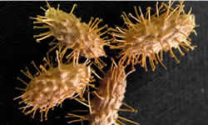ox-eye daisy can host a virus which damages potatoes.   
  
**5. Tainting and contamination**   
Wool can be contaminated by the seeds of many weed species. The presence of burr and vegetable matter ("fault") in the wool leads to a down-grading of the fleece. Bathurst burr and other burrs, as well as grass seeds in general, are common contaminants of wool. When animals eat wild garlic their milk and meat becomes tainted. This subsequently lowers the value of these products, and may make them unsaleable. Grain milled with saffron thistle or amsinckia (yellow 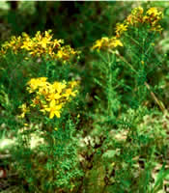burr weed) results in discoloured flour.   
  
  
**6. Allergies**   
Some people have developed skin reactions after being in contact with St John's wort or Bathurst burr. Tree of heaven, especially at the flowering stage, may cause dermatitis in susceptible people. Parthenium weed is known to cause dermatitis more generally.   
  
**7. Interference with agricultural practices**   
Some weeds make cultivation difficult. Weeds can become entangled in machinery and prevent efficient harvesting. Cucurbits (such as the wild melons) and skeleton weed provide examples. Thistles and nettles in hand-picked crops cause discomfort to workers. Spiny emex is a problem to workers in vineyards. Fleeces contaminated by spiny burr grass and caltrop can cause discomfort or injury to shearers.   
  
**8. Interference with transport, essential services and recreation**   
Weeds near railway lines can foul signaling equipment and can obscure warning signs along roadsides. Water hyacinth and alligator weed choke drains, irrigation channels and other waterways. Blackberries and furze can form impenetrable barriers to livestock, vehicle movement and bushwalkers. Boneseed and bridal creeper may impede access to beaches and other natural areas. Weeds may also become a fire hazard once they dry off in the summer.   
  
**9. Agricultural**   
These weeds threaten agricultural productivity. Agricultural weeds may also be environmental weeds and may also be noxious. However the term usually refers to species that are not noxious, such as wild oats and ryegrass in cereal crops, and barley grass, docks and erodium in pastures. Serrated tussock is a noxious weed which severely affects stock production. It is not poisonous but has very little nutritive value so although stock may eat the grass, they may still starve to death.   
  
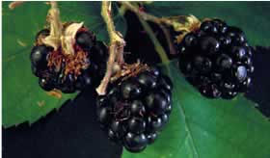**10. Environmental**   
Many plants have become weeds by invading the Australian environment and damaging natural forests, bushland wetlands and grasslands. If weeds take over an area, the habitat value can be severely degraded. Wandering tradescantia completely smothers all other vegetation and can drastically alter the natural balance of an area. Boneseed can similarly destroy all other plants by forming dense stands under which nothing else will grow.   
  
**11. Soil erosion**   
Some weeds such as Paterson's curse are very good competitors and shade out other plants, but die off in summer, leaving the ground bare and prone to erosion.   
  
**12. Aesthetics**   
'Aesthetic weeds' are plants which are simply not liked or wanted. They may be interrupting a view, crowding out other more desirable species, have an offensive odour or be generally causing problems. Dandelion, bristly ox-tongue, hawthorn and bamboo provide examples

This page is based on: What is a weed? Anne-Marie Tenni, Melbourne and Ian Faithfull, Frankston February, 1998 Department of Primary Industries, Vic.

Photos from Cooperative Research Centre for Australian Weed Management education resources "Ghastly Guests": Noogoora burr, Bathurst Burr, St John's wort, blackberry.

## 3a. Weed management research paper background

Pastures for grazing animals such as sheep and cattle consist of both the grasses you want and the weeds you don't want. Most weed management on farms currently relies on broadleaf herbicides sprayed on the pasture which kill the weeds and not the grasses. Herbicides are expensive and some weeds are becoming resistant to the 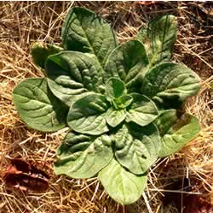herbicides, they don't work as well as they did before.

**Broadleaf weeds**

General term for pasture plants growing in the wrong area which have wide leaves as distinct from grasses which have narrow leaves. When broadleaf plants first develop from seeds they have two seed leaves (dicotyledons) and grasses have one (monocotyledons). The photo at right shows Paterson's curse, a broadleaf weed in the rosette stage.

**Defoliation**

Defoliation is the removal of some of the plant. A 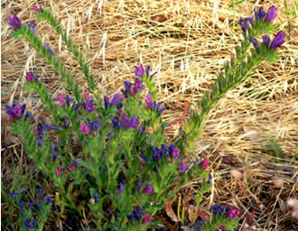sheep can eat some or we can mechanically remove some by cutting (mowing) it. The plant is still alive, just shorter. If we defoliate the weeds during flowering but before the seeds have formed we may be able to reduce the number of weeds in future years. Pastures will normally have a number of different grasses we want and a number of different weeds we want to get rid of. These different plants will flower and set seed at different times so timing the defoliation is critical. We want the grasses to set seed and not the weeds.

Non-selective defoliation technique: cutting the 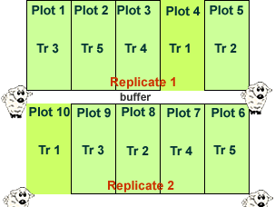pasture mechanically is a non-selective method, all plants are defoliated to the same height. If we use sheep to defoliate the pasture it is a selective method. Sheep will eat their favourite plants and leave others plants alone to grow bigger.

**Experimental design**

This is very important so we obtain reliable data. Five different treatments (Tr 1-5) consisting of different defoliation times were tried to see which worked the best. These were done on plots 10 m wide x 20 m long. If Annabel just had one set of plots, her results may not be very accurate, so for her data to be more reliable she repeated (replicated) each plot four times. A 10 m wide buffer, just an unused area, was placed between the replicates to separate them.

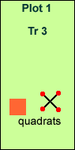**Quadrat**

It is very difficult and time consuming to count every plant in an area when doing a plant survey to find what species of plants are present and how many of each there are. One method is to use quadrats. These are small sample areas which are representative of the area studied. To give reliable data you need to do a lot of them and they need to be randomly placed in the study area. If you look at the study area and decide where to place your quadrats, you may end up with a biased result, you don't mean to but you may choose areas with more weeds. The diagram at right shows two types of quadrats, a typical square (orange) where all plants are counted within the square and a point quadrat (cross) where plants are identified at the four red points.

## 3b. Weed management research - short version

**Background**

Pastures on farms for grazing animals such as sheep and cattle consist of both the grasses you want and the weeds you don't want. The following research by Annabel investigated whether cutting the pasture at different times could remove the weeds. Most weed management relies on expensive broadleaf herbicides sprayed on the pasture which kill the weeds and not the grasses.

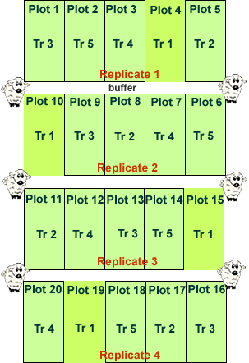Check how this investigation was done so that it was a "fair test".

**Experimental design and treatments**

The experimental area contained four replicates that were separated by 10 m wide buffers. Each replicate consisted of five, 10 m x 20 m plots. Defoliation treatments were allocated to the plots randomly, hence the plots in the diagram,Tr 1-5, are all mixed up. The plots were either grazed or mechanically defoliated during spring. There were four mechanical defoliation treatments and one treatment continuously grazed by sheep:

Tr 1 (Treatment 1) Continuously grazed by sheep (10 DSE) and not cut. This was the control plot to compare the others to.

Tr 2 Grazed by sheep 1 Jan – 1 Aug; sheep excluded and mechanically defoliated early Oct

Tr 3 Grazed by sheep 1 Jan – 1 Aug; sheep excluded and mechanically defoliated late Oct

Tr 4 Grazed by sheep 1 Jan – 1 Aug; sheep excluded and mechanically defoliated early Nov

Tr 5 Grazed by sheep 1 Jan – 1 Aug; sheep excluded and mechanically defoliated late Nov

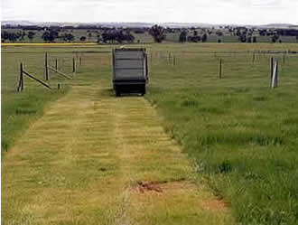The treatments were repeated over three years (1997-1999).

**Mechanical defoliation treatments**

Mechanical defoliation was achieved using a small plot forage harvester (large lawn mower). The pasture was cut to 5 cm and the harvested material removed from the experimental area.

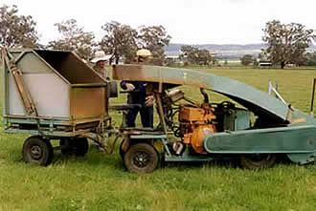

**Management of livestock**

The experimental area was grazed by sheep (wethers) at 10 dry sheep equivalents (DSE) from July 1997.

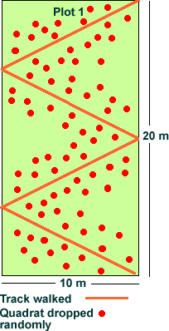**Plant survey**

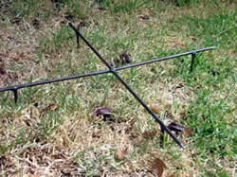The number of each plant type was assessed at various times during the spring using a non-destructive technique. A modified rod-point quadrat method (Little and Frensham 1993) was used to assess botanical composition of the pastures. The rod consisted of two 50 cm pieces of steel welded in the middle to form a cross with the ends sharpened. Metal legs (4 cm high) were attached to each arm of the cross. The point-quadrat was then randomly placed on the pasture and the plants closest to the four elevated points were recorded (Kemp and Dowling 1991).

The quadrat was thrown 80 times/plot while walking back and forth across the 200 m 2 area. This method was used to assess the plant 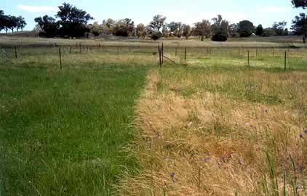composition of the plots.

**The results**

The photo at right shows two plots, the left one cut in early October has reduced vulpia content but the plot on the right , cut in early November has increased vulpia content.

Large changes in pasture composition occurred as a result of the various defoliation methods and their timing, after two years (Table 1).

**Table 1** Effect of grazing by wethers (10 DSE stocking rate) and cutting times on species composition of a mixed annual grass/subclover/perennial grass pasture the third spring after cutting or grazing in each of the two previous springs.

|  |  |  |  |  |  |  |
| --- | --- | --- | --- | --- | --- | --- |
|  | | | **Grazed then cut in spring** | | | |
| **Species** | **Initial pasture composition (%)** | **Grazing only** | **Early Oct (silage)** | **Late Oct  (late silage or early hay)** | **Early Nov (traditional hay – district practice)** | **Late Nov (late hay)** |
|  | | | **(% of species in pasture in year 3)** | | | |
| **Phalaris + cocksfoot** | 15.9 | 15.4 | 18.4 | 14.2 | 14.1 | 16.6 |
| **Subclover** | 31.4 | 18.1 | 36.6 | 11.6 | 15.6 | 19.9 |
| **Naturalised clovers** | 3.9 | 0.5 | 4.5 | 0.3 | 4.0 | 6.6 |
| **Annual ryegrass** | 25.1 | 17.7 | 28.3 | 52.8 | 9.8 | 9.2 |
| **Vulpia (silvergrass)** | 16.4 | 26.3 | 2.0 | 10.3 | 53.2 | 41.3 |
| **Great brome (grass)** | 1.0 | 14.1 | 2.1 | 0.2 | 1.3 | 3.9 |
| **Barley grass** | 0.3 | 4.8 | 0.2 | 0 | 0.4 | 0.1 |
| **Paterson 's curse (weed)** | 3.5 | 0.3 | 6.9 | 4.4 | 1.4 | 1.5 |
| **Other broadleaf weeds** | 2.3 | 2.7 | 1.2 | 6.0 | 0.8 | 0.2 |

Continuously grazing the pastures during spring had a large impact on Paterson 's curse seed production (Table 2) and subsequent autumn seedling germination but favoured annual grass species such as vulpia (silver grass), bromes and barley grass.

Compared to grazing, defoliating in early October (equivalent to an early silage cut in this region), significantly improved subclover and annual ryegrass content, and reduced vulpia. Cutting at this time may favour an increase in the content of Paterson 's curse if the regrowth is not managed as the regrowth can successfully produce viable seed.

A traditional hay cut for this region would equate to cutting in early November. Defoliating at this time reduced annual ryegrass and subclover but significantly increased vulpia content as vulpia produced and shed vast quantities of viable seed before the defoliation occurred.

The stage of growth of a species at the time of defoliation determines its response to the cutting e.g. subsequent growth and seed production. For weed management in this trial, the optimum stage for cutting annual grasses is when the majority of the **most advanced** seed heads is between post-flowering and very early seed fill. For Paterson 's curse, the optimum cutting time appears to be when the earliest (lowest) flowers are starting to form green seeds on the **most advanced** flowering head.

Further research is required to provide clear guidelines on the critical growth stages for other pasture species, so that farmers can identify the optimum cutting time. This approach will be much more reliable with respect to weed management than setting defoliation dates by a calendar as species development will vary with region and year.

If mechanical defoliation is to be used as a weed management tool in pastures, the optimum time to manage the target weed may not correspond with the optimum time for obtaining maximum forage quality. Farmers wishing to incorporated strategic spring defoliation into their pasture weed management plans need to determine a balance between forage quality and desirable changes to pasture composition.

# ****Table 2**** Impact of one or two years of grazing or cutting on the seed production of annual ryegrass, vulpia, and Paterson 's curse.

|  |  |  |  |  |  |  |
| --- | --- | --- | --- | --- | --- | --- |
| **Defoliation method** | **Annual species seed production (seeds/m 2 )** | | | | | |
| **Annual ryegrass** | | **Vulpia** | | **Paterson 's curse** | |
|  | **1 year** | **2 years** | **1 year** | **2 years** | **1 year** | **2 years** |
| Grazing | 1 481 | 1 669 | 6 824 | 18 469 | 20 | 22 |
| Cut early October | 981 | 834 | 1 004 | 56 | 973 | 877 |
| Cut late October | 95 | 7 | 208 | 29 | 303 | 86 |
| Cut early November | 237 | 2 896 | 2 248 | 13 650 | 7 | 223 |
| Cut late November | 990 | 6 879 | 11 985 | 29 895 | 208 | 2 153 |

**References**

Kemp, D.R. and Dowling, P.M. (1991). Species distribution within improved pastures over Central N.S.W. in relation to rainfall and altitude. Australian Journal of Agricultural Research **42** , 647-59.

Little, D.L. and Frensham, A.B. (1993). A rod-point technique for estimating botanical composition of pastures. Australian Journal of Experimental Agriculture **33** , 871-5.

## 4. Student investigation: competition

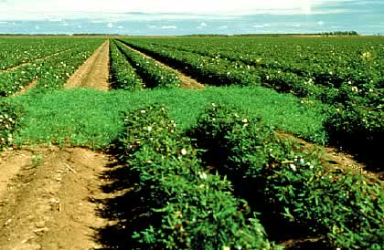1. What do we want to investigate?   
To determine the effect of competition among plants for limited resources such as water. Weds compete with crops for soil nutrients, water, sunlight and space to grow. They cost farmers 4 billion dollars each year in lost yield and control costs. The cotton crop at right cannot compete with the weed "take all" in the middle of the photo. *Photo: Weeds CRC education resource, "Ghastly Guests".*

2. What do we already know?

3. What do we think will happen?

4. Why do we think this will happen?

5. What are we going to do to find out more?

Plant one bean seed in a pot on its own, the control. Then set another two pots with one bean seeds and 3 corn seeds on one and a bean seed and 9 corn seeds in the other. The beans represent the crop plant and the corn seeds represent the weeds.

You must give each pot exactly the same amount of water. Only water when the bean plant in the control pot requires it. You will need to count the number of drops to be accurate.

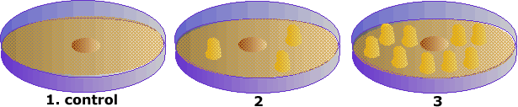

6. How will we make this a fair test?

* Will we just have one of each pot or more?
* Will the pots be the same size?
* Same amount of soil?
* Same amount of sunlight?
* Anything else?

7. What do we need?

8. What data did we collect from our observations?

Below are our results after three weeks. Compare the size and colour of the one bean plant in each and the corn plants in pots two and three.

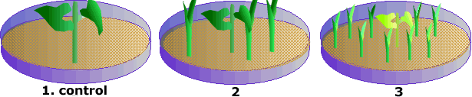

9. What does our data tell us? Can we analyse it for any relationships?

9. What did we conclude?

10. Is this what we expected?

11. How could I improve this investigation?

12. How are we going to report?

Try this investigation yourself with real seeds.

*Investigation based on activity in Weeds CRC, education resource, "Ghastly Guests".*

## 5. Student investigation: seed dispersal

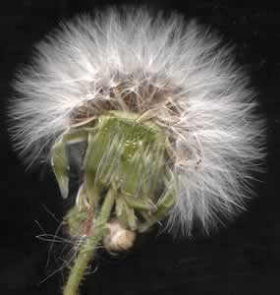1. What do we want to investigate?   
The design of seeds for dispersal by wind .

2. What do we already know?

3. What do we think will happen?

4. Why do we think think this will happen?

5. What are we going to do to find out more?

Design and make a seed suitable for wind dispersal using a pea or corn seed to add things to.

6. How will we make this a fair test?

* Finished seeds will dropped in front of a fan from the same height.
* Each seed will be dropped three times and the distance travelled from the fan measured then the average calculated.
* Other ideas on making a fair test:

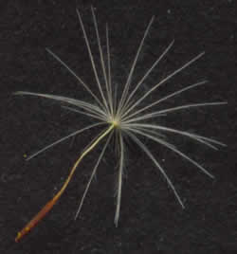7. What do we need?

* pea seeds or similar
* straws, feathers, blue-tac, balloons, sticky tape.

8. What data did we collect from our observations?

9. What does our data tell us? Can we analyse it for any relationships?

9. What did we conclude?

10. Is this what we expected?

11. How could I improve this investigation?

12. How are we going to report?

Investigation based on activity in Weeds CRC, education resource, "Ghastly Guests".

## 6. Student investigation: seed dormancy

1. What do we want to investigate?   
Many plant seeds can remain dormant in the soil for long periods of time (several years). Weed seeds are especially cleaver at this. This is one reason they keep popping up.

|  |  |  |
| --- | --- | --- |
| http://www.reec.nsw.edu.au/geo/scient/image/rswr6d.jpg | http://www.reec.nsw.edu.au/geo/scient/image/rswr6f.jpg | http://www.reec.nsw.edu.au/geo/scient/image/rswr6e.jpg |

Collect some soil from a weedy area, water it to keep moist and see how many seeds germinate in 21 days.

2. What do we already know?

3. What do we think will happen?

4. Why do we think this will happen?

5. What are we going to do to find out more?

* Collect enough soil from a weedy area to fill 4 pots. Place the pots in a warm, sunny position.
* Water the pots when required and check the pots each school day.
* Record the number of seeds germinated each day and graph them.

6. How will we make this a fair test?

* Have four pots, not just one.
* Other ideas on making a fair test:

7. What do we need?

8. What data did we collect from our observations?

9. What does our data tell us? Can we analyse it for any relationships?

9. What did we conclude?

10. Is this what we expected?

11. How could I improve this investigation?

12. How are we going to report?

Investigation based on activity in Weeds CRC, education resource, "Ghastly Guests".

http://www.reec.nsw.edu.au/geo/scient/image/rsbi1b.gif**Environmental scientist: Skye Wassens**

**Background Information on invertebrates**

**Arthropod Research**

**Student Investigation: sampling techniques**

**Student Investigation: food webs**

Original report produced by Charles Sturt University students Samantha Coburn and Megan Posselt



## 1. ****Environmental scientist: Sky Wassens****

Skye Wassens is a lecturer within the School of Science and Technology at Charles Sturt University, Wagga Wagga campus. She lectures in Environmental Science and Biology subjects.

Skye's qualifications:

* Bachelor of Environmental Science (Honours), Charles Sturt University
* PhD, Charles Sturt University

Skye's interests include:

* animal movement patterns;
* relationships between habitat condition and animal communities; and
* Conservation biology and spatial modelling (where things are).

Skye's work helps the management of biodiversity and endangered species within modified landscapes (human changes). This includes issues such as how much water wetlands need in order to maintain frog communities.

Research projects include:

* Radio tracking the Southern Bell Frog (Litoria raniformis);
* Post release survival and movement of captive bred mallee fowl; and
* Selection of arthropod indicator taxa to monitor biodiversity.

## 2. ****Background on invertebrates****

* Invertebrates are animals without a backbone. Arthropods are one type of invertebrates.
* The arthropods are the most diverse group of fauna on Earth and in Australia, it's estimated that there are over 253,000 species but less than 25% of these have been identified.
* Arthropods are different from other invertebrates because they have hard external skeletons and jointed limbs.

There are three groups of arthropods:

|  |  |  |
| --- | --- | --- |
| http://www.reec.nsw.edu.au/geo/scient/image/rssw2b.jpg | http://www.reec.nsw.edu.au/geo/scient/image/rssw2a.jpg | http://www.reec.nsw.edu.au/geo/scient/image/rssw2c.jpg |
| Insects (beetles, flies, bees, ants and butterflies), millipedes and centipedes. Insects have six legs, three body parts and one pair of antennae. Millipedes and Centipedes have long bodies with many sections. | Spiders, ticks, mites and scorpions. All have two body parts, no antennae and four pairs of legs. | Crabs and shrimp. This group have two pairs of antennae and usually five pairs of legs. |

## 3. ****Arthropod research****

Skye's research focused on determining the species diversity of arthropods over time in the Murrumbidgee Irrigation Area (MIA).

**Method**

Fourteen sites were surveyed for arthropods. Four different habitats were chosen containing 14 different sites. Black box habitat, 4 sites; boree habitat, 4 sites; cypress pine habitat, 4 sites and Mallee habitat, 2 sites.

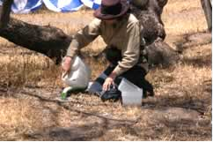Specimens were collected using the following sampling techniques.

1. Pitfall traps: Ten, 2 litre containers were placed into the ground at each site at 10 metre intervals, with their tops level with the ground. Antifreeze is placed into the container and arthropods drop into the container and remain there. The traps were collected after a 10-day period. A 10cm x 2cm hole was cut into the lid of the containers to prevent reptiles, frogs and small mammals from falling into the traps.

2. Sweeping: A 42cm x 42 cm net was swept back and forth to sample grasses. Within each site, two sweep transects of 50m x 5m were marked out and swept with the net. Samples were then collected into labelled bags containing 75% Ethanol to preserve the specimens. Samples were collected on three occasions approximately 10 days apart.

3. Beating: this was conducted at each site for 10 minutes. This technique is used to sample shrubs that can't be swept. A sheet is placed under the shrub and the shrub is then beaten with a stick and the Arthropods are collected on the sheet and then placed in 70% Ethanol for preservation. Individual shrubs within the sample site were selected at random and sampled for between 30 and 60 seconds.

Once returning to the lab, the arthropods were classified into Orders and then morphospecies, which are recognisable taxonomic units.

**Results**

* Overall species diversity was relatively high with 594 morphospecies being identified. Ants, bees and wasps were the most diverse groups found.
* The species diversity was influenced by habitat characteristics at each site. Species diversity increased with increasing percent cover of grasses, the amount of fallen timber and the amount of loose bark present on the ground.
* Skye's research resulted in an increase in the number of arthropods known in the MIA from 65 to over 600 species and added an additional 15 Orders.

## 4. Student investigation: evaluation of sampling techniques

When scientists are working in the field trying to determine the kinds of arthropods are present, they utilise a number of different catching techniques. There are three main ones you will be investigating.

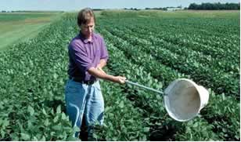**Sweeping:** This technique is used to sample grass and understorey. A sweep net is swept back and forth across the top of the understorey to collect arthropods in the foliage.

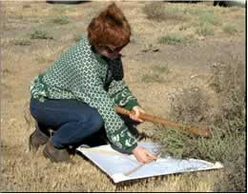

**Beating:** Beating is used to sample shrubs and other bushy understorey species that cannot be sampled using sweeping. A nylon fabric “kite” is held under the shrub that is beaten vigorously with a large stick.

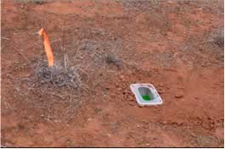

**Pitfall Traps:** A wet pitfall trap is a small plastic container partially filled with 500ml of killing and preserving solution (Ethylene Glycol). The traps are set into the ground with the tops at ground level. Ground dwelling arthropods fall into the traps, which are then collected. The container has a lid with a small hole to let arthropods fall in but not larger animals such as lizards and frogs.

**Student Investigation**

Your job is to write an investigation which assesses all three of these techniques, and decide if one is better over the others. A study was conducted using all three of these techniques. The results of this study are given below. Use the following questions to write your investigation report.

1. What do we want to investigate?

2. What do we already know?

3. What do we think will happen?

4. Why do we think this will happen?

5. What are we going to do to find out more?

6. How will we make this a fair (controlled experiment) and reliable test?

7. What do we need?

8. What data did we collect from our observations?

These are the following results from the study carried out to survey arthropods in your local area.

|  |  |  |
| --- | --- | --- |
| **Sweeping** | **Beating** | **Pitfall Traps** |
| Flies Parasitic wasps  Bugs  Weevils Leaf beetles  Crab spiders  Jumping spiders  Hunting wasps  Crickets | Tree crickets  Thorn bugs Leaf beetles  Orb spiders  Aphids Ants | Ground beetles Ants Hunting wasps  Wolf spiders Stealthy spiders Cockroaches Flies |

9. What does our data tell us? Can we analyse our data to find any relationships, patterns or trends?

10. What did we conclude?

11. Is this what we expected?

12. Can you recommend one technique over the other? Why or why not?

13. How are we going to report?

## 5. Student investigation: arthropod food webs

Not all organisms produce their own food. Plants produce their own food and are autotrophs. Animals are consumers (heterotrophs), they eat food produced by other organisms. Animals that eat plants are referred to as primary consumers or herbivores. The animals that eat herbivores are called secondary consumers or carnivores. Those consumers that are able to eat both plants and animals are referred to as omnivores.

The nutritional sequence between these organisms is referred to as a food chain. It is called a chain because each living organisms in the chain is like a link, and each one depends on the organism that comes before it. In every ecological community, several food chains are interrelated because the organisms that make up those food chains have various food sources. This interaction of food chains is known as a food web. Arthropods play an important role in ecological food webs. Your job is to write an investigation which analyses what would happen if grasshoppers were to be eliminated from the following food web.

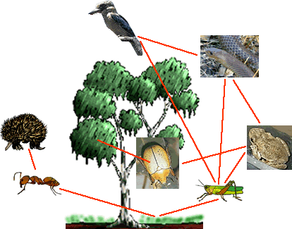

Use the following questions to write your investigation report.

1. What do we want to investigate?

2. What do we already know?

3. What do we think will happen?

4. Why do we think this will happen?

5. What are we going to do to find out more?

* Survey an area of bushland and record the number of each animal present.
* Spray the area with a grasshopper specific herbicide.
* Resurvey the area at 3 monthly intervals.

6. How will we make this a fair (controlled experiment) and reliable test?

7. What do we need?

8. What data did we collect from our observations?

Data was collected over a 9 month period after the grasshoppers were eliminated.

|  |  |  |  |  |
| --- | --- | --- | --- | --- |
| **Organism** | **0 months** | **3 months** | **6 months** | **9 months** |
| **Beetle** | 100 | 120 | 150 | 160 |
| **Ant** | 100 | 120 | 150 | 160 |
| **Grasshopper** | 100 | 0 | 0 | 0 |
| **Frog** | 10 | 7 | 5 | 3 |
| **Echidna** | 2 | 2 | 1 | 2 |
| **Snake** | 7 | 5 | 4 | 3 |
| **Kookaburra** | 5 | 6 | 8 | 8 |
| **Magpie** | 5 | 5 | 3 | 3 |

9. What does our data tell us? Can we analyse our data to find any relationships, patterns or trends?

10. What did we conclude?

11. Is this what we expected?

12. How are we going to report?

http://www.reec.nsw.edu.au/geo/scient/image/rsae1b.gifAquatic ecologist: Lorraine Hardwick

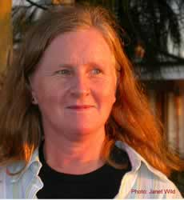Background information

Billabongs and environmental flows

Student investigation: billabongs

Student investigation: billabongs and invertebrates

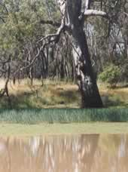

## 1. Aquatic ecologist

Lorraine Hardwick is an Aquatic Ecologist working with the New South Wales Department of Natural Resources at Wagga Wagga.

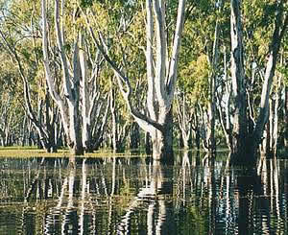  
Lorraine's qualifications:

* Bachelor of Science (Biology), Latrobe University;
* Graduate Diploma of Environmental Studies, Macquarie University; and
* Masters of Applied Science, Charles Sturt University

Note: special thanks to Lorraine for her assistance, research and photos.

There is not enough water in the Murray-Darling Basin to supply everyone's needs. Years ago we were mainly concerned about storing river water in dams and releasing it when people needed it. This had a negative impact on the health of the rivers and their floodplain ecosystems.

With the decision to allocate some of this scarce water resource to environmental flows, it has become very important we understand the impact these flows are having - are they doing any good? Are we using this water wisely e.g. have environmental flows resulted in greater numbers of swans nesting and cynets being recruited into the adult population, do we have more native fish, are river red gum forests healthier?

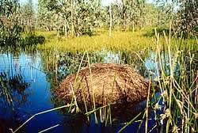Scientists are playing an important role in investigating the impact of environmental flows and whether they are actually doing what we hope they are. Their investigations will help the community use water more wisely.

* Do environmental flows have the intended outcomes?
* Do we need to change the seasonal release of environmental flows to achieve these outcomes?
* Do we need to have lower volume but more frequent flows or the reverse?
* Do we need environmental flows or are they a waste of water, better used for other purposes?

Water released from a large dam for environmental maintenance?

## 2. Background information

The following will help you understand the research outlined in the following wetlands 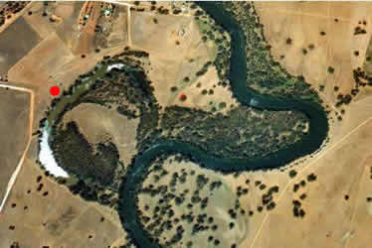pages.

**Billabongs** are lagoons usually located on floodplains near rivers. They form when meanders (bends) are cut off from the river. The red dot is beside Berry Jerry Lagoon on the Murrumbidgee River near Wagga Wagga.

**Regulated rivers** have large dams in their upper reaches to store water which is released for downstream users when required. Irrigation farmers require water for growing crops in spring and summer so water is released in those seasons.

Photo:Hume Weir on the Murray River near Albury.

**Environmental flows** are releases of water from storage dams for the benefit of floodplain 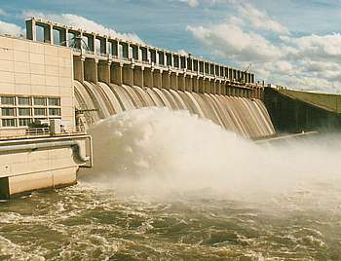and river ecosystems. The provision of environmental flows appears to be a simple answer to some of the problems caused by river regulation to the floodplain ecosystem, however, the functioning of ecosystems is not that simple.

One scientist at the Inland Fisheries Research Station at Narrandera placed a cage of young silver perch in an area of red gum forest flooded by an environmental flow. All fish were dead within an hour. It appears chemicals from the bark of red gum trees caused the gill filaments to stick together so the fish could not breathe.

Locals at Barmah recall how the yabbies and Murray Crays tried to leave the water during an environmental flow by climbing the trees. Yabbies and crays are very sensitive to pollution which quickly kills them.

**Invertebrates** are animals without backbones such as the dragonfly nymph shown at right or the Murray Cray on the left.

Images courtesy MDBC.

**Turbidity**  
Turbidity is a measure of how muddy water is. Plants need sunlight energy for photosynthesis and turbid water blocks light reaching underwater plants.

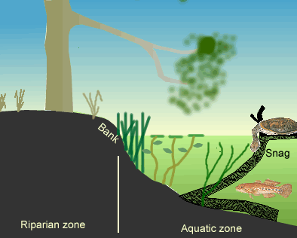**Vegetation Structure**   
The number of height layers of plants, tall, short etc.

In this diagram there are five layers: submerged aquatic, floating aquatic, emergent aquatic, grasses and trees. The more layers the better the habitat for supporting animals.

Top of Form

Bottom of Form

Top of Form

Bottom of Form

## 3. Billabongs and environmental flows

The New South Wales Water Reforms have allocated water for environmental flows to assist the maintenance of healthy wetland, river and floodplain ecosystems. The problem is that there is not enough water in the river for everyone. If the environment gets more, the irrigators producing important food crops such as rice, don't get as much and we don't get as much food.

Politicians, irrigation farmers and environmental lobby groups all need some solid evidence based on scientific research which shows if environmental flows are actually helping the environment.

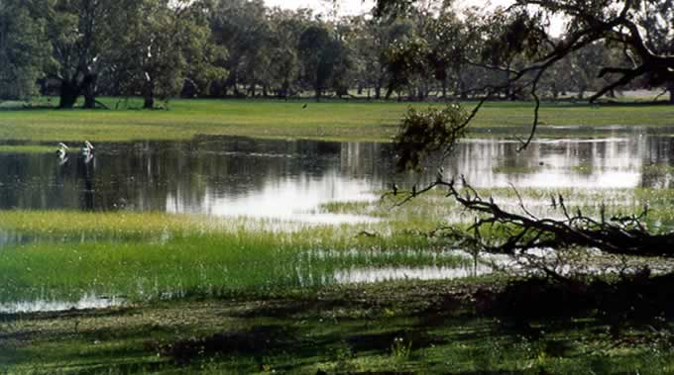

**Student Investigation**

You are a Technical Assistant working with Lorraine to investigate what impact environmental flows have. The main investigation will study different billabongs one month after they were filled by an environmental flow and compare the following indicators: aquatic vegetation, aquatic invertebrates, and birds, grazing pressure, water quality, frogs and fish.

Before you do this major study you need to do a smaller study to see if all billabongs are the same or if they differ. If they are all the same your main investigation will be easier because you will only need to investigate a few billabongs but if they are all different you will have to study many more.

You decide to randomly select three billabongs which were dry until the environmental flow filled them. You compare these to Berry Jerry Lagoon, which had the same environmental flow but has permanent water. Berry Jerry is your reference or control to compare the others to.

## 4. Student investigation: billabongs

Write a report on part of your preliminary investigation on abiotic characteristics using the following headings to assist you. The results given are for four billabongs along a similar reach of the Murrumbidgee River near Wagga Wagga. Berry Jerry is a permanent billabong so use this as a reference (control) to compare the other three to which you are measuring one month after they filled (from dry) by an environmental flow.

**Location**

Three of the billabongs are shown on the satellite image below, the fourth, Molley's, is just off the image to the left. The four billabongs occur over a 15 km length of river, the total length of the Murrumbidgee is approximately 1 600 km. Satellite image: Australian Greenhouse Office.

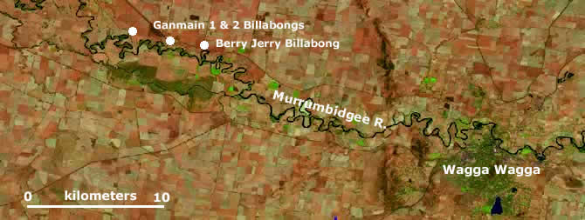

1. What do we want to investigate?  
We will make a Null hypothesis that all billabongs are the same and see if we can prove or disprove this.

|  |  |
| --- | --- |
| http://www.reec.nsw.edu.au/geo/scient/image/gl1a.jpg | http://www.reec.nsw.edu.au/geo/scient/image/g2a.jpg |
| http://www.reec.nsw.edu.au/geo/scient/image/mol.jpg | http://www.reec.nsw.edu.au/geo/scient/image/bjla.jpg |

2. What do we already know?

3. What do we think will happen?

4. Why do we think this will happen?

5. What are we going to do to find out more?

6. How will we make this a fair and reliable investigation? To have confidence in the collected data, you need to be sure the investigation was fair and that sources of error were minimised.

For example, how would you take temperature measurements? At the same or different time of day/night; same or different depths; middle or edge of billabong; just one measurement or average a number? Think of the methods you will use to take your other measurements so they are "fair".

7. What do we need (equipment)?

8. What data did we collect from our observations?

|  |  |  |  |  |
| --- | --- | --- | --- | --- |
| **Bottom profile:** depth and width (metres) | | | | |
| http://www.reec.nsw.edu.au/geo/scient/image/rsae4j.gif | | | | |
|  | Ganmain 1 | Ganmain 2 | Molley's | Berry Jerry |
| Vegetation | | | | |
| Trees on bank (% cover) | 100 | 90 | 95 | 100 |
| Aquatic vegetation (% cover water) | 5 | 70 | 5 | 50 |
| Vegetation structure (height layers) | 2 | 5 | 1 | 4 |
| **Water characteristics** | | | | |
| pH (acidity) | 6.9 | 7.4 | 6.9 | 7 |
| Temperature (0C) | 16 | 23 | 17 | 18 |
| Dissolved Oxygen (mg/L) | 3 | 11 | 3 | 5 |
| Turbidity | 15 | 25 | 40 | 100 |
| Salinity | 218 | 337 | 227 | 189 |

9. What does our data tell us? Can we analyse our data to find any relationships, patterns or trends? Are deeper, narrower billabongs different to wider, shallower ones? If so, why?

Does vegetation have an impact on water characteristics? Are the three which dry out different to the permanent one?

10. What did we conclude?

11. Is this what we expected?

12. How are we going to report?

## 5. Student investigation: billabongs and invertebrates

It is thought that billabongs on floodplains are like a concentrated soup of nutrients and invertebrates. During flood events the contents of billabongs spread across the floodplain and into the Main River and are an important part of the life cycle of native fish and water birds. River regulation has reduced the number of floods and billabongs no longer participate in the floodplain ecosystem the way they used to.

Following on from your previous investigation into abiotic characteristics, you now need to investigate the biotic characteristics. In this part of your investigation you look at invertebrate populations in the four billabongs.

1. What do we want to investigate?  
We will make another Null hypothesis that all billabongs have the same invertebrate populations and see if we can prove or disprove this. Use Berry Jerry, the permanent billabong as your reference (control) to compare the other three which dry out.

2. What do we already know?

3. What do we think will happen?

4. Why do we think this will happen?

5. What are we going to do to find out more?   
Describe methods you will use to do this investigation.

6. How will we make this a fair and reliable investigation?   
You will use a fine meshed net to catch your invertebrates in but what methods will you use to make sure all lagoons are sampled the same. Consider the type of habitat - muddy bottom, aquatic plants, and open water. Will you sample each habitat in each lagoon? How many sweeps of the net? What length of bank? What time of day? Are some invertebrates nocturnal?

7. What do we need (equipment list)?

8. What data did we collect from our observations?   
Below are four catch trays with the invertebrates you caught in each billabong. The first diagram is a guide to species and numbers caught. A picture of a large snail represents 10 snails, a small picture 1 and so on. (These results are very close to the actual numbers captured in the real investigation.)

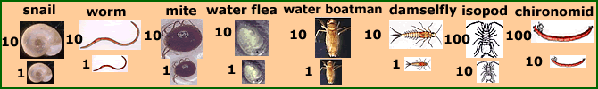

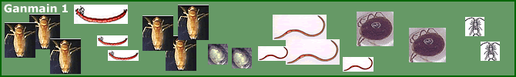

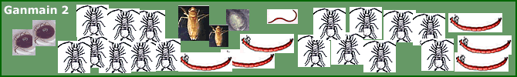

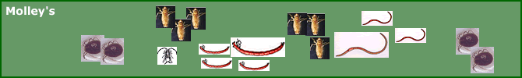

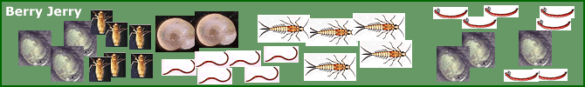

9. What does our data tell us? Can we analyse our data to find any relationships, patterns or trends? You will need to make a table of your results and then graph them.

* Compare your biotic results with the results of your abiotic investigation on the previous page.
* Compare Berry Jerry which has permanent water with the others which dry out. How do the invertebrate types vary?
* Was depth a factor - temperature, amount of sunlight, water plants?
* Was turbidity a factor - clearer water has more sunlight energy for the food chain?
* Look for other possible relationships.

10. What did we conclude?

11. Is this what we expected?

12. How are we going to report?

http://www.reec.nsw.edu.au/geo/scient/image/rsbi1b.gif**1. Aquatic biologist: Andrea Wilson**

**2. Background information**

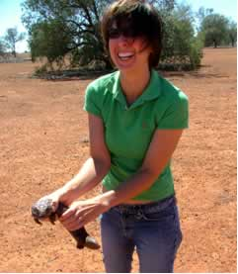**3. Research report: Rapid Appraisal of Riparian Condition**

**4. Student investigation: rapid appraisal simulation**

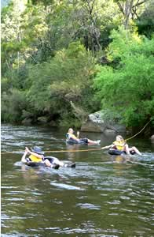

## 1. Aquatic biologist: Andrea Wilson

Land along river banks (riparian) is very important in maintaining water quality, particularly for cities and towns downstream which have to treat the water before it is suitable for drinking. Good riparian zones with good vegetation cover act as a buffer stopping eroded soil and other pollutants reaching the river. Andrea is a senior lecturer with the School of Science and Technology at Charles Sturt University (CSU) based in Wagga Wagga, New south Wales. Many of Andrea's research projects have been on assessing the quality riparian zones and how they can be managed.

Andrea's qualifications include:

* Bachelor of Applied Science (Honours), Charles Sturt University;
* Doctor of Philosophy, Charles Sturt University

I am broadly interested in biodiversity in agricultural landscapes, with a focus on freshwater ecology. I am currently involved in a number of ecological research projects, including an examination of stream rehabilitation in the Tarcutta catchment near Wagga Wagga and an investigation of the effects of fire on reptile populations in the western mallee regions of NSW.

Previous research projects I have undertaken include studies of aquatic biodiversity in Australian rice fields and a project entitled ‘Understanding landholder management of riparian zones in the Goulburn Broken catchment'. Riparian areas are beside rivers and have an important role in maintaining water quality.

Note: special thanks to Andrea for her assistance, research and photos.

## 2. Background information on riparian zones

**Riparian Zones**

Riparian habitats occur where water and land ecosystems meet such as the banks of rivers. Good riparian zones with lots of plants help water quality by trapping eroded soil and pollution before it can reach rivers and lakes.

There is extensive degradation of riparian zones in Australia, mainly caused by livestock. Before we can improve our management of riparian zones we need to develop methods of measuring their condition. Andrea and her colleagues developed the Rapid Appraisal of Riparian Condition Index below. It is used to assess the ecological condition of a riparian habitat. Different features of a riparian area are given a score which is then added up, the higher the score, the better the riparian zone.

**Rapid Appraisal of Riparian Condition Index**

|  |  |  |
| --- | --- | --- |
|  | **Score** |  |
| **Width**  How wide is the riparian zone? | * less than 5 m = 0 * 5 to 9 m = 1 * 10-29 m = 2 * 30-40 m = 3 * more than 40 m = 4 | http://www.reec.nsw.edu.au/geo/scient/image/rsbi2a.gif |
| **Length**  Is there a continuous line of plants along the bank or are there gaps? | * less than 50% with plants= 0 * 50-64% with plants= 1 * 65-79% with plants= 2 * 80-94% with plants=3 * 95% and more = 4 | http://www.reec.nsw.edu.au/geo/scient/image/rsbi2b.gif |
| **Cover**  If we look down from above, how much of the ground is covered by plants?   * Canopy: plants taller than 5 m * Understorey: 1-5 m tall * Ground: plants less than 1 m * Number of height layers | For each of canopy, understorey and ground plants score the following:   * 0= none * 1=1 to 30% * 2= 31 to 60% * 3= over 60%   Layers   * 0 if no layers * 1 if one layer e.g. grass * 2 if 2 layers * 3 if 3 layers | http://www.reec.nsw.edu.au/geo/scient/image/rsbi2c.gif |
| **Debris**  Dead things such as trees, logs and leaf litter | Leaf litter   * 0=none * 1=30% cover * 2=31-60% cover * 3= over 60%   Dead trees: 0=none; 1= some  Logs: 0=none; 1=few; 2=lots but some removed; 3=lots. | http://www.reec.nsw.edu.au/geo/scient/image/rsbi2d.gif |
| **Natives**  What proportion of the plants are native eg. gums, compared to introduced plants such as willows. | For each of canopy, understorey, ground and leaf litter score the following:   * 0=none * 1=1 to 30% * 2=31 to 60% * 3= over 60% | http://www.reec.nsw.edu.au/geo/scient/image/rsbi2e.gif |
| **Regeneration**  Regeneration is important. It means the riparian area is improving.  Reeds are important ground plants | Native canopy regeneration: 0=no seedlings; 1=scattered seedlings; 2= lots seedlings  Damage to regeneration: 0=all seedlings damaged; 1=some damage; 2=no damage  Native understorey regeneration: 0=none; 1=some; 2=lots seedlings  0=none; 1=some |  |

## 3. Rapid Appraisal of Riparian Condition

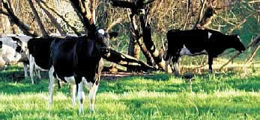This method of assessing how good riparian vegetation is, was developed to determine the impacts of grazing and to identify the best way to manage grazing in these areas. To find whether the Rapid Appraisal Index worked, it was tested in three catchments.

**Methods**

Some pristine sites with minimal damage were selected on purpose to act as 'controls' or 'benchmarks' to compare the others to. The main study sites were chosen randomly. One way is to lay a grid over a map of a catchment, locate and number all squares which have a riparian zone, put these numbers into a hat and pull out as many numbers as you want to 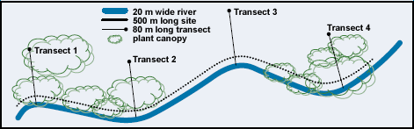study.

A single observer should conduct all assessment to ensure consistency in data collection.

Survey all sites at a similar time of year.

Allow 20-60 minutes per site, depending on size and accessibility.

Vegetation was sampled at each site using four transects which were 10 m wide. The length varied depending on the width of the river e.g. river less than 10 m wide, 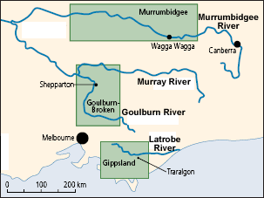the transect was 40 m long.

Murrumbidgee River: 138 sites, each 1 kilometre long, between Gundagai and Hay were sampled.

Gippsland: 108 sites, each 150 metres long, were sampled.

Goulburn-Broken: 46 sites, each 200 metres long, were surveyed in the upper and middle catchment.

**Results**

Murrumbidgee River: the majority of sites on private property were in very poor condition. State Forest sites were in good to excellent condition.

Gippsland: most sites were in very poor condition.

Goulburn-Broken: most sites were in very poor condition.

## 4. Student investigation

Try this investigation using the diagram and two photos given.

Use the following headings to assist you to do your investigation.

1. What do we want to investigate? Assess the condition of the riparian vegetation at a site along the Murrumbidgee River.

2. What do we already know?

3. What do we think will happen? What do we know from previous studies?

4. Why do we think this will happen?

5. What are we going to do to find out more? Use the diagram and photos below.

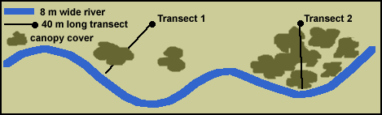

|  |  |
| --- | --- |
| http://www.reec.nsw.edu.au/geo/scient/image/rsbi4b.jpg | http://www.reec.nsw.edu.au/geo/scient/image/rsbi4c.jpg |
| Transect 1  Mainly cleared of trees and understorey, just introduced pasture grasses, no natives. No leaf litter, dead trees or logs. No regeneration due to cattle. | Transect 2  State Forest site, good canopy of native river red gum trees, understorey of regenerating saplings, ground cover of native grasses and reeds along bank. Dead trees still standing with logs on ground. |

6. How will we make this a fair (controlled experiment) and reliable test? Are two transects enough?

7. What do we need?

8. What data did we collect from our observations? You will need to use the assessment sheet given in the Background information page and reprinted at the bottom of this page.

|  |  |  |  |  |  |  |  |  |  |  |  |  |  |  |  |  |  |  |  |  |  |  |  |  |  |  |  |  |  |  |  |  |  |  |  |  |  |  |  |  |  |  |  |  |  |  |  |  |  |  |  |  |  |  |  |  |  |  |  |  |  |  |  |  |  |  |  |  |  |
| --- | --- | --- | --- | --- | --- | --- | --- | --- | --- | --- | --- | --- | --- | --- | --- | --- | --- | --- | --- | --- | --- | --- | --- | --- | --- | --- | --- | --- | --- | --- | --- | --- | --- | --- | --- | --- | --- | --- | --- | --- | --- | --- | --- | --- | --- | --- | --- | --- | --- | --- | --- | --- | --- | --- | --- | --- | --- | --- | --- | --- | --- | --- | --- | --- | --- | --- | --- | --- | --- |
| **Score Sheet**  **Length**: is there a continuous line of plants along the whole river section? Score:  **Width**: how wide is the riparian zone?   |  |  |  | | --- | --- | --- | | Transect | Vegetation Width | Score | | 1 |  |  | | 2 |  |  |   **Vegetation cover**: how much of the ground is covered by each? Just record the score for each.   |  |  |  |  |  | | --- | --- | --- | --- | --- | | Transect | Canopy | Understorey | Ground cover | Number of layers | | 1 |  |  |  |  | | 2 |  |  |  |  |   **Debris**   |  |  |  |  | | --- | --- | --- | --- | | Transect | Leaf litter | Dead trees | Logs | | 1 |  |  |  | | 2 |  |  |  |   **Natives:** What proportion of the plants are native compared to introduced?   |  |  |  |  |  | | --- | --- | --- | --- | --- | | Transect | Canopy | Understorey | Ground cover | Leaf litter | | 1 |  |  |  |  | | 2 |  |  |  |  |   **Regeneration**   |  |  |  |  |  | | --- | --- | --- | --- | --- | | Transect | Native canopy regeneration | Grazing damage to regeneration | Understorey regeneration | Reeds | | 1 |  |  |  |  | | 2 |  |  |  |  |  |  |  |  | | --- | --- | --- | | **Total Score** | **Transect 1:** | **Transect 2:** | |

9. What does our data tell us? Can we analyse our data to find any relationships, patterns or trends?

10. What did we conclude?

11. Is this what we expected?

12. How are we going to report?

|  |  |  |
| --- | --- | --- |
|  | **Score** |  |
| **Width**  How wide is the riparian zone? | * less than 5 m = 0 * 5 to 9 m = 1 * 10-29 m = 2 * 30-40 m = 3 * more than 40 m = 4 | http://www.reec.nsw.edu.au/geo/scient/image/rsbi2a.gif |
| **Length**  Is there a continuous line of plants along the bank or are there gaps? | * less than 50% with plants= 0 * 50-64% with plants= 1 * 65-79% with plants= 2 * 80-94% with plants=3 * 95% and more = 4 | http://www.reec.nsw.edu.au/geo/scient/image/rsbi2b.gif |
| **Cover**  If we look down from above, how much of the ground is covered by plants?   * Canopy: plants taller than 5 m * Understorey: 1-5 m tall * Ground: plants less than 1 m * Number of height layers | For each of canopy, understorey and ground plants score the following:   * 0= none * 1=1 to 30% * 2= 31 to 60% * 3= over 60%   Layers   * 0 if no layers * 1 if one layer e.g. grass * 2 if 2 layers * 3 if 3 layers | http://www.reec.nsw.edu.au/geo/scient/image/rsbi2c.gif |
| **Debris**  Dead things such as trees, logs and leaf litter | Leaf litter   * 0=none * 1=30% cover * 2=31-60% cover * 3= over 60%   Dead trees: 0=none; 1= some  Logs: 0=none; 1=few; 2=lots but some removed; 3=lots. | http://www.reec.nsw.edu.au/geo/scient/image/rsbi2d.gif |
| **Natives**  What proportion of the plants are native eg. gums, compared to introduced plants such as willows. | For each of canopy, understorey, ground and leaf litter score the following:   * 0=none * 1=1 to 30% * 2=31 to 60% * 3= over 60% | http://www.reec.nsw.edu.au/geo/scient/image/rsbi2e.gif |
| **Regeneration**  Regeneration is important. It means the riparian area is improving.  Reeds are important ground plants | Native canopy regeneration: 0=no seedlings; 1=scattered seedlings; 2= lots seedlings  Damage to regeneration: 0=all seedlings damaged; 1=some damage; 2=no damage  Native understorey regeneration: 0=none; 1=some; 2=lots seedlings   0=none; 1=some |  |