Making a Kite

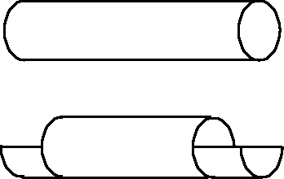
Cut a straw, both ends
1 cm deep as shown

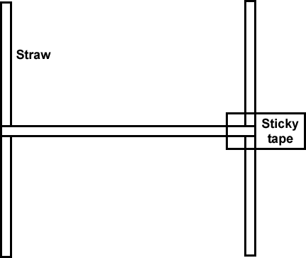
Wrap the cut ends of the straw around the other straws and sticky tape.

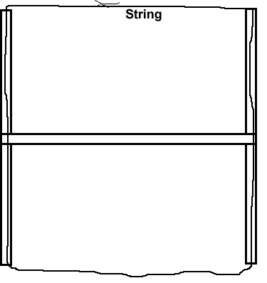
Thread string through the straws and tie.

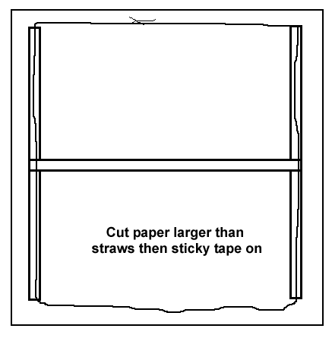

Cut paper larger than kite so it can be turned over and sticky taped down

Tie string onto cross beam on the same side as the paper.

Attach two tails, 1 metre long.

Attach string to hold on to.

