Climate Change Logbook
Teachers can choose to change this logbook to suit their needs.

Question numbers refer to web page numbers.

1. Our planet
Look at the pictures. Choose one to write a simple poem using a noun, an adjective and a verb in each line.
In the middle column rite the names of some of the things you can see in the picture (noun).
Then in the left column write a word (adjective) that describes the thing in the middle column.
Then in the right column write a word (verb) that says what these things are doing.

1a. Complete this poem for the image showing the whole planet

Adjective | Noun | Verb
 | planet
blue | planet
blue | planet | spinning
 | clouds
 | oceans

1b. Write your own poem for one of the other pictures.

2. A bad day
2a. Write your own poem for one of the other pictures.

Adjective | Noun | Verb

3. Weather and climate
Define the term weather.
Name four weather elements.
Explain how weather is different to climate.

4. Australian climates
Draw a map showing the six major Australian climatic zones based on temperature and humidity.

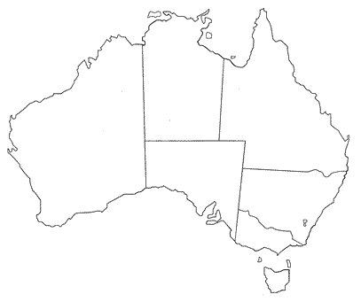

Location | Annual  average temperature | Annual temperature range | Average annual rainfall | Highest rainfall  month and amount | Lowest rainfall  month and amount
Darwin
Tennant Creek
Alice Springs
Brisbane
Sydney
Canberra
Wagga Wagga

5. Temperature
Explain why the poles are cold and the equatorial areas are hot in terms of solar radiation.

EARTH
6. Seasons

Draw the Earth with an axis and lines to
SUN
show the Tropics and Equator for summer in
the southern hemisphere.

Explain why there are seasons.

7. Tree rings
Below is a set of tree rings labelled A to D.
Each ‘ring’, the distance between two lines, is one years growth. The light grey pith (middle of tree) in sample A and bark in sample B do not count as tree rings. Sample B was taken from a tree in the year 2006.

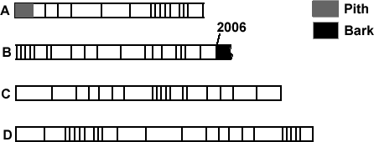
Sample A is from a river red gum log beside the Murray River near Deniliquin.
Sample B was taken from a live river red gum tree near Albury.
Sample C was from a piece of red gum furniture in a house.
Sample D was from a support beam in a bridge.

7a. The age of the samples overlap so determine the age of the oldest tree ring, the one before the pith in sample A.

7b. Determine how many years each sample grew for, the date of it’s youngest ring and that of it’s oldest ring

Sample | Age of Sample | Date of youngest ring | Date of oldest ring
A
B
C
D

7c. Give the date e.g. 1996 of:

- drought year
- wet year

8. Past climate change
8a. Estimate the approximate dates in years before present of the four cold periods over the past 400,000 years.
8b. How much colder than now were the cold periods?
8c. How much warmer than now were the warmest periods of the 'interglacials', the periods between ice ages such as now?
8d. Why do scientists report temperature change as being warmer or cooler than the 1961-1990 average instead of giving the actual temperature?

9. Changing temperature

9a. How much has temperature increased between 1860 and the present?

9b. The graph line has been smoothed to take out the yearly variation shown by the light green and yellow lines. Give 2 reasons why the temperature is variable over the short term and not just a smooth line as indicated by the graph line.

9c. Draw the graph for temperature change since 1860 but extend the line to 2020 to the temperature you think it will be by then. Will it start to decrease?

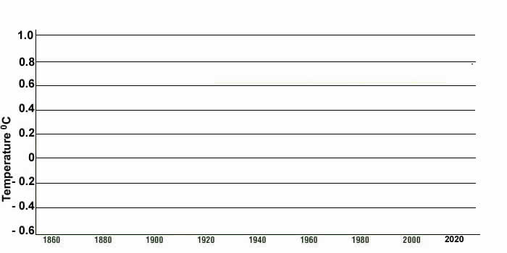
9d. Look at the world temperature maps.
Which hemisphere has warmed more?
What has happened to the area which was cooler than average since 1950?

10. Changing ice: poles

10a. What does the term perennial ice cover mean?

10b. Describe how the area of perennial sea ice has changed in the Arctic.

10c. Explain the term albedo.

10d. Describe the difference in albedo between land and sea.

11. Changing ice: glaciers.

11a. Describe what is happening to the world’s glaciers.

11b. Explain why the melting of glaciers on land will cause sea levels to rise but the melting of sea ice will not.

12. Changing sea level

12a. Describe the difference in the rate of sea level rise between the period 1900 to 1980 and the period 1998 to 2006.

12b. Give two reasons for the rise in sea levels.

12c. Local councils should protect private property from beach erosion caused by storms and sea level rise. Give points for and against this statement.

13. Changing carbon dioxide levels

13a. How did carbon dioxide levels vary between 400,000 and 100,000 years ago?

13b. How have carbon dioxide levels varied between 1950 to 2006?

13c. Give reasons for the Cape Grim carbon dioxide graph line being bumpy and not smooth?

13d. Which countries produce the most carbon dioxide in 2004?

13e. Which countries increased their output and which decreased their output between 1980 and 2004?

14. Changes to animals and plants

Many insects such as mosquitoes live within a particular temperature range. As cool places get warmer, some such as mosquitoes move in. | Mountain  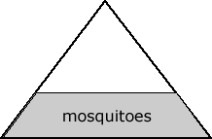 | 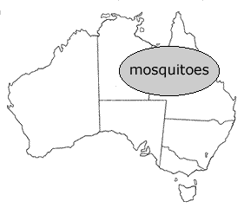
10a. The diagram of a mountain and map above show make believe areas where particular types of mosquito live. Predict and draw where you think they will live if the climate gets warmer.
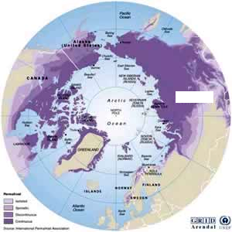

15. Changes on land

15a. Explain what permafrost is.

15b. Show its location on the map and name the countries.

15c. Name the types of things included in severe weather.

15d. Fires: Give reasons why the number of extreme fire days is likely to rise.

15e. Famine: Why can’t poor countries feed their people if the crops fail while rich countries can?

16 Changes in Australia
The maps show temperature and rainfall changes to Australia since 1950.

16a. Minimum temperature: shade the map below in three colours to indicate areas where minimum temperatures have increased, stayed the same or decreased. | 16b. Rainfall: shade the map below in three colours to indicate areas where rainfall has increased, stayed the same or decreased.

16c. Rainfall
Describe the location of areas where rainfall has decreased significantly since 1950.

16d. Predictions for the Riverina
The maps show what has actually happened since 1950. The table showing temperatures for Wagga Wagga, Deniliquin and Wyalong are predictions, what scientists think will happen in the future.

16e. Compare the number of cold (below 0⁰C) and hot (above 35⁰C) days we presently have in Wagga Wagga to what scientists think will happen by the year 2030.

17. Ice core evidence

17a. Give reasons why the Law Dome was chosen for measuring atmospheric carbon dioxide levels.

17b. In what time period did the Law Dome evidence show carbon dioxide levels started to rise? What did this coincide with?

Basic science

18. Sunlight
18a. Name three major types of radiation from the sun and how we detect them.

18b. Explain how long and shortwave radiation differ.

Investigation: colour and temperature
18a. What do we want to investigate?
Does colour affect the temperature of objects left in the sun?
18b. What do we already know?
18c. What do we think will happen?
18d. Why do we think this will happen?
18e. How are we going to find out more?
- Three cans were painted different colours, fitted with thermometers by placing cling wrap over the top and putting the thermometer through it and left in the sun for 40 minutes.
- Repeat the experiment three times and calculate the average temperature changes.
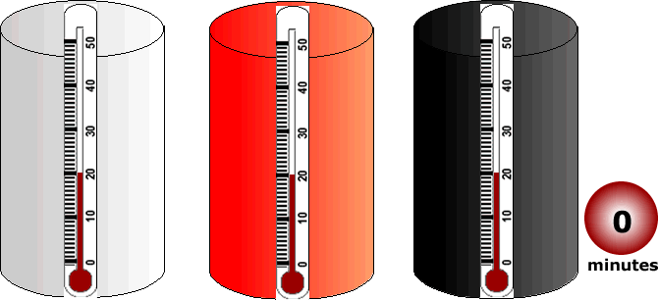
18f. How will we make this a fair and reliable test?
- Is each can the same size?
- List other things to consider.
18g. What do we need?
18h. What data did we collect from our observations?
18i. What does our data tell us? Can we analyse our data to find any relationships, patterns or trends?
18j. What did we conclude?
18k. Is this what we expected?
18l. How are we going to report?
18m. Apply this knowledge. Car air conditioners cause the car engine to use more fuel and so release more greenhouse gases. What would be the best colour car to save greenhouse gas emissions in a hot climate? What would be the best colour for a house roof in a cold climate to save heating costs and greenhouse gas emissions?
18n. How else could you apply your knowledge of colours and temperature?

19. Atmosphere
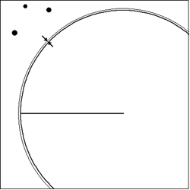
19a. Put labels on the diagram.

19b. Explain why it is difficult to say how thick the atmosphere is.

19c. Is the atmosphere thicker or thinner than you thought?

19d. From the information given, choose your own thickness for the atmosphere and explain your reasons.

19e. Name the two lower layers of the atmosphere and their height.

19f. At what height would 99.9% of the atmosphere be in?

20. Air
20a. Composition of the atmosphere
Gas | Percentage
Nitrogen
Oxygen
Carbon dioxide and others
Each dot in the diagram represents 1% of the atmosphere. Calculate the percentage of the gases in the atmosphere.

20b. Name 4 greenhouse gases which would be included as trace gases. (You may need to look this up.)

21. Carbon Cycle
21a. In the space draw a basic carbon cycle which includes each of the sinks and their amount of carbon in billions of tons.

21b. Add up all the carbon in the sinks to obtain the total amount of carbon.

21c. What percentage of the total carbon in sinks is in vegetation?

21d. What would happen if all the vegetation burnt?

21e. In which sink is most of the carbon stored?

21f. Using the graph, describe how global carbon fossil emissions have changed since 1800.

22. Photosynthesis

22a. Why are plants green?

22b. Where is air exchanged in the leaf?

22c. Write the formula for photosynthesis.

22d. Draw a leaf and label it to explain photosynthesis.

23. Renewable & non-renewable
23a. Complete the table below. We can’t make or destroy energy but we can change it from one form to another e.g. solar to electrical energy with photovoltaic cells or wind to mechanical energy in a windmill. Indicate two uses of each source of energy and indicate how the energy has changed.

Energy Sources | Two Uses | Renewable or non-renewable?
Solar radiation

Wind

Moving water

Fossil fuel: oil

Fossil fuel: coal

Fossil fuel: gas

24. Fossil fuels

24a. What did oil and gas form from and about how long ago?

24b. What are hydrocarbons?

24c. Name 4 things petroleum is used for.

24d. How much carbon is in coal and when did it form?

24e. Name the major gas released when fossil fuels are burnt.

25. Greenhouse effect

25a. Use the diagram to explain how the greenhouse effect causes global warming.

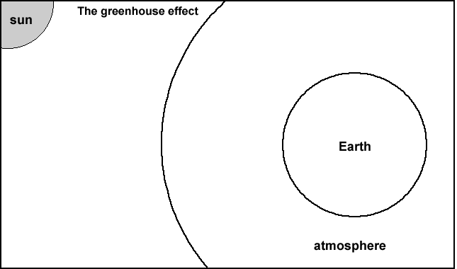
25b. Explain how the greenhouse effect works in your own words.

25c. Name two main human activities which put greenhouse gasses into the atmosphere.

25d. Name 3 major greenhouse gases.

26. Water cycle

26a. How much heat energy does it take to evaporate one millilitre of water?

26b. What happens to this heat energy when water condenses to form clouds?

26c. Explain why you feel cooler when water evaporates from your body.

26d. Explain why some cumulus clouds ‘bubble’ up.

26e. Explain why the water cycle is very important in transporting energy and climate change.

27. Ocean currents

27a. Explain what the thermohaline circulation is.

27b. Explain why the Gulf Stream is important.

27c. What might happen to world climates if the thermohaline circulation stopped or slowed?

28. East Australian current

28a. Describe the East Australia current.

28b. Nemo the clown fish and some of his tropical friends are now being found off Sydney and further south. What does this mean?

28c. Describe how the climate of the east coast would change if the East Coast Current became stronger and went further south.

Geography behind climate change

29. Cartoons

29a. Choose one of the cartoons and do the following.
- Draw it in the space opposite.  - Describe what you see.  - Explain the cartoonist’s message.  - Give your opinion of the message? | - Cartoon drawing

29 b. Draw your own cartoon in the space and explain your message.
Your message | Your cartoon

29c. Discuss or think about responsibility for climate change. Is climate change damaging the planet?
- What evidence is there of climate change?
- Who is responsible for climate change?
- What impact is climate change having on the planet?
- How might you, your school, businesses and governments act responsibly towards climate change?

30. Population
30a. Do you think all of the people in the photo are equally responsible for climate change? Give your reasons.
30a. What was the world’s population in 2008?
30b. Earth's atmosphere, water, soils and other resources now support twice as many people as they did forty years ago. What are the consequences if world population continues to grow at the current rate?
30c. Population is not the only factor influencing how many resources we use. Discuss this statement.
30d. Draw a graph below to show world population growth but continue it through to 2025 and estimate the population for then.

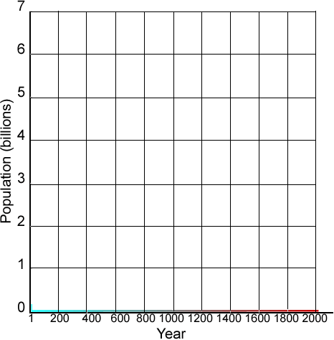

31. Footprints
31a. Define the term ecological footprint.
31b. Do some research on the internet to find more information on how it is calculated.
31c. What can the footprint be used to indicate?
31d. Explain the term ‘sustainable development’.
32. Country footprints
32a. Look at the list of countries in rank order. Label the map below with the names of 3 countries in each of Africa, Asia, and Europe and give the size of their footprint.

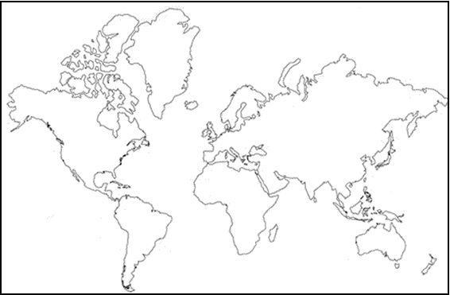

33. Who left the lights on?
33a. Name the countries numbered on the two maps below. The maps show population density. Indicate on the maps which areas had more lights on.

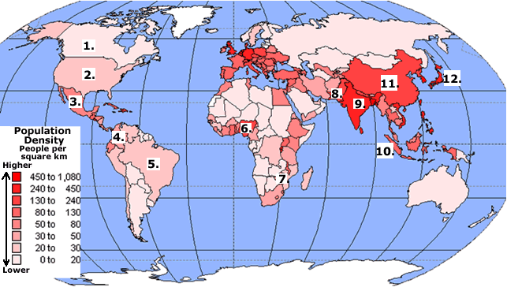

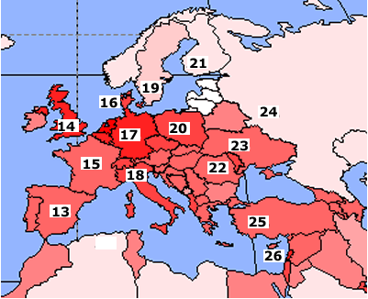
33b. Do the areas with the most lights on in the satellite image match the areas with the most people? Give reasons for your answer.

33c. The satellite image may be used to indicate which countries are rich and which are poor. Give reasons for and against this statement.

34. Planes
34a. Explain ‘global dimming’.

34b. Explain how jet contrails form.

34c. Indicate the areas on the map below with the highest jet traffic. Why could the number of plane flights be used to indicate ecological footprint size and level of economic development.

34d. What happens to the amount of jet traffic in Australia it night. Give reasons for this.

35. Electricity consumption
35a. Compare the electricity consumption of the top five consumers.

35b. A country’s total electricity consumption does not give the whole story but consumption per capita allows us to compare individual impact/usage.
Divide the total electricity consumption by the population to get per capita consumption for USA, Australia, China, Kuwait and Fiji. Make a bar graph of your results.
36. Coal consumption

36a. Coal consumption is a bigger concern for climate change than electricity consumption. Explain this statement.

36b. Which two countries use far more coal than the others.

36c. Which countries decreased their coal consumption between 1980 and 2004?
36d. Give reasons why coal consumption could decrease in a country apart from them becoming very environmentally conscious and turning the lights off.

37. Gross Domestic Product
37a. Define what gross domestic product is.
37b. Use the cartoon to explain GDP and the environmental impact of countries with high GDP.
37c. Use the graph of GDP from 1500 to 2003 to explain how our impact on the planet has changed.
37d. Discuss this statement. “We should use the total GDP of a country rather than per capita when comparing and blaming countries for climate change.”
37e. Mark on the footprint world map, in question 32, the GDP per capita of 3 rich and 3 poor countries.

38. GDP rank order
No questions

39. Global fairness
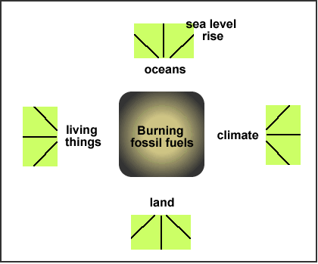
39a. The Kyoto Protocol attempts global fairness by requiring developed countries with large footprints to reduce greenhouse gas emissions while exempting poorer countries. List 3 points for and 3 points against this attempt of global fairness.

39b. Explain the term environmental cost.

39c. Write on the diagram some of the environmental costs from using fossil fuels.

Management

40. Kyoto
40a. Explain what the Kyoto Protocol is.
40b. Explain why only the developed countries must reduce their greenhouse gas emissions.
40c. Give one criticism of the protocol.

41. Carbon trading
41a. Who is the government blaming for high levels of carbon pollution?

41b. Explain the mechanics of the cap and trade Carbon Pollution Reduction Scheme.

41c. How is the price of carbon pollution permits set?

41d. Which sector contributes most to carbon pollution in Australia? Which sectors are second and third in carbon pollution?

41e. Describe how a Carbon Pollution Reduction Scheme will impact on you in the short term and the long term?

42. Power generation
42a. What percentage of electricity in Australia is obtained from non-renewable resources?

42b. What percentage comes from renewable resources?

42c. Explain why coal burning power stations are inefficient.

43d. Try to name the parts of the power station in the photo using the diagram below it.

43. Calculations

43a. To make one kWh of electricity in a coal power station produces ……………of CO₂

43b. One kilogram of CO₂ has a volume of ……………litres.

43c. To heat 15 litres of water for a shower produces………………..of CO₂

43d. Do the calculations on the web page.

44. Vehicles

44a. How much greenhouse gas is produced by using one litre of petrol?

44b. How much CO₂ is released each year in Australia for transport?

44c. If a car uses 10 litres of petrol, how many kilograms of CO₂ is produced and what volume is this?

4dc. According to the Australian Government Green Vehicle Guide, how much petrol will you use if you drive 200 km in the following vehicles?

Vehicle | Commodore | Falcon | Corolla | Prius
Litres of petrol

44d. Investigation: car occupancy survey
a. What do we want to investigate?
Do we use cars efficiently? How many people are in cars that drop students off at school in the morning?
b. What do we already know?
c. What do we think will happen?
d. Why do we think this will happen?
e. How are we going to find out more?
Do a car occupancy survey of vehicles dropping students off at school.
f. How will we make this a fair and reliable test?
- How many days should we do the survey for?
- Which day or days of the week should we do it on?
- Other things to consider?
g. What do we need?
h. What data did we collect from our observations?
i. What does our data tell us? Can we analyse our data to find any relationships, patterns or trends?
j. What did we conclude?
k. Is this what we expected?
l. How are we going to report?
m. Apply this knowledge. If there are many cars with just two occupants, the driver and one student, perhaps we can develop a program to encourage people to share vehicles or have car pools.

Some alternatives:

45. Wind
45a. A government receives a development application for a rural area on the outskirts of a large, growing city. What factors would you need to consider? Give advantages and disadvantages for the wind farm.


46. Water
46a. Use the model of the marble on a slope to explain why the water supply pipes for a hydro-electric power station need to be on a long, steep slope.
Do an investigation. Roll a marble from the top of a slope and part way up it and measure the distance the marble travels.
46b. List the advantages and disadvantages of hydro-electricity.
47. Bioufuels
47a. Draw a carbon cycle diagram for a car using fossil fuel and another for a car using biofuel.
47b. Some biofuels are made from crops such as corn.
List all the good and bad points about this from the point of view of farmers, car owners and people who need food.
47c. Some biofuels are made from palm oil, a crop which grows in rainforest areas. List the good and bad points about biofuel made from palm oil.
47d. When a car burns fuel, it produces carbon dioxide gas that goes into the atmosphere. Explain why biofuels are thought to be more environmentally friendly than fossil fuels?
47e. What are the advantages and disadvantages in using biofuels instead of fossil fuels?
48. Photovoltaic panels

48a. How many things can you think of which are powered by solar cells (PV panels)?

48b. Give advantages and disadvantages of small items such as watches being powered by sunlight.

48c. In the future, say 20 years, can you envisage every house having PV panels to provide some of the energy needs.

What can I do: school light audit?

a. What do we want to investigate?
Is my school environmentally friendly? Are classroom lights turned off at lunch time in unused rooms?

b. What do we already know?

c. What do we think will happen?

d. Why do we think this will happen?

e. What are we going to do to find out more?
Go to every classroom in the school at lunch time and count:

- The total number of fluorescent light tubes;
- The number of fluorescent light tubes left on in unused rooms; and
- Calculate the weight of greenhouse gas produced to make the electricity for the lights.
- Each light may have two or three fluorescent tubes so you will need to turn a couple of lights on and check on this because we need to count the number of tubes, not lights.

f. How will we make this a fair and reliable test?

g. What do we need?

h. What data did we collect from our observations?
Total fluorescent tubes in classrooms | Total fluorescent tubes in classrooms left on at lunch. | Weight of greenhouse gas if all classroom lights are left on for one hour. | Weight of greenhouse gas from lights actually left on at lunch for one hour.

Calculations
We will assume the fluorescent tubes use 40 watts of electricity each and they are left on for one hour. Number of lights X 40 watts X 1 hour = total watts used in an hour e.g. if ten lights are left on then 10 X 40 X 1 = 400 watts per hour. Divide by 1000 to convert to kilowatt hours e.g. 400 watts divided by 1000 = 0.4 kilowatt hours or kWh. To make one kWh of electricity in a coal burning power station produces 1 kilogram (kg) of greenhouse gas.

i. What does our data tell us? Can we analyse our data to find any relationships, patterns or trends?

j. What did we conclude?

k. Is this what we expected?

l. How are we going to report?

m. What can we do to make the school more environmentally friendly?

School energy campaign
After investigating if lights are left on at lunch time at school and surveying vehicles to see how many occupants they have it is time to do something as a class. Consider the following:

- Class light monitors who make sure the lights are turned off when the class leaves a room.

- A poster competition to make students and teachers aware of global warming.

- Present your finding from this topic to the school on World Environment Day, 5 June.

Properties of energy: conduction of heat

Building codes require all new houses to have insulation in the ceiling and walls. Some materials are poor conductors of heat, it passes through it slowly. They may also block heat radiated by objects.

a. What do we want to investigate?
What difference does insulating a tin can make to the internal temperature?

b. What do we already know?

c. What do we think will happen?

d. Why do we think this will happen?

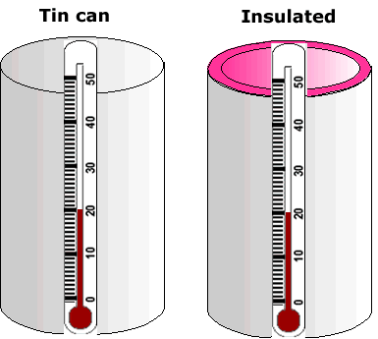
e. What are we going to do to find out more?
Place two tin cans in the sun. One will have cardboard or another insulation material lining the inside of the can, the other will have none. Place a thermometer in the lid of each can. Record the temperature of each can every minute for 10 minutes.

f. How I will make it a fair and reliable test?
- Should each of the cans be the same size and shape?
- Should they be placed in the sun at the same time?
- Should they be the same colour?
- What else should we do?

g. What will we need?

h. What data did we collect from our observations?

i. What does our data tell us? Can we analyse our data to find any relationships, patterns or trends?

j. What did we conclude?

k. Is this what we expected?

l. How are we going to report?

m. How will we use this knowledge?
Materials which are poor conductors of heat make good insulators. Woollen jumpers make good insulators to keep us warm. Can you think of some other users of poor conductors?

