|  |
| --- |
|  |
| Climate Change |
|  |
|  |

March 2014

Riverina Environmental Education Centre



**Table of Contents**

Workbook (21 pages, Word 570kb)

20. Air

21. Carbon cycle

22. Photosynthesis

23. Renewable & non renewable

24. Fossil fuels

25. Greenhouse effect

26. Water cycle

27. Ocean currents

28. East Australian current

**Geography behind climate change**

29. Cartoons

30. Population

31. Footprints

32. Country footprints

33. Who left the lights on?

34. Planes

35. Electricity consumption

36. Coal consumption

37. Gross Domestic Product

38. GDP rank order

39. Global fairness

**Management**

40. Kyoto

41. Carbon tax 2011

**Revision**

Quick quiz

1. Our planet

2. Nature is powerful

3. Weather and climate

4. Australian climates

5. Temperature

6. Seasons

**Evidence and impacts**

7. Tree rings

8. Past climate change

9. Changing temperature

10. Changing ice: poles

11. Changing ice: glaciers.

12. Changing sea level

13. Changing carbon dioxide levels

14. Changes to animals and plants

15. Changes on land

16 Changes in Australia

17. Ice core evidence

**Basic science**

18. Sunlight

19. Atmosphere

**Table of Contents- continued**

**Management- continued**

42. Power generation

43. Calculations

44. Vehicles

**Some alternatives:**

45. Wind

46. Water

47. Biofuels

48. Photovoltaic panels

## 1. Our planet

Earth is the only planet with an atmosphere which supports life. It has been described as a 'pretty blue planet'. Images courtesy NASA

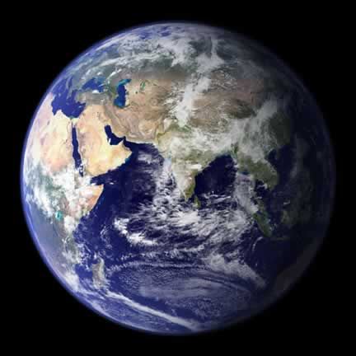

## 2. ****Nature can be very powerful.****

## A definition of energy is the ability to do work and power is the rate of doing work.

An object has kinetic energy if it has mass and is moving.

Strong winds have a lot of energy and can do a lot of work such as make big waves which have a lot of energy to do more work.

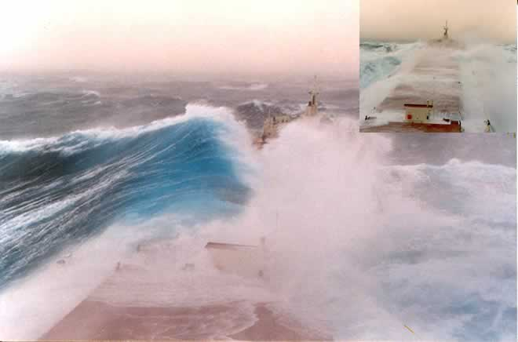

Image:ship Selkirk Settler, North Atlantic 1987 photo by Captain George Ianiev. Ship and crew survived.

## 3. Weather and climate

Go outside and see what the weather is like. Weather is the current condition of the atmosphere and varies from day-to-day.

* Is the temperature hot, warm, cool or cold?

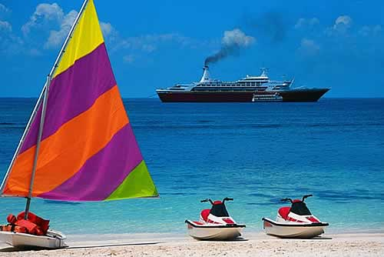

* Is it sunny or cloudy?
* Is it dry or raining?
* Is it windy or still?

Describe the weather if you were sitting on the beach in the photo above. Use the four weather elements (temperature, cloud, rain and wind) in the four dot points above.

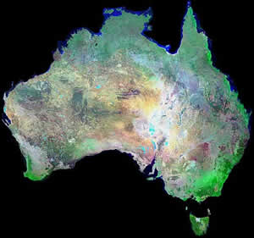Climate is the general weather condition for a place. It is what you expect it to be like over a long period of time. Technically it is the average weather condition for a place.

If you visited central Australia would you expect it to be?

* hot or cold
* wet or dry

If you visited a rainforest in northern Queensland would you expect it to be?

* hot or cold
* wet or dry

**QUIZ**

Word for the current condition of the atmosphere is?

## 4. Australian climates

There are different ways of classifying climate. One way is to divide Australia into six main climatic regions on the basis of air temperature and humidity.

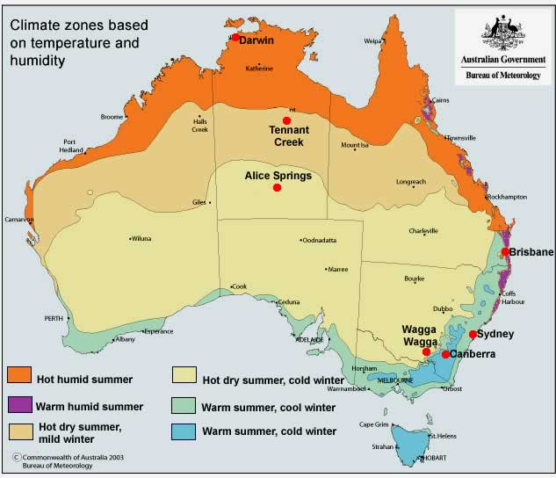

* How does temperature vary from north to south?
* What would you expect the weather to be like if you were in Darwin in summer?
* Name a city you would live in if you wanted warm summers and cold winters?

**Average 9.00am temperature 0C (close to the average daily temperature).**

|  |  |  |  |  |  |  |  |  |  |  |  |  |  |
| --- | --- | --- | --- | --- | --- | --- | --- | --- | --- | --- | --- | --- | --- |
| **Location** | **Jan** | **Feb** | **Mar** | **Apr** | **May** | **June** | **July** | **Aug** | **Sep** | **Oct** | **Nov** | **Dec** | **Annual** |
| **Darwin** | **27.9** | **27.6** | **27.4** | **27.0** | **25.2** | **22.9** | **22.4** | **24.0** | **26.6** | **28.5** | **29.0** | **28.7** | **26.4** |
| **Tennant Creek** | **29.2** | **28.2** | **27.0** | **24.1** | **19.9** | **16.3** | **15.7** | **18.6** | **23.1** | **26.8** | **28.9** | **29.8** | **24.0** |
| **Alice Springs** | **28.3** | **26.8** | **23.9** | **19.1** | **13.8** | **10.1** | **9.4** | **12.6** | **18.1** | **22.7** | **25.9** | **27.8** | **20.0** |
| **Brisbane** | **25.7** | **25.3** | **24.1** | **21.3** | **17.8** | **14.7** | **13.8** | **15.5** | **18.8** | **21.8** | **23.9** | **25.4** | **20.8** |
| **Sydney** | **22.3** | **22.3** | **21.1** | **18.2** | **14.5** | **11.8** | **10.6** | **12.4** | **15.5** | **18.3** | **19.8** | **21.6** | **17.4** |
| **Canberra** | **19.1** | **18.3** | **16.3** | **12.3** | **7.9** | **4.9** | **3.8** | **5.8** | **9.4** | **13.2** | **15.5** | **18.1** | **12.1** |
| **Wagga Wagga** | **22.5** | **21.8** | **19.1** | **14.5** | **10.0** | **6.9** | **5.8** | **7.7** | **10.8** | **14.7** | **17.8** | **21.0** | **14.4** |

* Where would you go if you preferred little variation in seasonal temperature?

**Average monthly rainfall (mm)**

|  |  |  |  |  |  |  |  |  |  |  |  |  |  |
| --- | --- | --- | --- | --- | --- | --- | --- | --- | --- | --- | --- | --- | --- |
| **Location** | **Jan** | **Feb** | **Mar** | **Apr** | **May** | **June** | **July** | **Aug** | **Sep** | **Oct** | **Nov** | **Dec** | **Annual** |
| **Darwin** | **422.6** | **360.6** | **318.8** | **98.9** | **21.3** | **2.0** | **1.4** | **5.7** | **15.4** | **70.7** | **141.8** | **247.9** | **1707.1** |
| **Tennant Creek** | **100.5** | **129.9** | **58.2** | **15.7** | **8.0** | **4.5** | **5.0** | **1.9** | **7.9** | **19.5** | **36.8** | **72.1** | **460.0** |
| **Alice Springs** | **38.0** | **44.1** | **32.3** | **17.3** | **18.9** | **14.5** | **14.0** | **9.8** | **8.6** | **21.6** | **27.5** | **38.1** | **284.7** |
| **Brisbane** | **159.6** | **158.3** | **140.7** | **92.5** | **73.7** | **67.8** | **56.5** | **45.9** | **45.7** | **75.4** | **97.0** | **133.3** | **1146.4** |
| **Sydney** | **98.2** | **112.8** | **119.5** | **106.4** | **103.6** | **118.5** | **68.8** | **79.1** | **60.5** | **71.3** | **81.2** | **74.1** | **1094.0** |
| **Canberra** | **60.0** | **55.6** | **51.8** | **47.8** | **46.4** | **39.3** | **41.5** | **47.3** | **52.7** | **64.4** | **63.5** | **52.5** | **622.8** |
| **Wagga Wagga** | **40.2** | **39.4** | **42.3** | **42.5** | **53.6** | **50.2** | **55.7** | **52.7** | **50.7** | **60.6** | **42.8** | **44.4** | **575.1** |

* Would you go to inland or coastal locations if you preferred wetter climates?
* You like to grow plants which require an even monthly rainfall. Where would you live?

**QUIZ**

A capital city with warm, humid summers is?

## 5. Global temperature

Most solar radiation goes through the atmosphere to the Earth's surface. It is changed to heat energy and warms the surface. This warms the air next to the surface. The average temperature for the world is about 15 degrees Celsius.

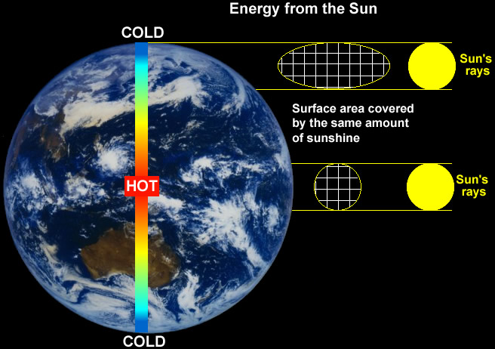

* Count the number of squares in the surface area diagrams. Explain why the polar regions are colder than the Equatorial region.
* What would happen to global temperatures if the Earth's orbit took it closer or further from the sun?
* What would happen to global temperatures if the sun gave off less or more radiation?
* Why does the air get colder the higher you go even though this is closer to the sun?

**QUIZ**

Imaginary line around the middle of the Earth is called?

## 6. Why do we have seasons?

* The Earth orbits the sun.
* It takes one year or 365 1/4 days to orbit the sun.
* During this orbit, our seasons change. In much of Australia we have four seasons: summer, autumn, winter and spring.
* The seasons are caused by the tilt of the Earth.
* The Earth's axis has a tilt of 23 1/2 degrees and as it orbits the sun, the tilt always faces the same direction.

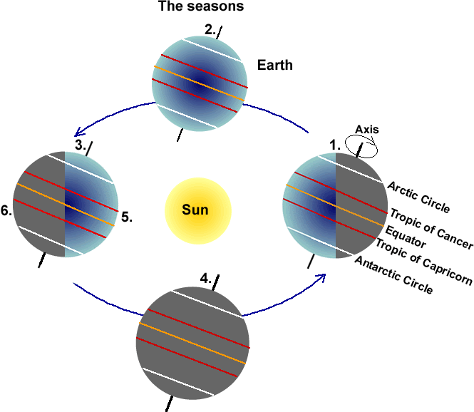

Look at the diagram above.

* At position 1, is the South Pole having summer or winter?
* At position 3, would Australia be having summer or winter?
* At position 3, would the South Pole be having a season of permanent light or permanent dark?
* What would happen to the seasons if the Earth had no tilt?

**QUIZ**

Imaginary circles around the Earth at latitude 231/2 degrees?

## 7. Evidence: tree rings

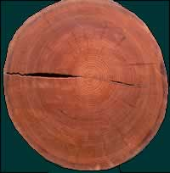The Earth's temperature change is not just measured with thermometers. There are natural indicators including tree rings. They show how much a tree has grown in width each year. In wetter years, trees grow more so the growth ring will be wider than for drier years.

This field of scientific study is called dendrochronology. Scientists can use tree ring patterns to reconstruct patterns of drought and climate change. Scientists have used Siberian pines from Mongolia which indicate yearly temperatures dating back to the year 262, over 1,700 years ago.

Each yearly tree ring has two layers, a light coloured layer which grows in good seasons such as spring and a dark coloured layer which grows in difficult seasons such as late summer or during droughts. Tree rings of a similar width each year indicate the climate did not vary.

The tree at right and below is a mountain ash from Batlow.

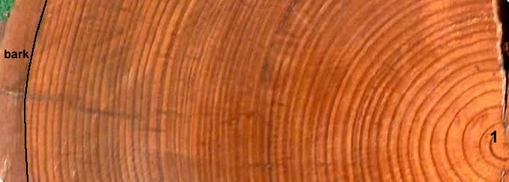

* Count just the dark rings to find how old the tree was when it was cut down. The first ring has been numbered 1. The last ring is next to the bark.
* The tree was logged in 1992. In which year did it start growing?
* In which three years of its life did the tree grow most?
* In which years of its life did it grow least?
* Ignore the first few years of life when the tree was young. When were the most favourable conditions for growth?

## 8. Past climate changes

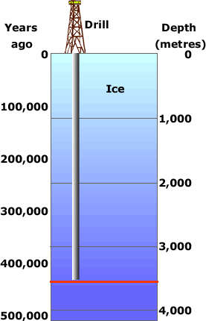Russian scientists drilled 3,623 metres into the Antarctic ice cap at their Vostok base and took cores of ice to study.

By studying the ice and the air bubbles trapped in it they were able to estimate the age of the ice and global temperatures at that time.

The ice at the bottom had been undisturbed for nearly half a million years.

Below is a graph showing how the temperature changed over that time. There were four cold periods when much of the world was covered in thick sheets of ice.

The most recent cold period ended about 12,000 years ago.

When looking at the graph below, scientists compare past temperatures to the average global temperature from 1961 to 1990 which was about 150C. This average temperature is 0 on the graph. So -2 on the graph is really 130C and +2 is 170C.

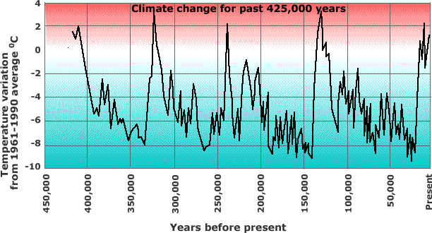

* Estimate the approximate dates in years before present of the four cold periods over the past 400,000 years.
* How much colder than now were the cold periods?
* How much warmer than now were the warmest periods of the 'interglacials', the periods between ice ages such as now?
* Why do scientists report temperature change as being warmer or cooler than the 1961-1990 average instead of giving the actual temperature?

## 9. Changing temperature

**Temperature graph**  
The graph shows the combined global land and marine surface temperature record from 1850 to 2007. The year 2007 was eighth warmest on record, exceeded by 1998, 2005, 2003, 2002, 2004, 2006 and 2001.   
(Credit: NASA/Goddard Scientific Visualization Studio)

When looking at the graph below, scientists compare past temperatures to the average global temperature from 1961 to 1990 which was about 150C. This average temperature is 00C on the graph. So -2 on the graph is really 130C

The green line is a best fit line smoothing out the actual data for each year which is represented by light green (under 0) and yellow (over 0) columns.

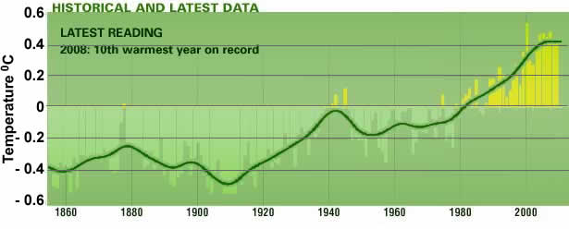

Describe how global temperatures have varied since 1850?

Give reasons why the graph line is not straight?

**Temperature maps**  
Dark blue indicates areas cooler than average. Dark red indicates areas warmer than average. (Credit: NASA/Goddard Scientific Visualization Studio)

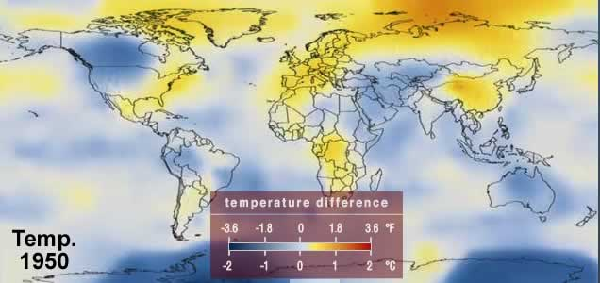

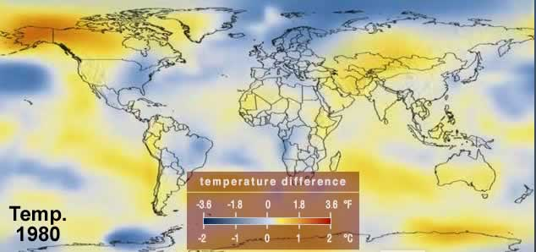

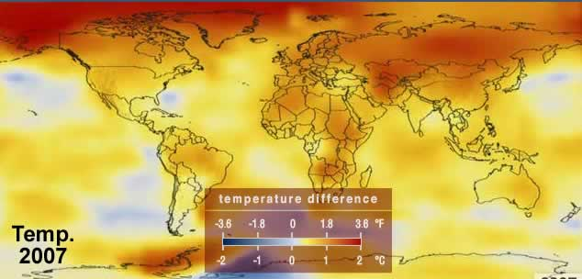

Explain why land temperatures appear to have warmed more than sea temperatures.

**Quiz-** According to the maps, which hemisphere has warmed the most?

## 10. The poles

**Artic summer sea ice**  
The image shows the annual Arctic sea ice minimum for 1979 and 2007. At the end of each summer, sea ice has melted and reached its minimum extent, leaving what is called the perennial ice cover (permanent). The area of the perennial ice has been steadily decreasing since the satellite record began in 1979.   
(Credit: NASA/Goddard Scientific Visualization Studio)

When sea ice melts, sea level does not change but the albedo (reflectivity) of that surface does. Ice reflects about 90% of solar radiation while water reflects about 10% and absorbs about 90%.

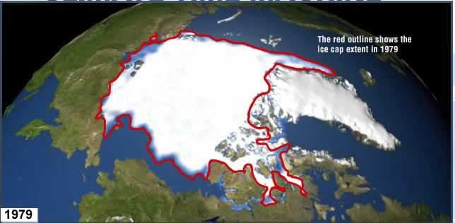

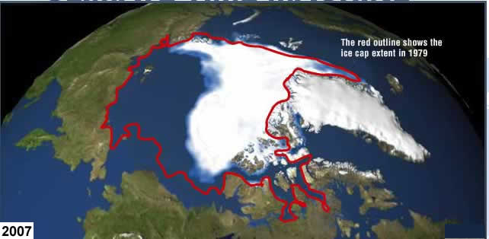

Explain why the ice area to east of the red line is not included.

Explain why the area of sea ice would vary seasonally, throughout a single year.

Explain why the change in albedo when sea ice is replaced by water is important for climate change.

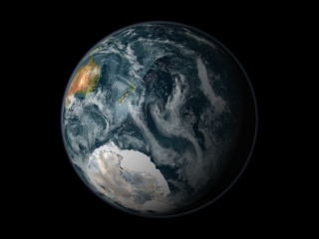**Antarctica**  
Ice shelves are thick plates of ice, fed by glaciers, that float on the ocean around much of Antarctica.

The Larsen B shelf was about 220 meters thick. The northern section of the ice shelf, a large floating ice mass on the eastern side of the Antarctic Peninsula, shattered and separated from the continent. The shattered ice formed a plume of thousands of icebergs adrift in the Weddell Sea. A total of about 3,250 square kilometres of shelf area disintegrated in a 35-day period beginning on January 31, 2002. Over the last five years, the shelf has lost a total of 5,700 square kilometres and is now about 40 percent the size of its previous minimum stable extent.   
(Credit: NASA/Goddard Scientific Visualization Studio)

|  |  |
| --- | --- |
| http://www.reec.nsw.edu.au/geo/climate/image/clch10d.jpg  This image, taken on 31/1/02, shows meltwater starting to form on the Larsen Iceshelf prior to its collapse. | http://www.reec.nsw.edu.au/geo/climate/image/clch10e.jpg  The aftermath of the Larsen Iceshelf collapse on 7/3/2002.The collapsed area is light blue. |

Investigation: place several ice cubes in a glass of warm water. Carefully measure the height of the water then check it again when the ice melted. What happened to the water level in the glass?

**Quiz**

The 'reflectivity' of a surface is called its?

## 11. Glaciers

A March 2005 WWF report concluded that 67% of all Himalayan glaciers are retreating. In examining 612 glaciers in China between 1950 and 1970, 53% of the glaciers studied were retreating. After 1990, 95% of these glaciers were measured to be retreating, indicating that retreat of these glaciers was becoming more widespread.

This image shows the termini of the glaciers in the Bhutan-Himalaya. Glacial lakes have been rapidly forming on the surface of the debris-covered glaciers in this region during the last few decades. USGS researchers have found a strong correlation between increasing temperatures and glacial retreat in this region.   
(Credit: NASA/Goddard Scientific Visualization Studio)

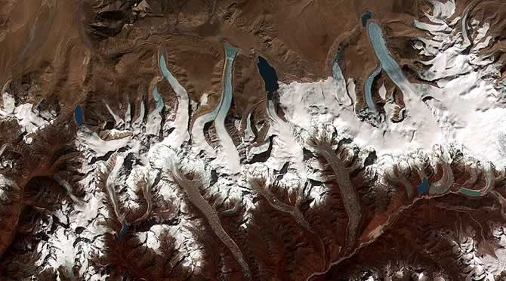

Perhaps the most visible sign that Earth's climate is warming is the gradual shrinking of its glaciers. Since 1960, glaciers around the world have lost an estimated 8,000 cubic kilometers of ice. The largest glacier in the world's largest tropical ice mass shrank by 6 metres per year between 1963 and 1978 but is now shrinking at a rate of 60 metres per year.

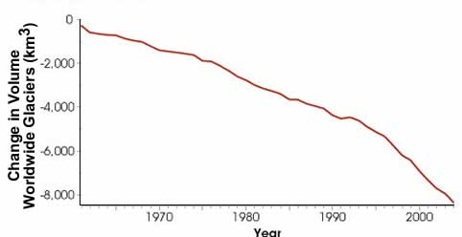

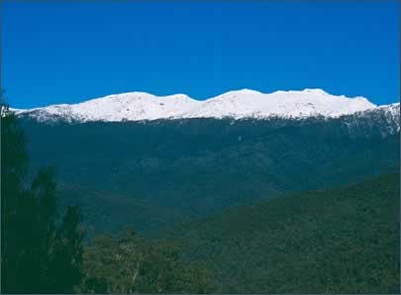This photo shows a winter snowline in the Snowy Mountains. When temperatures are below zero, water stays in its frozen state, above zero and it starts to melt. Hence glacier melting is a good indicator of temperature change; it is very sensitive to it.

|  |  |
| --- | --- |
| http://www.reec.nsw.edu.au/geo/climate/image/clch11k.jpg | http://www.reec.nsw.edu.au/geo/climate/image/clch11i.jpg |

The retreat of the Arapaho Glacier in the Colorado Rocky Mountains between 1898 and 2003. The Arapaho is an alpine glacier that contributes to sea-level rise through melting. The retreat of mountain glaciers is directly tied to increasing temperatures and melting. (Credit: NASA)

|  |  |
| --- | --- |
| http://www.reec.nsw.edu.au/geo/climate/image/clch11n.jpg | http://www.reec.nsw.edu.au/geo/climate/image/clch11m.jpg |

The top pair of images shows the retreat of Alaska’s Colombia Glacier between about 1980 (left) and in 2005 (right). The Columbia is a tidewater glacier—one that terminates in water—that contributes to sea-level rise mostly through iceberg calving. Since the Columbia began retreating around 1980, the terminus—the ending edge—has retreated approximately 15 kilometres. (Credit: NASA)

**Quiz**

Where the snout of a glacier melts it leaves behind a mound of debris called a?

## 12. Changing sea level

Global sea level rose about 17 centimetres in the last century. In the last decade, however, the rate of rise nearly doubled threatening island communities.

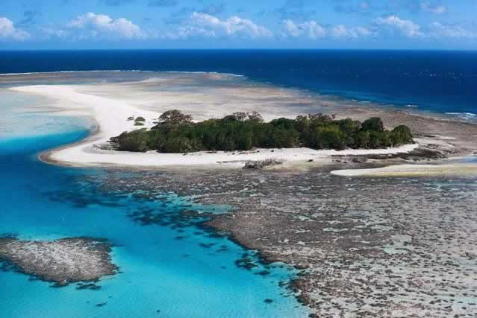

With a 1-metre rise in sea level, more than a third of Shanghai would be under water. The rice-growing river floodplains and deltas of Asia would be particularly vulnerable. A World Bank analysis shows that Bangladesh would be hardest hit, losing half of its rice production—the food staple of its 140 million people. Rising sea level could create millions of climate refugees in Bangladesh, China, India, Indonesia, the Philippines and Viet Nam.   
  
Two thirds of the Marshall Islands and Kiribati would be under water. The United States would lose 36,000 square kilometres of land, Japan would lose 2,340 square kilometers of the country and four million Japanese would be affected. From: Lester R. Brown, Eco-Economy: Building an Economy for the Earth

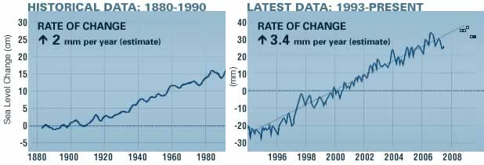

The chart on the left shows historical sea level data derived from 23 tide-gauge measurements. The chart on the right shows the average sea level since 1993 derived from global satellite measurements, updated monthly. Sea level rise is associated with the thermal expansion of sea water due to climate warming and widespread melting of land ice.   
(Credit: NASA/Goddard Scientific Visualization Studio)

The oceans have absorbed much of the increased heat from global warming, with the top 700 meters of ocean showing warming of 0.1 degrees Celsius since 1955.

Describe likely impacts of rising sea levels.

Local councils should protect private property from beach erosion caused by storms and sea level rise. Give point for and against this statement.

## 13. Changing carbon dioxide levels

Carbon dioxide (CO2) is an important greenhouse gas released through natural processes such as respiration and volcano eruptions and through human activities such as deforestation and burning fossil fuels.

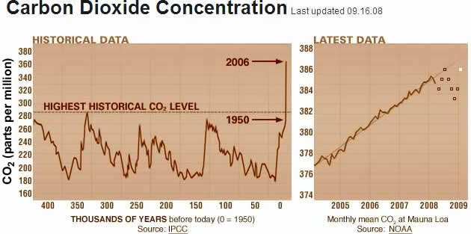

The chart on the left shows the historical levels of CO2 in the Earth's atmosphere. The chart on the right shows CO2 levels in recent years.   
(Source: NOAA)

The graph on the right, based on the comparison of atmospheric samples contained in ice cores and more recent direct measurements, provides evidence that atmospheric CO2 has increased since the Industrial Revolution began in the period 1780 to 1830.

Research: what was the Industrial Revolution?

Do the carbon dioxide levels for 2005 at Mauna Loa and Cape Grim support the statement that air does not mix between the northern and southern hemispheres?

**Cape Grim**

The Cape Grim Baseline Air Pollution Station in Tasmania began taking samples of the atmosphere in April 1976 and has taken more than 3 billion measurements of carbon dioxide and other gases. A 10% increase in carbon dioxide has been measured.

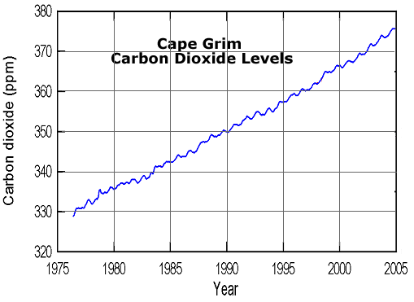

Give reasons for the seasonal variations in carbon dioxide levels at Cape Grim.

The maps below show the annual carbon dioxide emissions produced by the top 12 nations or regions from 1980-2004. Units are given in thousand metric tons of carbon dioxide emitted from fossil fuel consumption.   
(Source: U.S. Department of Energy)

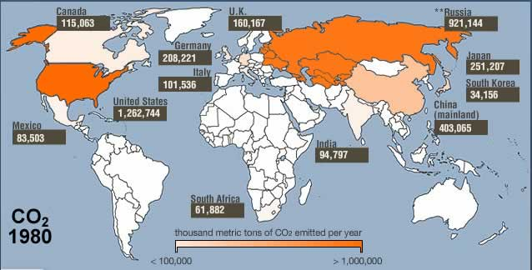

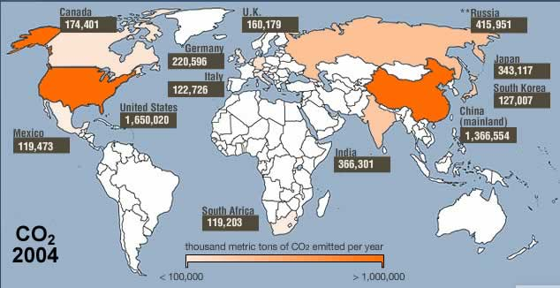

**Quiz**

Which country had the highest carbon dioxide emissions in 2004?

Which country or region had the largest increase in carbon dioxide emissions between 1980 and 2004?

## 14. Changes to animals and plants

|  |  |
| --- | --- |
| **Animals**  Many animals have responded to climate change. Sixty five bird species in the United Kingdom are laying eggs nine days earlier than they did in 1971 and dragonflies have moved 90 km north. The red fox in Canada has moved 900 km north where it is now competing with the Arctic fox. The Bulletin 17 Oct 06 | http://www.reec.nsw.edu.au/geo/climate/image/en7h.jpg |
| Timing mismatches in food webs are appearing. A bird, the Pied Flycatcher now lays its eggs 7 days earlier but, a caterpillar which is the main food source for the young birds appears 14 days earlier than it did in the past.  What is likely to happen to baby Pied Flycatchers now their main food hatches and finishes earlier than before? | http://www.reec.nsw.edu.au/geo/climate/image/clch14b.jpg  Image: The Royal Society for the Protection of Birds |
| **Polar Bears**  Polar bears hunt seals from Arctic sea ice. As the ocean warms, there is less ice and the bears catch less food. Their population has decreased by 17% in the last 10 years and the average weight of bears in Hudson Bay has decreased from 295 kg to 230 kg. | http://www.reec.nsw.edu.au/geo/climate/image/en7e.jpg |
| Wine grapes have an upper limit for their average growing season temperature of 210C for quality grape production. The average for the period 1971-2000 was 21.10C in the Riverina, 17.90C for Tumbarumba and 18.60C for Rutherglen.  How will a small increase in temperature impact on these three areas? | http://www.reec.nsw.edu.au/geo/climate/image/clch14a.jpg |
| **Diseases**  Many diseases such as malaria and dengue fever are spread from an infected person to others by invertebrates such as mosquitoes and ticks. The invertebrates carrying the disease are called vectors. Mosquitoes are very sensitive to temperature change. Warming boosts their rate of reproduction. Mosquitoes are spreading to areas previously too cold for them.  Photo: mosquito commonly known as the 'Dengue' or Yellow Fever' mosquito. S. Doggett, NSW Health | http://www.reec.nsw.edu.au/geo/climate/image/en8c.jpg |

### http://www.reec.nsw.edu.au/geo/climate/image/cc29a.jpgTemperature and animals and plants

All organisms have an upper and lower temperature which will kill them. In between these two extremes they can survive. A place which is not too cold nor too hot but just right. This is called the organisms habitat, the area where it can live.

The photo of the Thredbo valley shows three vegetation zones, montane of several tree types below 1350 metres in altitude, sub-alpine of just snow gum trees between about 1350 and 1800 metres and alpine, above the treeline at approximately 1800 metres where no trees can grow.

Trees have difficulty surviving as it gets colder by going up mountains or near the poles.

* Describe what happens to the number of tree species as altitude increases.

The Mountain Pygmy-possum (Burramys) lives among granite boulders above an altitude of 1600 metres in alpine areas of Australia. The females live in the better, cooler habitat near the tops of mountains, while the males live in poorer habitat lower down.

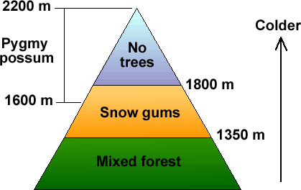Look at the diagram to the right.

If the climate gets warmer:

* What will happen to the three vegetation zones?
* Will the area with snow gums get wider, narrower, move up or move down?
* What will happen to the alpine zone with no trees?
* Will the habitat of the pygmy possum get bigger, smaller, move up or move down the mountain?

The diagram of a mountain and map below show fictitious areas where particular types of mosquito live. Predict where you think they will move if the climate gets warmer.

|  |  |
| --- | --- |
| http://www.reec.nsw.edu.au/geo/climate/image/clch14d.gif | http://www.reec.nsw.edu.au/geo/climate/image/clch14c.gif |

## 15. Changes to the land

|  |  |
| --- | --- |
| **Permafrost**  Permafrost is a permanently frozen layer in the soil, found in alpine, Arctic, and Antarctic regions.  Buildings, roads and railway lines have been built on it and rely on it staying frozen to prevent damage which will occur if it melts.  In Siberia, the world's largest frozen swamp the size of both France and Germany combined has melted in the past 3 years and is releasing methane gas. The Arctic Circle region, including Siberia, has warmed by 30C in the past 40 years which is much more than the rest of the world. | http://www.reec.nsw.edu.au/geo/climate/image/enws8a.jpg  Original map: International Permafrost Association |
| **Severe weather**  There has been an increase in the severity of tropical cyclones in Australia with higher maximum wind speeds. Tropical cyclones can form when sea temperatures are above 26.80C  The number of severe thunderstorms has increased with associated damage from large hail stones, flash flooding and strong winds. | [http://www.reec.nsw.edu.au/geo/climate/image/en7a.jpg](http://www.reec.nsw.edu.au/geo/climate/page/clch15.htm) |
| **Fires**  In south-east Australia, since 1950:   * rainfall has decreased * droughts have become more severe * the number of extremely hot days has risen.   As a result it is predicted the number of very high and extreme forest fire danger days is likely to increase by  15 to 70 per cent by 2050. CSIRO | http://www.reec.nsw.edu.au/geo/climate/image/en8b.jpghttp://www.reec.nsw.edu.au/geo/climate/image/en8e.jpg Fire photo CSIRO |
| **Drought and famine**  The length, severity and occurrence of droughts around the world has increased around the world with big crop losses. People in poor countries suffer more because they cannot afford to buy food from other countries.  The United Nations estimates 65 developing countries will suffer crop losses of 280 million tonnes because of climate change.  Photo: dust storm Wagga Wagga | http://www.reec.nsw.edu.au/geo/climate/image/en7f.jpg Photo: Vic Shoemark Wagga Wagga |

What will happen to infrastructure built on permafrost with global warming?

Methane gas is twenty times stronger than carbon dioxide as a greenhouse gas. Why is this a problem as arctic swamps thaw?

**Quiz**

Permanently frozen soil is called?

## 16. Changes to Australia

The maps below are based on data produced by the CSIRO for the New South Wales Government Greenhouse Office.

|  |  |  |  |  |
| --- | --- | --- | --- | --- |
| Map showing how maximum temperatures have changed since 1950. Red indicates areas where they have increased and blue where they have decreased. | http://www.reec.nsw.edu.au/geo/climate/image/en9a.jpg | | | |
| Map showing how minimum temperatures have changed since 1950. | http://www.reec.nsw.edu.au/geo/climate/image/en9b.jpg | | | |
| Since 1950 yearly rainfall patterns have changed a lot. | http://www.reec.nsw.edu.au/geo/climate/image/en9c.jpg | | | |
| http://www.reec.nsw.edu.au/geo/climate/image/en9d.gifThere has been a rise in sea level of about 1.2 mm per year from 1920 to 2000 which is a little bit below the global average. | | | | |
| **Predictions for the Riverina** | **Days Below 00C** | | **Days Above 350C** | |
| **Present** | **Year 2030** | **Present** | **Year 2030** |
| **Wagga Wagga**  **Deniliquin**  **Wyalong** | 26  10  9 | 10-23  2-8  2-7 | 20  24  26 | 21-34  25-37  27-42 |

Note: the predictions for the Riverina are based on climatic models, the figures are what scientists think will happen by the Year 2030. They are not sure so they have given two figures, a low and a high one. Scientists estimate Wagga Wagga will have somewhere between 10 and 23 days each year with temperatures below zero degrees.

Most of the rise in sea level has been due to thermal expansion of the oceans as they warm. This would give a fairly straight graph line. Give reasons for the yearly variations shown by the red line.

Make a list of the things impacted upon in the Riverina if the number of hot days above 350C increases from 20 to 34.

## 17. Ice core evidence

|  |  |  |
| --- | --- | --- |
| **Law Ice Dome**  The Law Ice Dome in Antarctica was ideal for testing trapped air for carbon dioxide levels. The site had good stratigraphic layering (oldest ice at the bottom and most recent ice at the top), negligible melting, little pollution and a high snow accumulation rate.  The air in three cores (named DSS, DE08 and DE08-2) dating from 1978 back to 1006 A.D. was tested for carbon dioxide levels. | http://www.reec.nsw.edu.au/geo/climate/image/cc5ac.gif | http://www.reec.nsw.edu.au/geo/climate/image/cc5ab.gif |

The graph below shows the results.

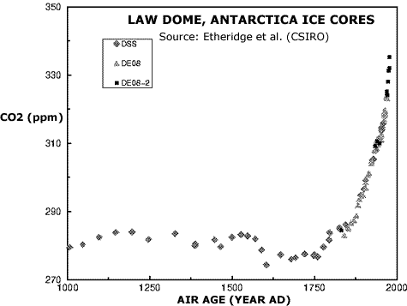

The Industrial Revolution began in the period 1780 to 1830.

**Quiz-** Continent the Law Ice Dome is located in?

## 18. Basic science: sunlight

The sun gives out waves of energy called solar radiation.

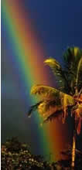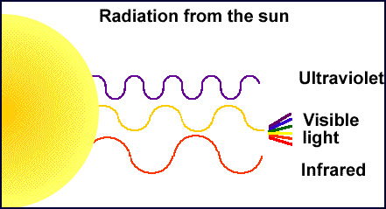

The sun's waves of energy are not all the same.

* Ultraviolet waves are shorter, invisible and cause sunburn.
* We can detect visible light with our eyes as different colours. Each colour has a different wave length, a bit less than one thousandth of a millimetre. When we look at a rainbow the red and yellow waves are longer than the blue and violet ones.
* We detect (feel) infrared waves as heat when we stand in sunlight.

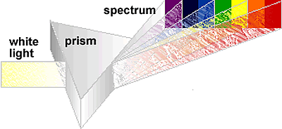

The Earth gives off longer waves of radiation (over one thousandth of a millimetre). The wave length is a bit over ten times longer than visible light and it is called longwave radiation. Hot objects like the sun give off mostly shorter waves of radiation such as visible light which are less than one thousandth of a millimetre long.

* Research why the sky is blue.
* Try to make or see a rainbow. Sometimes light passing through a window or fish tank will form a rainbow. Draw a rainbow and indicate which colours have longer wave lengths and which have shorter wave lengths.

**QUIZ**

What type of radiation does the Earth give off?

**Investigation**   
Does colour affect the temperature of objects left in the sun?

* Three tin cans were painted different colours, fitted with thermometers and left in the sun for 40 minutes.
* Repeat the experiment three times and calculate the average temperature changes.

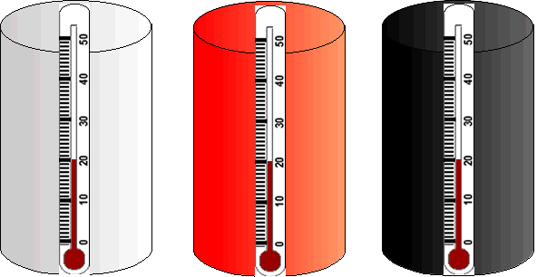

**Apply this knowledge.** Car air conditioners cause the car engine to use more fuel and so release more greenhouse gases. What would be the best colour car to save greenhouse gas emissions in a hot climate? What would be the best colour for a house roof in a cold climate to save heating costs and greenhouse gas emissions?

## 19. Basic science: the atmosphere

* Earth is the only planet with an atmosphere which supports life.
* Look up at the sky on a clear day and the 'blue' atmosphere seems to go on for ever. It is a mixture of gases we call air.
* Scientists divide the atmosphere into four layers depending on temperature.
* Weather occurs in the lowest layer, the Troposphere. Large jets fly at about the top of the Troposphere called the Tropopause. Nearly all air pollution is trapped in this layer.

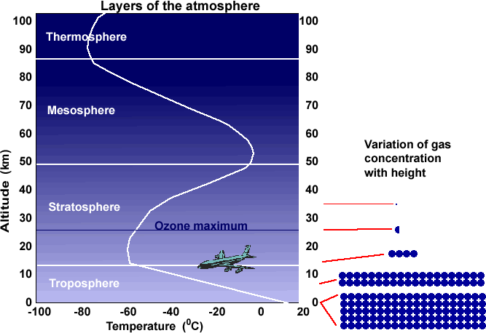

In the diagram above, the left side shows the altitude and the right side shows how the concentration of gas in the air varies with height. The concentration at the surface is 100%.

* What is the concentration of gas (%) in the air at about 8 km altitude?
* What is the concentration at about 12 km?
* Go outside and estimate where the Tropopause is (about 12 km) by looking for a cruising jet or a contrail.

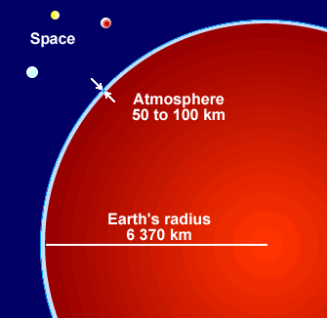99.9% of the gas in the air is in the first 42 km because gravity causes most air molecules to settle near the surface.

The ozone layer in the stratosphere protects us from the sun's harmful ultraviolet rays. Ozone is made up of three oxygen atoms, O3. Ozone blocks ultraviolet rays while allowing longer wavelengths to travel through.

Go outside and look at the sky:

* Does it go on for ever?
* Do you think it would be possible to fill it up with pollution from cars, factories and power stations or is it too big for this?

**QUIZ**

Nearly all of the gas in the atmosphere occurs in this layer?

Gas which protects us from ultraviolet rays?

## 20. Basic science: air

Earth is the only planet with an atmosphere (air) which supports life.

* 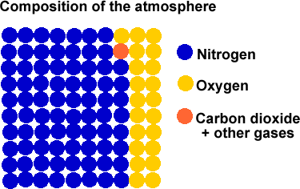Take in a really deep breath. What gasses were in the air you just breathed in?
* In the diagram below, each dot represents one percent of the air we breathe in. What is the main gas?
* How much oxygen did you breathe in?
* How much carbon dioxide?

In the diagram above, each dot represents one percent of the atmosphere. The orange dot represents other gases made up of argon (0.93%), carbon dioxide (0.04%) and trace amounts of other gases. Water vapour is not normally included but varies from nearly zero over deserts to 4% over oceans. Carbon dioxide levels have increased from 280 ppm in pre-industrial levels to 379 ppm in 2005.

Carbon dioxide is not the only greenhouse gas. Others include water vapour, methane, nitrous oxide, ozone and others.

When expressing how much of the trace gases are present we normally use parts per million (ppm) so a sample of air may have 379 molecules of carbon dioxide for every one million molecules of air. This is expressed as 379 ppm.

Take a guess at what we breathe out. The amount of oxygen and carbon dioxide we breathe out varies from person to person depending on fitness.

* 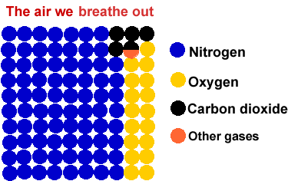How much oxygen do we breathe out?
* How much carbon dioxide do we breathe out? Did the amount of nitrogen vary?

**QUIZ**

The gas we breathe out which is the second highest by volume is?

Gas which makes up 78% of the air?

## 21. Carbon cycle

Carbon is the most abundant element in plants and animals. All living things are based on the carbon atom. Carbon atoms continually move through the atmosphere, the oceans, soils and living organisms. This is called the carbon cycle.

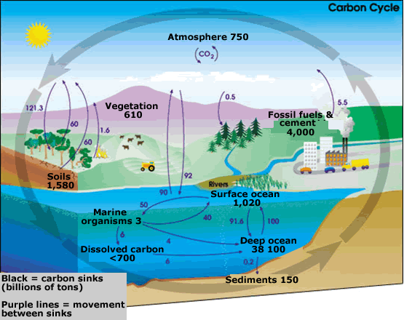

Image: NASA Earth Science Enterprise.

There are many places where carbon can be stored, carbon 'sinks'. These include the atmosphere, oceans, terrestrial biosphere such as soils and in fossil fuels and cement (this contains limestone, CaCO3, where the C in CO3 is carbon). The black numbers in the diagram indicate how much carbon is stored in sinks in billions of tons. The purple numbers indicate how much carbon moves between sinks each year.

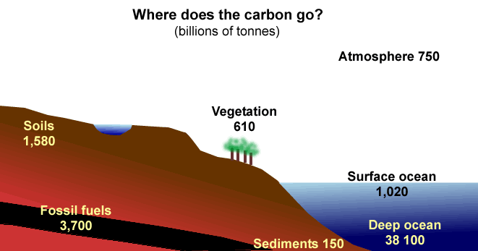

Name the carbon sinks in order of importance in the diagram above.

Explain how a carbon sink could become a source of carbon and release carbon dioxide?

Scientists now believe the Southern Ocean which absorbed 15% of our greenhouse gas emissions has now reversed and is out gassing, giving off CO2.2. Stronger winds are causing more waves and mixing the deep ocean sink which has a lot of CO2 with surface water and this deep CO2 is going back into the atmosphere. (CSIRO May 2007)

The graph below shows the global addition of carbon to the atmosphere. Source: Wikipedia

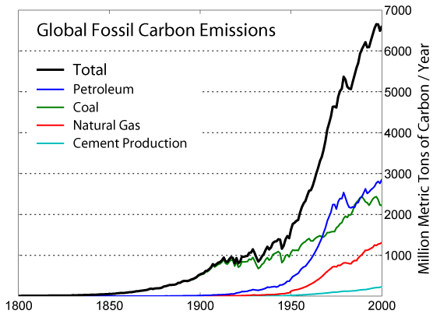

**QUIZ**

An important global warming gas taken out of the air by plants?

Name for places where carbon is stored?

Can carbon sinks reverse and give off carbon dioxide? Yes or no.

## 22. Photosynthesis

The body of a plant, the leaves, trunk and roots are a store of carbon.

The Bushfire Cooperative Research Centre says climate change will cause more bushfires, which will release more carbon pollution, which makes climate change worse. A bad fire could release 30 million tonnes of carbon into the air. This is the equivalent of 108 million tonnes of carbon dioxide gas.

The energy in plants comes from the sun through a process called photosynthesis.

Plants have a green chemical called chlorophyll which can trap solar energy. It uses this energy with nutrients and water from the soil and carbon dioxide from the air to make sugar (food) for the plant. This process is called photosynthesis.

The carbon taken from the air is stored in the plant. When the plant dies and decomposes or is burnt, the carbon is released back into the atmosphere as carbon dioxide gas.

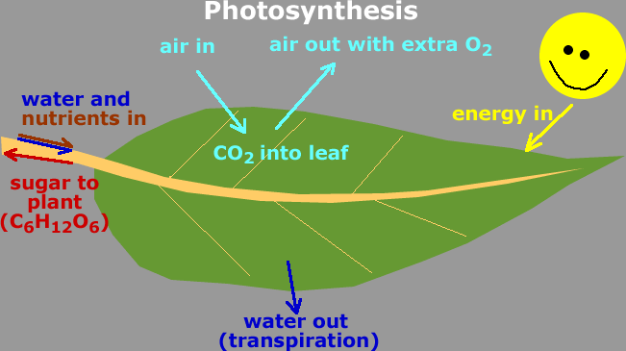

* Carefully pick a leaf and have a close look. Try drawing it or make a rubbing. Write labels on it to explain how photosynthesis works.

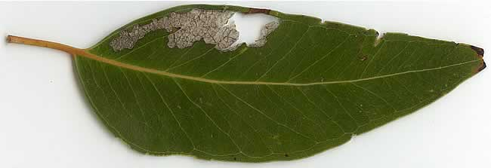

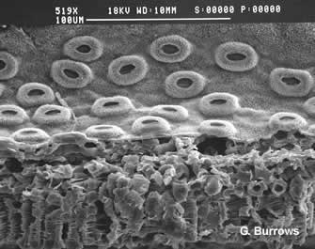Have a very close look under a powerful microscope and you will see the stomata (donuts), the holes through which the leaf breathes.

* Take in a deep breath. Our lungs take some of the oxygen out of the air. What happens when a leaf breaths in?
* Breath out. What gasses come out? What does a leaf breath out?
* Watch a match burn. What happens to the carbon in the wood?
* Draw a carbon flow diagram for your body.

**Advanced**

Photosynthesis  
Carbon dioxide from the air + water from the soil + sunlight = sugar (chemical energy) + water + oxygen.

CO2 + H2O + light = CH2O + H2O + O2

When the plant energy is used such as in a fire or when our bodies digest food the reverse happens.

CH2O + H2O + O2 = CO2 + H2O + heat

We use food (sugar, CH2O), water and oxygen to obtain our energy and waste products are carbon dioxide, water and heat.

Calculate the amount of carbon stored in trees (carbon sinks) in your school grounds using a Tree Carbon Calculator go to:   
**http://svc237.bne113v.server-web.com/calculators/treecarbonhow.htm**

or Google: Tree Carbon Calculator and look for the above address.

**QUIZ**

Name the process by which plants use the sun's energy to make food?

## 23. Resources: renewable and non-renewable

There are a number of resources which provide us with energy. Some are renewable (replaceable) and don't run out. Others are non-renewable, we cannot replace them and they will run out. These include the fossil fuels of coal, oil and gas.

|  |  |
| --- | --- |
| **Energy Source** | **Use** |
| **Solar radiation**  http://www.reec.nsw.edu.au/geo/climate/image/en19c.gif | http://www.reec.nsw.edu.au/geo/climate/image/en15a.jpg |
| http://www.reec.nsw.edu.au/geo/climate/image/enqqf.jpg | http://www.reec.nsw.edu.au/geo/climate/image/en15b.jpg |
| **Moving water**  http://www.reec.nsw.edu.au/geo/climate/image/en15f.jpg | http://www.reec.nsw.edu.au/geo/climate/image/en15e.jpg |
| **Fossil fuel: oil**  http://www.reec.nsw.edu.au/geo/climate/image/en15g.gif | http://www.reec.nsw.edu.au/geo/climate/image/en15h.jpg |
| **Fossil fuel: coal**  **http://www.reec.nsw.edu.au/geo/climate/image/enqqh.jpg** | http://www.reec.nsw.edu.au/geo/climate/image/en15i.gif |
| **Fossil fuel: gas** | http://www.reec.nsw.edu.au/geo/climate/image/en15j.gif |

All three fossil fuels, oil, coal and gas release greenhouse gases when burnt.

Other sources of energy, solar, wind and running water do not release greenhouse gases when used.

**Quiz**

Term used for resources which are replaceable and do not run out?

## 24. Fossil fuels

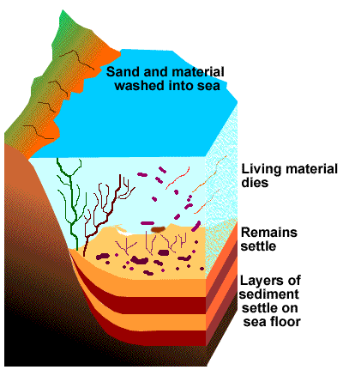**Oil and natural gas**

Oil and natural gas are fossil fuels. They formed from microscopic decayed plants, algae and bacteria in oceans.

When the microscopic plants and algae died, they sank to the bottom and were covered by layers of sediment.

Many deposits formed during the Jurassic dinosaur period, about 150 million years ago.

They are called hydrocarbons because they are mainly made of hydrogen (about 12%) and carbon (about 85%).

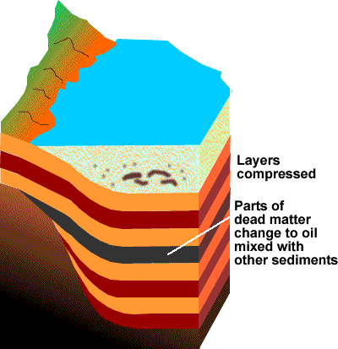As more layers of sediment covered the fossil remains, they were changed by the extra pressure and heat into petroleum.

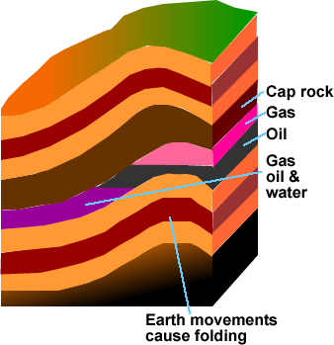The oil and gas moved upwards through the sedimentary rock until they either escaped at the surface or were trapped by a layer of impermeable rock. The layer that traps the oil and gas is called a cap rock.

The oil, gas and sea water occur in porous rock, not big hollows like caves in the rock.

About 84% of petroleum is used for fuel, the other 16% is used for products such as fertilisers, pesticides and plastics.

* Explain why oil, gas and coal are called fossil fuels?
* Why are oil and gas called hydrocarbons?

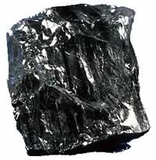**Coal**

Coal formed from larger dead plants than oil. As the plants were buried by more sediments with more pressure and heat, different types of coal formed. First brown coal, then black coal and lastly anthracite.

Brown coal is approximately 70% carbon and anthracite is over 91% carbon.

Australia's black coal deposits formed about 200 million years ago.

When the fossil fuels (oil, gas and coal) are burnt in air, the carbon in them combines with oxygen in the air to form carbon dioxide gas, CO2.

* Look at a plant and imagine it buried in a swamp with layers of sediment on top squashing it.
* Watch a leaf burn. When alive, the leaf took carbon out of the air. Now it is burning, the reverse is happening, the carbon in the leaf is combining with oxygen from the air to form carbon dioxide gas.
* Explain why oil and coal are called hydrocarbons.

**Quiz**

Many fossil fuels in Australia formed during the time of which large animals?

## 25. Greenhouse effect

The greenhouse effect describes how gases in the Earth's atmosphere reduce the amount of heat escaping from the Earth into space. The more of these gases there are, the more the Earth heats up.   
(Image credit: NASA/Goddard Scientific Visualization Studio)

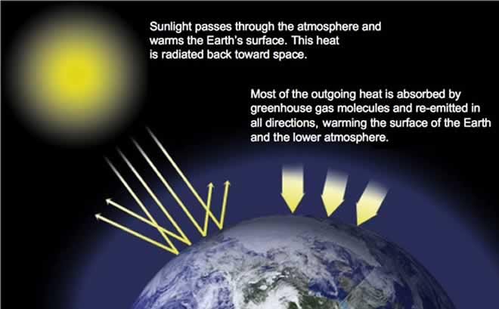

Greenhouse gases such as water vapour and carbon dioxide allow sunlight energy to pass through the atmosphere but prevent much of the Earth's heat energy escaping. The natural greenhouse effect of these gases is very important because without it the Earth's temperature would be minus 18 degrees.

Human actions, particularly the burning of fossil fuels (coal, oil and natural gas) and the clearing of land (burning vegetation), are increasing the quantity of some of the greenhouse gases, particularly carbon dioxide (CO2), causing global warming. (credit: NASA)

Greenhouse gases include: water vapor, carbon dioxide, methane, nitrous oxide, and ozone.

Make your own diagram to explain the greenhouse effect.

## 26. Water cycle

The water cycle moves a lot of water and also a lot of energy. It takes about 2,436 kilojoules (kJ) of heat energy to evaporate one millilitre of water which is a lot of heat for a small amount of water. A muesli bar has about 700 kJ of energy.

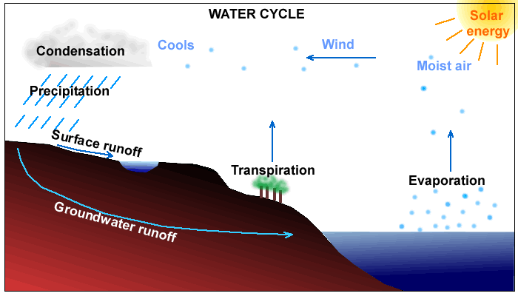

When water evaporates or changes state from a liquid to water vapour (gas), the 2,436 kilojoules per millilitre goes with the water vapour. That is why you feel cool when water evaporates from your body as sweat.

When the water vapour condenses into cloud droplets (liquid), the energy held in the vapour is released as heat energy (latent heat of condensation) into the atmosphere. The warm air expands, is lighter than the surrounding air and rises. When it rises it cools, more cloud droplets form, more heat energy is released and the cloud keeps forming and bubbling up. Watch a large cumulus cloud and see this happening as it keeps billowing up higher.

The water cycle can transport huge amounts of energy into the atmosphere. The cumulus clouds may form a thunderstorm or in the extreme, a tropical cyclone. Most of the extra heat from climate change is absorbed by the oceans. As the oceans become warmer, the amount of evaporation increases, the amount of energy transferred to the atmosphere increases and extreme thunderstorms with hail and high winds have become more common. An average tropical cyclone generates enough energy in one day, about 300-400 billion kilowatt-hours, to provide Australia's electricity needs for 18 months.

Draw a water cycle diagram for your local area.

Go outside and look for a cumulus cloud bubbling up. Explain why this is occurring.

Describe what will happen to the amount of energy transported in the water cycle as the oceans warm up. What are the consequences of this?

**Quiz**

Apart from water, the water cycle transports a lot of?

## 27. Oceans

The water in oceans is always moving because of waves and currents. Connecting the world's oceans is a large current, often called the ocean conveyor belt.

The conveyor belt (thermohaline circulation) takes warm surface water from the Pacific Ocean to the Atlantic and returns cold water from the Atlantic to the Pacific as a deep current.

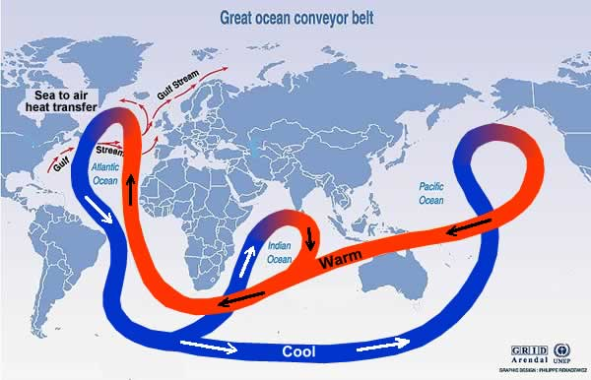

Warm water from the equator moves to the Arctic where it releases heat to the atmosphere. As the water cools it becomes denser and sinks to the deep ocean. This deep water travels along the ocean bottom, eventually coming back to the surface as much as 1000 to 2000 years later.

The Gulf Stream takes warm tropical water from near the Equator to the Arctic. It warms Western European countries such as Great Britain by 90C above what it would be without it.

Recent studies show global warming has caused the speed of the Gulf Stream to slow by 30% and carry 30% less water.

* Next time you have a shower turn the hot water down by one third and see what happens to the temperature.
* Explain what will happen to the climate of Great Britain if the Gulf Stream slows or has less water?

**QUIZ**

Name of the ocean current which warms Great Britain and Europe?

Technical term for the large ocean current which connects the world's oceans?

## 28. East Australia Current

|  |  |
| --- | --- |
| http://www.reec.nsw.edu.au/geo/climate/image/clch28a.gif | http://www.reec.nsw.edu.au/geo/climate/image/clch28b.jpg |

The East Australia Current is similar to a river in the ocean. It flows at up to 9km/h, is up to 100 km wide and can transport 30,000,000 cubic metres of water per second.

It starts in the Coral Sea off northern Queensland where water temperatures are approximately 300C.

It transports warm tropical water down the east coast which impacts on the climate along the coast.

The CSIRO have reported that the waters off the east coast of Tasmania have warmed over the past 50 years as the current has moved further south.

Water off the east coast has warmed by 2.280C which is much higher than the climate change global average of less than one degree.

Climate change is also impacting on other important world currents such as the Gulf Stream which starts in tropical waters and transports warm water to Europe which is thought to be 90C warmer because of it.

* Pour a glass of water from the tap and measure its temperature with a thermometer. Put your finger in to feel it, then put warm water in it until it is 90C warmer and feel it again.
* How would the East Australia Current effect fish, people swimming, shipping and the climate along the coast?

**QUIZ**

Sea where the East Australia Current starts?

## 29. Cartoons

|  |  |
| --- | --- |
| http://www.reec.nsw.edu.au/geo/climate/image/en5m.gif Cartoon courtesy Andy Slinger | http://www.reec.nsw.edu.au/geo/climate/image/en3b.gif Cartoon courtesy Andy Slinger |

|  |  |
| --- | --- |
| http://www.reec.nsw.edu.au/geo/climate/image/en5g.jpg Image courtesy Chris Madden | http://www.reec.nsw.edu.au/geo/climate/image/en5n.jpg |

|  |  |
| --- | --- |
| Select one of the cartoons.   * Describe what you see. * Explain the cartoonist's message. * Give your opinion of the message. | http://www.reec.nsw.edu.au/geo/climate/image/cc3a.jpg |

|  |  |
| --- | --- |
| **Example**  Describe what you see. There is an old fashioned meat grinder with the Earth being put in the top by a person and goods such as planes coming out the other end.  Cartoonist's message. To make money, we are using up the planet until it is all gone.  My opinion. It is not too late, only half the Earth has gone through the grinder so far. Perhaps if we make fewer things we can save the planet.  Perhaps we can make things more wisely and not damage the planet, sustainable use.  Cartoon courtesy Petty | http://www.reec.nsw.edu.au/geo/climate/image/en5j.gif |

|  |
| --- |
| Task: Draw your own cartoon to do with Earth change and explain your message. |

## 29a. Student cartoons

|  |  |
| --- | --- |
| **Stage 4/5** | |
| http://www.reec.nsw.edu.au/geo/climate/image/en14ab.gif | http://www.reec.nsw.edu.au/geo/climate/image/en14aa.jpg |
| http://www.reec.nsw.edu.au/geo/climate/image/en14ac.gif | http://www.reec.nsw.edu.au/geo/climate/image/en14ad.jpg |
| http://www.reec.nsw.edu.au/geo/climate/image/en14af.gif | http://www.reec.nsw.edu.au/geo/climate/image/en14ae.jpg |
| http://www.reec.nsw.edu.au/geo/climate/image/en14ag.gif | http://www.reec.nsw.edu.au/geo/climate/image/en14ah.jpg |
| **Stage 3** | |
| http://www.reec.nsw.edu.au/geo/climate/image/en14ak.gif | http://www.reec.nsw.edu.au/geo/climate/image/en14ai.jpg |
| http://www.reec.nsw.edu.au/geo/climate/image/en14ao.gif | http://www.reec.nsw.edu.au/geo/climate/image/en14aq.jpg |
| http://www.reec.nsw.edu.au/geo/climate/image/en14aj.gif | http://www.reec.nsw.edu.au/geo/climate/image/en14ap.jpg |
| http://www.reec.nsw.edu.au/geo/climate/image/en14am.gif | http://www.reec.nsw.edu.au/geo/climate/image/en14ar.gif |
| http://www.reec.nsw.edu.au/geo/climate/image/en14an.gif |  |
| **Stage 2** | |
| http://www.reec.nsw.edu.au/geo/climate/image/en14as.gif | http://www.reec.nsw.edu.au/geo/climate/image/en14au.gif |
| http://www.reec.nsw.edu.au/geo/climate/image/en14at.jpg | http://www.reec.nsw.edu.au/geo/climate/image/en14av.gif |
| http://www.reec.nsw.edu.au/geo/climate/image/en14aw.jpg | http://www.reec.nsw.edu.au/geo/climate/image/en14ay.jpg |
| http://www.reec.nsw.edu.au/geo/climate/image/en14ax.gif |  |

## 30. World population

World population growth is a major factor driving climate change. People require goods and services which are provided with the use of fossil fuels. The more people, the more we use. Some cultures have a lifestyle which consumes more resources than others.

Note: the figures for the table below are in thousands.

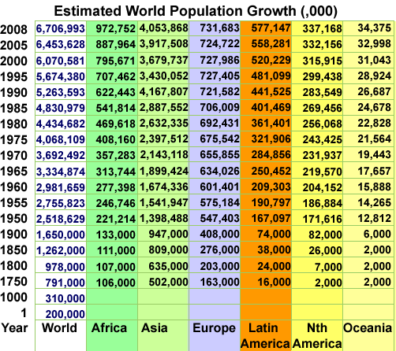

Use the table to graph population growth against time for the world and regions and compare.

Note: the population scale for the graph below is in billions.

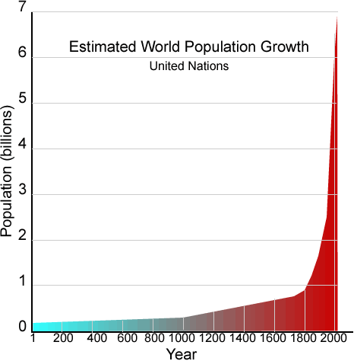

Earth's atmosphere, water, soils and other resources now support twice as many people as they did forty years ago. What are the consequences if world population continues to grow at the current rate?

Population is not the only factor influencing how many resources we use. Discuss this statement.

## 31. Ecological footprint

An 'ecological footprint' measures the area of land and sea we use, per person, to produce the goods and services we want, such as meat, cloth, vegetables, bricks, paper, plastic, metals, and to break down the waste we make. The larger the footprint the more natural resources we use such as soil and fresh water.

The world average is 2.2 hectares per person. In 2004 Australia's ecological footprint was 7.7 ha per person. It is estimated the global average needs to be 1.8 ha per person if we are to live sustainably.

**Sustainable development** can be defined as development that meets the needs of people without harming the environment and jeopardising the ability of future generations to meet their own needs. When resources are used faster than they are renewed, they are eventually used up. The Ecological Footprint is one method of measuring if we are living sustainably.

Draw your own cartoon to represent an ecological footprint.

How could Australians make their footprint smaller?

## 32. Country ecological footprints

Note: the footprint for Australia is different to that given on the previous page. Different methods for working out footprints give slightly different results and the figures are for different years. Source: Global Footprint Network 2003 data

|  |  |  |
| --- | --- | --- |
|  | **Millions of  people** | **Footprint Size**  hectares per person |
| **World** | 6,301.5 | **2.2** |
|  |  |  |
| **High income countries** | 955.6 | **6.4** |
| **Middle income countries** | 3,011.7 | **1.9** |
| **Low income countries** | 2,303.1 | **0.8** |
|  |  |  |
| **Africa** | **846.8** | **1.1** |
| Algeria | 31.8 | 1.6 |
| Angola | 13.6 | 1.0 |
| Benin | 6.7 | 0.8 |
| Botswana | 1.8 | 1.6 |
| Burkina Faso | 13.0 | 1.0 |
| Burundi | 6.8 | 0.7 |
| Cameroon | 16.0 | 0.8 |
| Central African Rep | 3.9 | 0.9 |
| Chad | 8.6 | 1.0 |
| Congo | 3.7 | 0.6 |
| Congo Dem Rep | 52.8 | 0.6 |
| Côte d'Ivoire | 16.6 | 0.7 |
| Egypt | 71.9 | 1.4 |
| Eritrea | 4.1 | 0.7 |
| Ethiopia | 70.7 | 0.8 |
| Gabon | 1.3 | 1.4 |
| Gambia | 1.4 | 1.4 |
| Ghana | 20.9 | 1.0 |
| Guinea | 8.5 | 0.9 |
| Guinea-Bissau | 1.5 | 0.7 |
| Kenya | 32.0 | 0.8 |
| Lesotho | 1.8 | 0.8 |
| Liberia | 3.4 | 0.7 |
| Libya | 5.6 | 3.4 |
| Madagascar | 17.4 | 0.7 |
| Malawi | 12.1 | 0.6 |
| Mali | 13.0 | 0.8 |
| Mauritania | 2.9 | 1.3 |
| Mauritius | 1.2 | 1.9 |
| Morocco | 30.6 | 0.9 |
| Mozambique | 18.9 | 0.6 |
| Namibia | 2.0 | 1.1 |
| Niger | 12.0 | 1.1 |
| Nigeria | 124.0 | 1.2 |
| Rwanda | 8.4 | 0.7 |
| Senegal | 10.1 | 1.2 |
| Sierra Leone | 5.0 | 0.7 |
| Somalia | 9.9 | 0.4 |
| South Africa | 45.0 | 2.3 |
| Sudan | 33.6 | 1.0 |
| Swaziland | 1.1 | 1.1 |
| Tanzania | 37.0 | 0.7 |
| Togo | 4.9 | 0.9 |
| Tunisia | 9.8 | 1.5 |
| Uganda | 25.8 | 1.1 |
| Zambia | 10.8 | 0.6 |
| Zimbabwe | 12.9 | 0.9 |
|  |  |  |
| **Asia-Pacific** | **3,489.4** | **1.3** |
| Australia | 19.7 | 6.6 |
| Bangladesh | 146.7 | 0.5 |
| Cambodia | 14.1 | 0.7 |
| China | 1,311.7 | 1.6 |
| India | 1,065.5 | 0.8 |
| Indonesia | 219.9 | 1.1 |
| Japan | 127.7 | 4.4 |
| Korea DPRP | 22.7 | 1.4 |
| Korea Republic | 47.7 | 4.1 |
| Laos | 5.7 | 0.9 |
| Malaysia | 24.4 | 2.2 |
| Mongolia | 2.6 | 3.1 |
| Myanmar | 49.5 | 0.9 |
| Nepal | 25.2 | 0.7 |
| New Zealand | 3.9 | 5.9 |
| Pakistan | 153.6 | 0.6 |
| Papua New Guinea | 5.7 | 2.4 |
| Philippines | 80.0 | 1.1 |
| Sri Lanka | 19.1 | 1.0 |
| Thailand | 62.8 | 1.4 |
| Vietnam | 81.4 | 0.9 |
|  |  |  |

|  |  |  |
| --- | --- | --- |
| **Latin America** | **535.2** | **2.0** |
| Argentina | 38.4 | 2.3 |
| Bolivia | 8.8 | 1.3 |
| Brazil | 178.5 | 2.1 |
| Chile | 15.8 | 2.3 |
| Colombia | 44.2 | 1.3 |
| Costa Rica | 4.2 | 2.0 |
| Cuba | 11.3 | 1.5 |
| Dominican Republic | 8.7 | 1.6 |
| Ecuador | 13.0 | 1.5 |
| El Salvador | 6.5 | 1.4 |
| Guatemala | 12.3 | 1.3 |
| Haiti | 8.3 | 0.6 |
| Honduras | 6.9 | 1.3 |
| Jamaica | 2.7 | 1.7 |
| Mexico | 103.5 | 2.6 |
| Nicaragua | 5.5 | 1.2 |
| Panama | 3.1 | 1.9 |
| Paraguay | 5.9 | 1.6 |
| Peru | 27.2 | 0.9 |
| Trinidad and Tobago | 1.3 | 3.1 |
| Uruguay | 3.4 | 1.9 |
| Venezuela | 25.7 | 2.2 |
|  |  |  |
| **Middle East and Central Asia** | **346.8** | **2.2** |
| Afghanistan | 23.9 | 0.1 |
| Armenia | 3.1 | 1.1 |
| Azerbaijan | 8.4 | 1.7 |
| Georgia | 5.1 | 0.8 |
| Iran | 68.9 | 2.4 |
| Iraq | 25.2 | 0.9 |
| Israel | 6.4 | 4.6 |
| Jordan | 5.5 | 1.8 |
| Kazakhstan | 15.4 | 4.0 |
| Kuwait | 2.5 | 7.3 |
| Kyrgyzstan | 5.1 | 1.3 |
| Lebanon | 3.7 | 2.9 |
| Saudi Arabia | 24.2 | 4.6 |
| Syria | 17.8 | 1.7 |
| Tajikistan | 6.2 | 0.6 |
| Turkey | 71.3 | 2.1 |
| Turkmenistan | 4.9 | 3.5 |
| United Arab Emirates | 3.0 | 11.9 |
| Uzbekistan | 26.1 | 1.8 |
| Yemen | 20.0 | 0.8 |
|  |  |  |
| **North America** | **325.6** | **9.4** |
| Canada | 31.5 | 7.6 |
| United States of America | 294.0 | 9.6 |
|  |  |  |
| **European Union (EU25)** | **454.4** | **4.8** |
| Austria | 8.1 | 4.9 |
| Belgium & Luxembourg | 10.8 | 5.6 |
| Czech Republic | 10.2 | 4.9 |
| Denmark | 5.4 | 5.8 |
| Estonia | 1.3 | 6.5 |
| Finland | 5.2 | 7.6 |
| France | 60.1 | 5.6 |
| Germany | 82.5 | 4.5 |
| Greece | 11.0 | 5.0 |
| Hungary | 9.9 | 3.5 |
| Ireland | 4.0 | 5.0 |
| Italy | 57.4 | 4.2 |
| Latvia | 2.3 | 2.6 |
| Lithuania | 3.4 | 4.4 |
| Netherlands | 16.1 | 4.4 |
| Poland | 38.6 | 3.3 |
| Portugal | 10.1 | 4.2 |
| Slovakia | 5.4 | 3.2 |
| Slovenia | 2.0 | 3.4 |
| Spain | 41.1 | 5.4 |
| Sweden | 8.9 | 6.1 |
| United Kingdom | 59.5 | 5.6 |
|  |  |  |
| **Rest of Europe** | **272.2** | **3.8** |
| Albania | 3.2 | 1.4 |
| Belarus | 9.9 | 3.3 |
| Bosnia Herzegovina | 4.2 | 2.3 |
| Bulgaria | 7.9 | 3.1 |
| Croatia | 4.4 | 2.9 |
| Macedonia | 2.1 | 2.3 |
| Moldova Republic | 4.3 | 1.3 |
| Norway | 4.5 | 5.8 |
| Romania | 22.3 | 2.4 |
| Russia | 143.2 | 4.4 |
| Serbia and Montenegro | 10.5 | 2.3 |
| Switzerland | 7.2 | 5.1 |
| Ukraine | 48.5 | 3.2 |

Name the 10 countries with the largest footprint in order.

Name the 10 countries with the smallest footprints.

Which country do you think has the biggest impact on the environment when you consider both footprint size and population size?

Which region has the biggest impact taking into account both footprint size and population size?

Mark on a world map the average footprint size for the different regions.

**Quiz**

Which country has the largest footprint?

## 33. Who left the lights on?

The world at night is not all dark. Photos from space show where the lights are turned on. This is a good indicator of regional energy consumption.

The satellite image may be used to indicate which countries are rich and which are poor. Give reasons for and against this statement.

Photo: courtesy NASA

[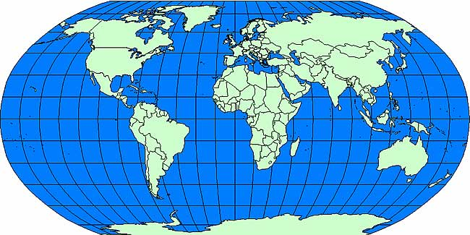](http://www.reec.nsw.edu.au/geo/climate/page/clch33.htm)

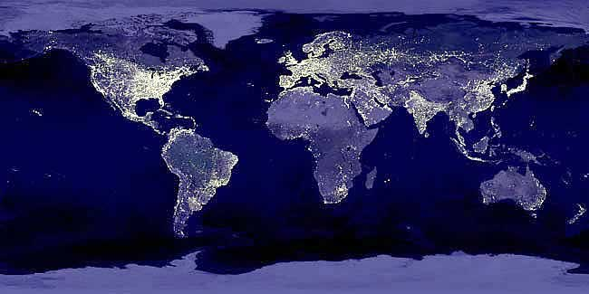

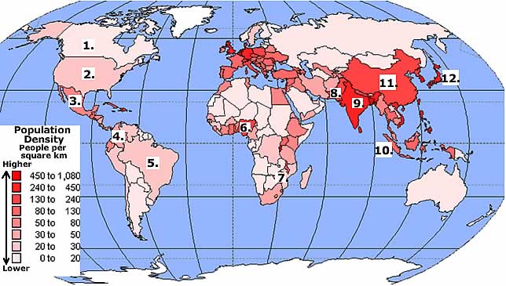

Name the countries numbered 1 to 12.

Which countries have the most people per area of land?

Do the countries with the most people per area have the most lights on at night?

Give other reasons why countries with few people per area have more lights on?

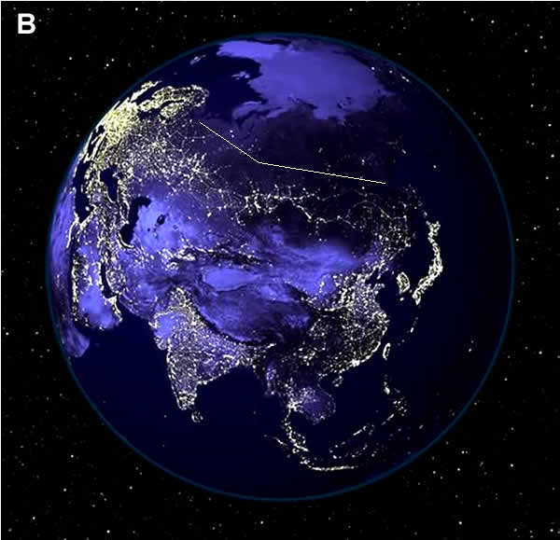

Image B: Name the major continent in the image.

There is a line of lights across Asia below the straight line. Explain this line of lights.

Name the area above India with few lights.

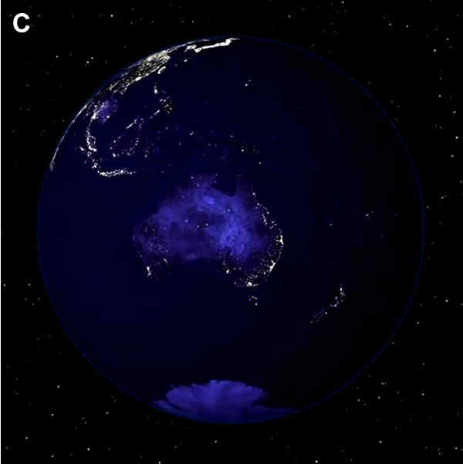

Image C: Explain why Australia has so few lights on. Are we really good at saving energy and turn the lights off?

Name the places which have high concentrations of lights on.

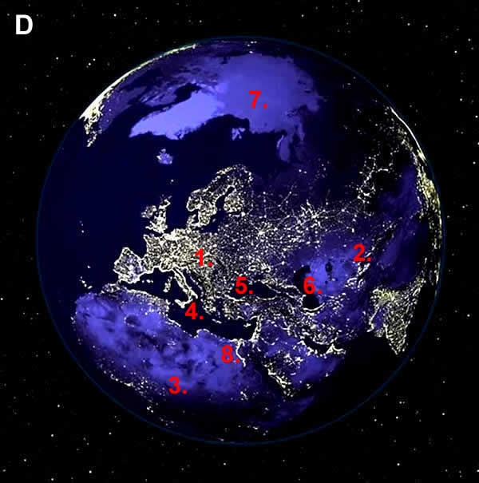

Image D: Name the three continents numbered 1,2,3

Name the three seas numbered 4,5,6

Name the light blue area toward the top with no lights numbered 7.

Explain the curious line of light numbered 8.

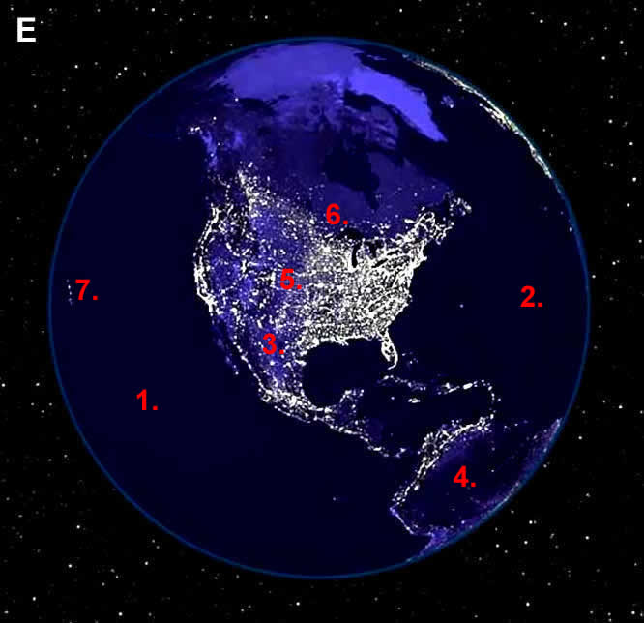

Image E: Name the oceans numbered 1 and 2.

Name the continents numbered 3 and 4.

Name the countries numbered 5 and 6.

Why are there bright lights at number 7?

What is the environmental cost to the planet of having all of these lights turned on? Check at home tonight. Can you turn some off?

## 34. Planes and global dimming

The amount of sunlight reaching the Earth's surface has decreased over the last 30 years counterbalancing some of the global warming.

Global dimming is caused by:

* Air pollution such as soot which has increased the reflectivity of clouds.
* Jet aircraft contrails or vapour trails.

Fine air pollution particles form the nucleus of cloud droplets and more, finer droplets are forming which reflect sunlight.

**Quiz**

Decreased amounts of sunlight reaching the Earth's surface because of pollution is called?

## 35. Electricity consumption

Electricity consumption is one indicator of resource use, production of greenhouse gases and the size of the ecological footprint of a country. The graph below shows electricity consumption of selected countries. The first five countries are in rank order from 1 to 5, the others are a random selection.

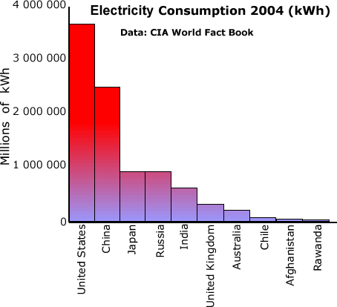

"In 2006, China's power generating capacity increased by 105,000 megawatts to 622,000 megawatts, adding in one year, more than twice Australia's total capacity." Australian newspaper 28 April 2007.

**CIA World Fact Book rank order of world electricity consumption**

|  |  |  |  |
| --- | --- | --- | --- |
| **Rank** | **Country** | **Electricity - consumption  (kWh)** | **Date of Information** |
| 1 | **World** | 16,330,000,000,000 | 2004 est. |
| 2 | **United States** | 3,717,000,000,000 | 2004 |
| 3 | **European Union** | 2,822,000,000,000 | 2004 est. |
| 4 | **China** | 2,494,000,000,000 | 2005 |
| 5 | **Japan** | 946,300,000,000 | 2005 |
| 6 | **Russia** | 940,000,000,000 | 2005 |
| 7 | **India** | 587,900,000,000 | 2004 |
| 8 | **Germany** | 524,600,000,000 | 2004 |
| 9 | **Canada** | 522,400,000,000 | 2004 |
| 10 | **France** | 482,400,000,000 | 2005 |
| 11 | **Brazil** | 415,900,000,000 | 2005 |
| 12 | **United Kingdom** | 345,200,000,000 | 2004 |
| 13 | **Korea, South** | 321,000,000,000 | 2004 |
| 14 | **Italy** | 303,800,000,000 | 2004 |
| 15 | **Spain** | 241,800,000,000 | 2004 |
| 16 | **Mexico** | 224,600,000,000 | 2004 |
| 17 | **Australia** | 209,500,000,000 | 2004 |
| 18 | **South Africa** | 207,000,000,000 | 2004 |
| 19 | **Ukraine** | 181,900,000,000 | 2006 |
| 20 | **Taiwan** | 175,300,000,000 | 2005 |
| 21 | **Iran** | 145,100,000,000 | 2004 |
| 22 | **Saudi Arabia** | 144,400,000,000 | 2004 |
| 23 | **Turkey** | 140,300,000,000 | 2005 |
| 24 | **Sweden** | 137,800,000,000 | 2004 |
| 25 | **Poland** | 124,100,000,000 | 2004 |
| 26 | **Thailand** | 116,200,000,000 | 2004 |
| 27 | **Norway** | 112,800,000,000 | 2004 |
| 28 | **Indonesia** | 107,700,000,000 | 2005 est. |
| 29 | **Netherlands** | 102,400,000,000 | 2004 |
| 30 | **Argentina** | 90,930,000,000 | 2004 |
| 31 | **Venezuela** | 86,520,000,000 | 2004 |
| 32 | **Egypt** | 84,490,000,000 | 2004 |
| 33 | **Belgium** | 82,410,000,000 | 2004 |
| 34 | **Finland** | 80,790,000,000 | 2004 |
| 35 | **Pakistan** | 74,620,000,000 | 2004 |
| 36 | **Malaysia** | 72,710,000,000 | 2004 |
| 37 | **Austria** | 65,200,000,000 | 2005 est. |
| 38 | **Kazakhstan** | 59,200,000,000 | 2006 est. |
| 39 | **Czech Republic** | 58,800,000,000 | 2004 |
| 40 | **Switzerland** | 56,930,000,000 | 2004 |
| 41 | **Greece** | 53,500,000,000 | 2005 est. |
| 42 | **Philippines** | 49,750,000,000 | 2005 |
| 43 | **Romania** | 49,620,000,000 | 2004 |
| 44 | **Chile** | 48,520,000,000 | 2006 |
| 45 | **Uzbekistan** | 47,000,000,000 | 2006 est. |
| 46 | **United Arab Emirates** | 46,050,000,000 | 2004 |
| 47 | **Portugal** | 46,050,000,000 | 2004 |
| 48 | **Hong Kong** | 44,550,000,000 | 2005 |
| 49 | **Colombia** | 42,010,000,000 | 2004 |
| 50 | **Israel** | 41,380,000,000 | 2004 |
| 51 | **New Zealand** | 38,220,000,000 | 2004 |
| 52 | **Kuwait** | 37,540,000,000 | 2004 |
| 53 | **Bulgaria** | 37,400,000,000 | 2006 |
| 54 | **Vietnam** | 37,300,000,000 | 2004 |
| 55 | **Hungary** | 37,100,000,000 | 2004 |
| 56 | **Denmark** | 36,410,000,000 | 2006 |
| 57 | **Syria** | 34,000,000,000 | 2005 est. |
| 58 | **Iraq** | 33,300,000,000 | 2005 |
| 59 | **Belarus** | 31,050,000,000 | 2004 |
| 60 | **Singapore** | 30,350,000,000 | 2004 |
| 61 | **Slovakia** | 28,570,000,000 | 2005 |
| 62 | **Algeria** | 27,400,000,000 | 2004 est. |
| 63 | **Ireland** | 23,230,000,000 | 2004 |
| 64 | **Puerto Rico** | 22,450,000,000 | 2004 |
| 65 | **Peru** | 22,310,000,000 | 2004 |
| 66 | **Azerbaijan** | 20,570,000,000 | 2004 |
| 67 | **Korea, North** | 20,190,000,000 | 2004 |
| 68 | **Morocco** | 18,890,000,000 | 2004 |
| 69 | **Libya** | 18,080,000,000 | 2004 |
| 70 | **Nigeria** | 17,710,000,000 | 2004 |
| 71 | **Bangladesh** | 16,820,000,000 | 2004 |
| 72 | **Croatia** | 16,530,000,000 | 2004 |
| 73 | **Tajikistan** | 15,700,000,000 | 2004 |
| 74 | **Cuba** | 14,100,000,000 | 2004 |
| 75 | **Dominican Republic** | 13,960,000,000 | 2004 |
| 76 | **Slovenia** | 13,710,000,000 | 2006 |
| 77 | **Oman** | 13,330,000,000 | 2004 |
| 78 | **Ecuador** | 12,950,000,000 | 2004 |
| 79 | **Qatar** | 11,530,000,000 | 2004 |
| 80 | **Bosnia and Herzegovina** | 11,030,000,000 | 2004 |
| 81 | **Zimbabwe** | 11,000,000,000 | 2004 |
| 82 | **Tunisia** | 10,970,000,000 | 2004 |
| 83 | **Uruguay** | 9,939,000,000 | 2004 |
| 84 | **Mozambique** | 9,592,000,000 | 2004 |
| 85 | **Lebanon** | 9,529,000,000 | 2004 |
| 86 | **Lithuania** | 9,358,000,000 | 2004 |
| 87 | **Turkmenistan** | 9,030,000,000 | 2004 |
| 88 | **Macedonia** | 8,929,000,000 | 2006 |
| 89 | **Georgia** | 8,528,000,000 | 2004 |
| 90 | **Jordan** | 8,387,000,000 | 2004 |
| 91 | **Sri Lanka** | 8,170,000,000 | 2005 |
| 92 | **Iceland** | 7,881,000,000 | 2004 |
| 93 | **Costa Rica** | 7,574,000,000 | 2004 |
| 94 | **Bahrain** | 7,248,000,000 | 2004 |
| 95 | **Ghana** | 7,095,000,000 | 2004 |
| 96 | **Panama** | 6,888,000,000 | 2004 |
| 97 | **Estonia** | 6,846,000,000 | 2004 |
| 98 | **Kyrgyzstan** | 6,777,000,000 | 2004 |
| 99 | **Zambia** | 6,692,000,000 | 2004 |
| 100 | **Guatemala** | 6,625,000,000 | 2005 |

|  |  |  |  |
| --- | --- | --- | --- |
| 101 | **Jamaica** | 6,429,000,000 | 2004 |
| 102 | **Latvia** | 6,329,000,000 | 2004 |
| 103 | **Luxembourg** | 6,140,000,000 | 2005 est. |
| 104 | **Trinidad and Tobago** | 5,626,000,000 | 2004 |
| 105 | **Kenya** | 5,459,000,000 | 2004 |
| 106 | **Burma** | 5,325,000,000 | FY05/06 |
| 107 | **El Salvador** | 5,204,000,000 | 2006 |
| 108 | **Congo, Republic of the** | 5,127,000,000 | 2004 |
| 109 | **Honduras** | 4,824,000,000 | 2004 |
| 110 | **Armenia** | 4,374,000,000 | 2005 |
| 111 | **Moldova** | 4,203,000,000 | 2005 |
| 112 | **Bolivia** | 4,168,000,000 | 2004 |
| 113 | **Yemen** | 3,792,000,000 | 2004 est. |
| 114 | **Cyprus** | 3,651,000,000 | 2004 |
| 115 | **Cameroon** | 3,649,000,000 | 2004 |
| 116 | **Sudan** | 3,576,000,000 | 2004 |
| 117 | **Albania** | 3,530,000,000 | 2005 |
| 118 | **Laos** | 3,260,000,000 | 2004 |
| 119 | **Cote d'Ivoire** | 3,202,000,000 | 2004 |
| 120 | **Paraguay** | 3,133,000,000 | 2004 |
| 121 | **Papua New Guinea** | 3,123,000,000 | 2004 |
| 122 | **Mongolia** | 2,940,000,000 | 2006 |
| 123 | **Nicaragua** | 2,929,000,000 | 2006 |
| 124 | **Namibia** | 2,819,000,000 | 2004 |
| 125 | **Brunei** | 2,726,000,000 | 2005 est. |
| 126 | **Botswana** | 2,464,000,000 | 2004 |
| 127 | **Tanzania** | 2,383,000,000 | 2004 |
| 128 | **Macau** | 2,159,000,000 | 2005 |
| 129 | **Ethiopia** | 2,133,000,000 | 2004 |
| 130 | **Malta** | 2,130,000,000 | 2004 |
| 131 | **Angola** | 2,040,000,000 | 2004 |
| 132 | **Mauritius** | 1,960,000,000 | 2004 |
| 133 | **Nepal** | 1,960,000,000 | 2006 |
| 134 | **Bahamas, The** | 1,669,000,000 | 2004 |
| 135 | **Guam** | 1,641,000,000 | 2004 |
| 136 | **Uganda** | 1,596,000,000 | 2004 |
| 137 | **New Caledonia** | 1,558,000,000 | 2004 |
| 138 | **Gabon** | 1,435,000,000 | 2004 |
| 139 | **Suriname** | 1,403,000,000 | 2004 |
| 140 | **Senegal** | 1,351,000,000 | 2004 |
| 141 | **Malawi** | 1,202,000,000 | 2004 |
| 142 | **Swaziland** | 1,123,000,000 | 2005 |
| 143 | **Netherlands Antilles** | 934,700,000 | 2004 |
| 144 | **Togo** | 929,200,000 | 2004 |
| 145 | **Madagascar** | 915,100,000 | 2004 |
| 146 | **Virgin Islands** | 911,400,000 | 2004 |
| 147 | **Barbados** | 833,300,000 | 2004 |
| 148 | **Guinea** | 832,900,000 | 2006 |
| 149 | **Cyprus** | 797,900,000 | 2004 |
| 150 | **Afghanistan** | 782,900,000 | 2004 |
| 151 | **Guyana** | 761,500,000 | 2004 |
| 152 | **Fiji** | 759,800,000 | 2004 |
| 153 | **Aruba** | 716,100,000 | 2004 |
| 154 | **Congo, Dem. Republic of the** | 658,300,000 | 2004 |
| 155 | **Jersey** | 630,100,000 | 2004 est. |
| 156 | **Bermuda** | 616,700,000 | 2005 |
| 157 | **Benin** | 576,300,000 | 2004 |
| 158 | **French Polynesia** | 533,000,000 | 2005 |
| 159 | **Bhutan** | 526,500,000 | 2004 |
| 160 | **Haiti** | 498,600,000 | 2004 |
| 161 | **Niger** | 415,800,000 | 2004 |
| 162 | **Mali** | 381,300,000 | 2004 |
| 163 | **Cayman Islands** | 372,000,000 | 2004 |
| 164 | **Burkina Faso** | 372,000,000 | 2004 |
| 165 | **Liberia** | 302,300,000 | 2004 |
| 166 | **Greenland** | 274,400,000 | 2004 |
| 167 | **Faroe Islands** | 272,100,000 | 2004 |
| 168 | **Saint Lucia** | 269,700,000 | 2004 |
| 169 | **Eritrea** | 256,700,000 | 2004 |
| 170 | **Somalia** | 250,200,000 | 2004 |
| 171 | **Lesotho** | 244,500,000 | 2004 |
| 172 | **Sierra Leone** | 226,900,000 | 2004 |
| 173 | **Rwanda** | 196,500,000 | 2004 |
| 174 | **Seychelles** | 193,400,000 | 2004 |
| 175 | **Djibouti** | 186,000,000 | 2004 |
| 176 | **Micronesia, Federated States of** | 178,600,000 | 2002 |
| 177 | **Mauritania** | 164,300,000 | 2004 |
| 178 | **Belize** | 162,800,000 | 2004 |
| 179 | **Grenada** | 159,300,000 | 2004 |
| 180 | **Burundi** | 157,400,000 | 2004 |
| 181 | **Maldives** | 139,400,000 | 2004 |
| 182 | **Mayotte** | 139,200,000 | 2005 |
| 183 | **Gambia, The** | 134,900,000 | 2004 |
| 184 | **Gibraltar** | 122,000,000 | 2004 |
| 185 | **Cambodia** | 121,800,000 | 2004 |
| 186 | **American Samoa** | 119,000,000 | 2004 |
| 187 | **Saint Kitts and Nevis** | 116,300,000 | 2004 |
| 188 | **Saint Vincent and the Grenadines** | 106,000,000 | 2004 |
| 189 | **Central African Republic** | 101,400,000 | 2004 |
| 190 | **Samoa** | 100,500,000 | 2004 |
| 191 | **Antigua and Barbuda** | 97,650,000 | 2004 |
| 192 | **Chad** | 87,420,000 | 2004 |
| 193 | **Western Sahara** | 79,050,000 | 2004 |
| 194 | **Dominica** | 78,010,000 | 2004 |
| 195 | **Guinea-Bissau** | 53,960,000 | 2004 |
| 196 | **Solomon Islands** | 51,150,000 | 2004 |
| 197 | **Saint Pierre and Miquelon** | 46,500,000 | 2004 |
| 198 | **Cape Verde** | 40,920,000 | 2004 |
| 199 | **Vanuatu** | 39,990,000 | 2004 |
| 200 | **British Virgin Islands** | 39,060,000 | 2004 |
| 201 | **Tonga** | 38,130,000 | 2004 |
| 202 | **Nauru** | 27,900,000 | 2004 |
| 203 | **Cook Islands** | 26,040,000 | 2004 est. |
| 204 | **Equatorial Guinea** | 24,180,000 | 2004 |
| 205 | **Montenegro** | 18,600,000 | 2004 |
| 206 | **Comoros** | 17,670,000 | 2004 |
| 207 | **Sao Tome and Principe** | 16,740,000 | 2004 |
| 208 | **Falkland Islands (Islas Malvinas)** | 14,880,000 | 2004 |
| 209 | **Kiribati** | 12,090,000 | 2004 |
| 210 | **Saint Helena** | 6,510,000 | 2004 |
| 211 | **Turks and Caicos Islands** | 6,510,000 | 2004 |
| 212 | **Niue** | 2,790,000 | 2004 |
| 213 | **Montserrat** | 1,860,000 | 2003 |
| 214 | **Gaza Strip** | 230,000 | 2005 |

Graph the electricity consumption of the first 20 countries. Do not include the European Union since this is a group of countries which are also included individually.

Explain why the United States has such a large electricity consumption.

How much bigger was the USA consumption than third placed India and 15 placed Australia (ignoring places 1 and 2).

## 36. Coal Consumption

|  |  |  |  |  |  |  |  |  |  |  |  |
| --- | --- | --- | --- | --- | --- | --- | --- | --- | --- | --- | --- |
| World Coal Consumption, 1980-2004 (Million Short Tons) | | | | | | | | | | | |
| Year | Australia | China | Germany | India | Japan | North Korea | Russia | South Africa | United  Kingdom | United States | World |
| 1980 | 74 | 679 | 535 | 130 | 98 | 49 | — | 105 | 134 | 703 | 4,126 |
| 1981 | 75 | 680 | 544 | 140 | 106 | 51 | — | 116 | 130 | 733 | 4,199 |
| 1982 | 79 | 726 | 548 | 147 | 105 | 54 | — | 124 | 122 | 707 | 4,301 |
| 1983 | 78 | 768 | 549 | 160 | 100 | 56 | — | 127 | 123 | 737 | 4,420 |
| 1984 | 81 | 845 | 573 | 179 | 113 | 57 | — | 137 | 88 | 791 | 4,661 |
| 1985 | 86 | 921 | 579 | 193 | 119 | 60 | — | 142 | 116 | 818 | 4,898 |
| 1986 | 84 | 962 | 576 | 209 | 109 | 59 | — | 145 | 123 | 804 | 4,969 |
| 1987 | 93 | 1,027 | 565 | 209 | 111 | 57 | — | 148 | 129 | 837 | 5,116 |
| 1988 | 96 | 1,098 | 561 | 228 | 123 | 58 | — | 151 | 123 | 884 | 5,274 |
| 1989 | 104 | 1,113 | 553 | 239 | 123 | 57 | — | 140 | 126 | 895 | 5,277 |
| 1990 | 104 | 1,124 | 528 | 256 | 126 | 54 | — | 139 | 119 | 904 | 5,269 |
| 1991 | 108 | 1,165 | 408 | 271 | 129 | 52 | — | 144 | 118 | 899 | 5,010 |
| 1992 | 111 | 1,199 | 362 | 283 | 125 | 46 | 326 | 147 | 111 | 908 | R 4,934 |
| 1993 | 109 | 1,276 | 335 | 294 | 127 | 42 | 313 | 146 | 96 | 944 | R 4,953 |
| 1994 | 110 | 1,390 | 314 | 314 | 137 | 39 | 284 | 161 | 91 | 951 | 5,016 |
| 1995 | 112 | 1,495 | 298 | 332 | 142 | 36 | 270 | 162 | 79 | 962 | 5,116 |
| 1996 | 120 | 1,509 | 296 | 332 | 142 | 31 | 278 | 164 | 77 | 1,006 | R 5,175 |
| 1997 | 127 | 1,450 | 280 | 359 | 151 | 30 | 253 | 172 | 69 | 1,030 | R 5,133 |
| 1998 | 138 | 1,392 | 269 | 363 | R 143 | 27 | 238 | 161 | 68 | 1,037 | R 5,039 |
| 1999 | 141 | 1,343 | 258 | 375 | R 155 | 31 | 247 | R 167 | 61 | 1,039 | R 4,969 |
| 2000 | 141 | 1,282 | 270 | 406 | R 169 | 33 | 253 | R 174 | 64 | 1,084 | R 5,100 |
| 2001 | 141 | 1,357 | 278 | R 417 | R 169 | 34 | 242 | R 178 | 70 | 1,060 | R 5,177 |
| 2002 | 145 | 1,413 | R 279 | R 434 | R 173 | 32 | 240 | R 170 | 64 | 1,066 | R 5,263 |
| 2003 | R 143 | R 1,720 | R 277 | R 449 | R 185 | R 33 | R 243 | R 187 | 69 | 1,095 | R 5,698 |
| 2004 P | 150 | 2,062 | 280 | 478 | 204 | 33 | 258 | 195 | 67 | 1,107 | 6,098 |
| |  | | --- | | Web Page: For related information, see http://www.eia.doe.gov/international. | | R=Revised. P=Preliminary. | | Sources: Energy Information Administration,  "International Energy Annual 2004" (May-July 2006) | | | | | | | | | | | | |

Give reasons why coal consumption could decrease in a country apart from them becoming very environmentally conscious and turning the lights off.

## 37. Gross Domestic Product (GDP)

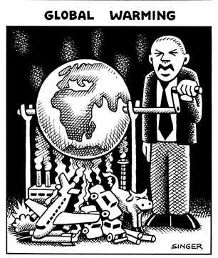Gross Domestic Product per capita is the value of all final goods and services produced within a country in a year divided by the population. It is an indication of how wealthy a country is e.g. whether it is developed, developing or underdeveloped.

GDP is also an indicator of the impact a country has on the environment or its ecological footprint. The cartoon by Singer shows GDP in the value of goods and services produced but the real cost is the environmental cost to the Earth's environment and global warming caused when making the goods.

China's economy is growing rapidly, more electricity is needed to make the additional goods and on average, one new coal-fired power station is coming into operation every five days. China was an exporter of coal, it is now an importer. Cartoon courtesy Andy Singer

Explain why GDP is also an indicator of a country's impact on the environment.

Explain the cartoon in terms of GDP, goods and services and environmental cost.

The map below shows world GDP per capita

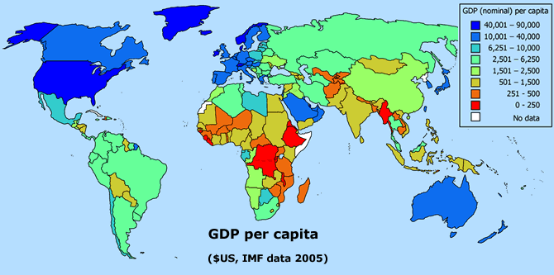  
Map source: Wikipedia

Name 10 countries with a GDP per capita above $10,000 per capita.

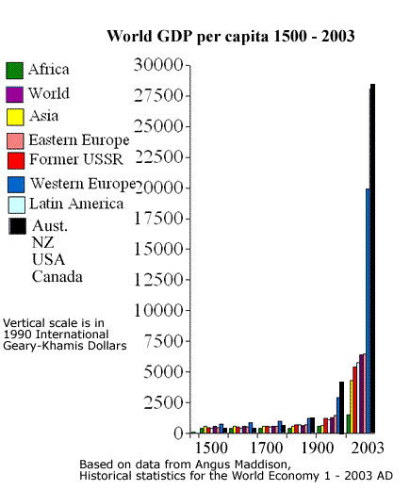Name 10 countries with a GDP per capita of $251 or less.

The GDP figures for the graph on the right can be used as an indicator of the change in our ecological footprint over time.

Geary-Khamis Dollars are a way of comparing the purchasing power in different countries.

Describe how GDP for Western Europe and the group of countries including Australia has changed since 1500. Give possible reasons for this.

**QUIZ**

The value of all goods and services produced by a country is called?

## 38. Gross Domestic Product (GDP) in rank order

Source: Wikipedia from International Monetary Fund, World Economic Outlook Database, September 2006

|  |  |  |
| --- | --- | --- |
| **RANK** | **COUNTRY** | **GDP $US** |
| 1 | Luxembourg | 80,288 |
| 2 | Norway | 64,193 |
| 3 | Iceland | 52,764 |
| 4 | Switzerland | 50,532 |
| 5 | Ireland | 48,604 |
| 6 | Denmark | 47,984 |
| 7 | Qatar | 43,110 |
| 8 | United States | 42,000 |
| 9 | Sweden | 39,694 |
| 10 | Netherlands | 38,618 |
| 11 | Finland | 37,504 |
| 12 | Austria | 37,117 |
| 13 | United Kingdom | 37,023 |
| 14 | Japan | 35,757 |
| 15 | Belgium | 35,712 |
| 16 | Canada | 35,133 |
| 17 | Australia | 34,740 |
| 18 | France | 33,918 |
| 19 | Germany | 33,854 |
| 20 | Italy | 30,200 |
| 21 | United Arab Emirates | 27,700 |
| 22 | Spain | 27,226 |
| 23 | Singapore | 26,836 |
| 24 | New Zealand | 26,464 |
| 25 | Kuwait | 26,020 |
| 26 | Brunei | 25,754 |
| 27 | Hong Kong | 25,493 |
| 28 | Greece | 20,327 |
| 29 | Cyprus | 20,214 |
| 30 | Israel | 19,248 |
| 31 | Bahrain | 18,403 |
| 32 | The Bahamas | 18,062 |
| 33 | Portugal | 17,456 |
| 34 | Netherlands | 17,270 |
| 35 | Slovenia | 16,986 |
| 36 | South Korea | 16,308 |
| 37 | Republic of China (Taiwan) | 15,203 |
| 38 | Malta | 13,803 |
| 39 | Saudi Arabia | 13,410 |
| 40 | Oman | 12,664 |
| 41 | Trinidad and Tobago | 12,625 |
| 42 | Czech Republic | 12,152 |
| 43 | Barbados | 11,088 |
| 44 | Saint Kitts and Nevis | 10,895 |
| 45 | Hungary | 10,814 |
| 46 | Antigua and Barbuda | 10,727 |
| 47 | Estonia | 9,727 |
| 48 | Slovakia | 8,775 |
| 49 | Croatia | 8,675 |
| 50 | Seychelles | 8,556 |
| 51 | Poland | 7,946 |
| 52 | Lithuania | 7,446 |
| 53 | Mexico | 7,298 |
| 54 | Chile | 7,124 |
| 55 | Latvia | 6,862 |
| 56 | Libya | 6,696 |
| 57 | Botswana | 6,439 |
| 58 | Gabon | 6,397 |
| 59 | Equatorial Guinea | 6,205 |
| 60 | Lebanon | 6,034 |
| 61 | Russia | 5,349 |
| 62 | Uruguay | 5,274 |
| 63 | South Africa | 5,106 |
| 64 | Turkey | 5,062 |
| 65 | Malaysia | 5,042 |
| 66 | Mauritius | 5,029 |
| 67 | Venezuela | 5,026 |
| 68 | Saint Lucia | 4,963 |
| 69 | Argentina | 4,799 |
| 70 | Panama | 4,794 |
| 71 | Grenada | 4,670 |
| 72 | Costa Rica | 4,620 |
| 73 | Romania | 4,539 |
| 74 | Brazil | 4,320 |
| 75 | Belize | 4,146 |
| 76 | Saint Vincent and the Grenadines | 3,950 |
| 77 | Dominica | 3,947 |
| 78 | Kazakhstan | 3,717 |
| 79 | Jamaica | 3,657 |
| 80 | Bulgaria | 3,459 |
| 81 | Dominican Republic | 3,411 |
| 82 | Turkmenistan | 3,406 |
| 83 | Fiji | 3,349 |
| 84 | Algeria | 3,086 |
| 85 | Belarus | 3,031 |
| 86 | Namibia | 3,022 |
| 87 | Serbia | 2,880 |
| 88 | Peru | 2,841 |
| 89 | Tunisia | 2,829 |
| 90 | Republic of Macedonia | 2,810 |
| 91 | Iran | 2,767 |
| 92 | Ecuador | 2,761 |
| 93 | Albania | 2,673 |
| 94 | Thailand | 2,659 |
| 95 | Colombia | 2,656 |
| 96 | Suriname | 2,637 |
| 97 | El Salvador | 2,468 |
| 98 | Bosnia and Herzegovina | 2,384 |
| 99 | Maldives | 2,350 |
| 100 | Swaziland | 2,336 |
| 101 | Jordan | 2,317 |
| 102 | Angola | 2,129 |
| 103 | Tonga | 2,106 |
| 104 | Cape Verde | 2,066 |
| 105 | Guatemala | 1,995 |
| 106 | Samoa | 1,832 |
| 107 | Republic of the Congo | 1,785 |
| 108 | Ukraine | 1,766 |
| 109 | Morocco | 1,713 |
| 110 | People's Republic of China | 1,709 |
| 111 | Iraq | 1,700 |
| 112 | Vanuatu | 1,530 |
| 113 | Azerbaijan | 1,493 |
| 114 | Georgia | 1,480 |
| 115 | Syrian Arab Republic | 1,464 |
| 116 | Paraguay | 1,288 |
| 117 | Indonesia | 1,283 |
| 118 | Egypt | 1,265 |
| 119 | Sri Lanka | 1,200 |
| 120 | Philippines | 1,168 |
| 121 | Honduras | 1,148 |
| 122 | Armenia | 1,140 |
| 123 | Bhutan | 1,126 |
| 124 | Guyana | 1,039 |
| 125 | Bolivia | 993 |
| 126 | Djibouti | 973 |
| 127 | Cameroon | 952 |
| 128 | Côte d'Ivoire | 900 |
| 129 | Moldova | 861 |
| 130 | Nicaragua | 850 |
| 131 | Sudan | 820 |
| 132 | Senegal | 738 |
| 133 | Mongolia | 736 |
| 134 | Pakistan | 728 |
| 135 | India | 705 |
| 136 | Nigeria | 678 |
| 137 | Kiribati | 672 |
| 138 | Mauritania | 663 |
| 139 | Papua New Guinea | 662 |
| 140 | Chad | 654 |
| 141 | Zambia | 627 |
| 142 | Lesotho | 621 |
| 143 | Vietnam | 618 |
| 144 | Comoros | 615 |
| 145 | Solomon Islands | 611 |
| 146 | Benin | 592 |
| 147 | Yemen | 586 |
| 148 | Kenya | 560 |
| 149 | Ghana | 512 |
| 150 | Laos | 485 |
| 151 | Haiti | 478 |
| 152 | Kyrgyz Republic | 473 |
| 153 | Uzbekistan | 444 |
| 154 | Mali | 432 |
| 155 | Burkina Faso | 430 |
| 156 | Cambodia | 430 |
| 157 | São Tomé and Príncipe | 430 |
| 158 | Bangladesh | 400 |
| 159 | Zimbabwe | 383 |
| 160 | Togo | 377 |
| 161 | Tajikistan | 364 |
| 162 | Guinea | 355 |
| 163 | Timor-Leste | 352 |
| 164 | Tanzania | 336 |
| 165 | Central African Republic | 335 |
| 166 | Mozambique | 331 |
| 167 | Nepal | 322 |
| 168 | The Gambia | 306 |
| 169 | Uganda | 303 |
| 170 | Afghanistan | 300 |
| 171 | Madagascar | 282 |
| 172 | Niger | 274 |
| 173 | Rwanda | 242 |
| 174 | Sierra Leone | 223 |
| 175 | Myanmar | 219 |
| 176 | Eritrea | 209 |
| 177 | Guinea-Bissau | 190 |
| 178 | Liberia | 161 |
| 179 | Malawi | 161 |
| 180 | Ethiopia | 153 |
| 181 | Democratic Republic of the Congo | 119 |
| 182 | Burundi | 107 |

## 39. Global fairness

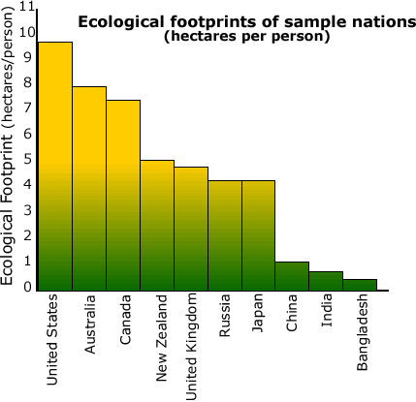In a fair world all people would have the same standard of living. Is it fair that wealthy countries use more resources and emit more air pollution per person than poor? Ecological footprints can be used to indicate global fairness.

Australia’s ecological footprint is three times greater than the world average. If poorer nations used as many resources per person as we do, the world would quickly become ecologically unsustainable.

The Kyoto Protocol attempts global fairness by requiring developed countries with large footprints to reduce greenhouse gas emissions while exempting poorer countries.

**Environmental cost**  
Cost: the price paid or the sacrifice made to obtain something. If you pay one dollar for something, your sacrifice is the dollar.

Environmental cost: we usually think of the price we pay for something in terms of money but it can be other things we value. The environmental cost or sacrifice we make to have electricity includes the coal used in the power station and the air pollution from the burning of the coal.

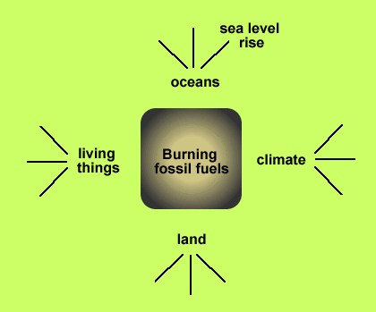Look at the diagram. What are some of the environmental costs, the things we are sacrificing by burning fossil fuels such as coal and petrol for electricity and cars?

Explain how the Kyoto Protocol attempts to be fair to poorer countries.

## 40. Kyoto protocol

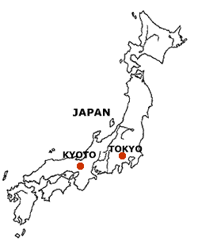Kyoto is the former imperial capital of Japan and has a population close to 1.5 million. The Golden Pavilion below is one of the best known temples in Japan.

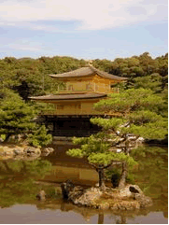  
 Image: Wikipedia

Kyoto happened to be the place selected to hold a major international meeting regarding climate change.

The Kyoto Protocol is an agreement under which industrialised countries will reduce their collective emissions of greenhouse gases by 5.2% compared to the year 1990.

The goal is to lower overall emissions of six greenhouse gases: carbon dioxide, methane, nitrous oxide, sulphur hexafluoride, HFC's, and PFC's calculated as an average over the five-year period of 2008-12.

National limitations range from 8% reductions for the European Union to 7% for the US, 6% for Japan, 0% for Russia, and permitted increases of 8% for Australia and 10% for Iceland.

The United Nations Framework Convention on Climate Change agreed that:

1. The largest share of historical and current global emissions of greenhouse gases has originated in developed countries;
2. Per capita emissions in developing countries are still relatively low;
3. The share of global emissions originating in developing countries will grow as they develop.

China, India and other developing countries were exempt from reducing greenhouse gas emissions because they were not the main contributors, the wealthy developed countries were.

Critics of Kyoto argue that China, India and other developing countries will soon be the top contributors to greenhouse gases because they are developing rapidly and have large populations. Without Kyoto restrictions on these countries, industries in developed countries will relocate to these countries and there would be no reduction in carbon emissions.

Australia signed the Kyoto Protocol in 1997. By signing the Protocol, countries agreed to continue with the treaty-making process, but did not agree to be bound by the Protocol by ratifying it. See map below.

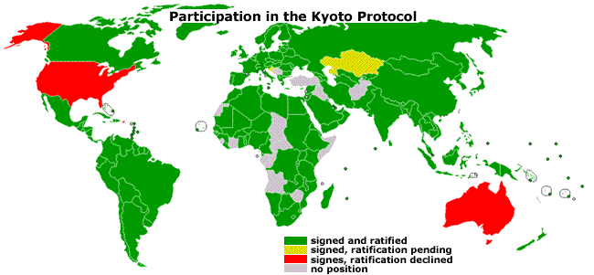

On 3rd December 2007 the first official act of the new Labour government was to sign the ratification of the Kyoto Protocol. We then became a green country on the map.

Australian Kyoto Protocol obligations include:

* Setting a target to reduce emissions by 60 per cent on 2000 levels by 2050.
* Establishing a national emissions trading scheme by 2010.
* Setting a 20 per cent target for renewable energy by 2020 to dramatically expand the use of renewable energy sources such as solar and wind.

Australia’s target is to limit the growth in emissions to an 8 per cent increase above 1990 levels over the period from 2008-2012.

Describe the goal of the Kyoto Protocol

Explain why developing countries were exempt from reducing emissions.

Describe Australia's obligations under the protocol.

Do you think developing countries should also reduce their emissions? Give reasons for your opinion.

## 41. Carbon tax and Emissions Trading Scheme 2011

The following is based on the Carbon Tax policy announcement in July 2011.

Climate change is a by-product of industrialisation. Environmental damage is caused by greenhouse gas emissions which are predominantly carbon-based. The emissions constitute carbon pollution yet those who generate the pollution are not held accountable for the costs they impose on us all.

The resulting environmental degradation is not currently reflected in the costs of business or the price of goods and services. Because firms face no cost from increasing emissions, the level of emissions is too high. Unless businesses and individuals over time take responsibility for their production and consumption decisions, the level of carbon pollution will remain at unsustainable levels.

Emissions trading schemes are simply a mechanism to achieve an objective. That objective is to reduce carbon pollution, and to do so efficiently, by putting a cap on emissions.

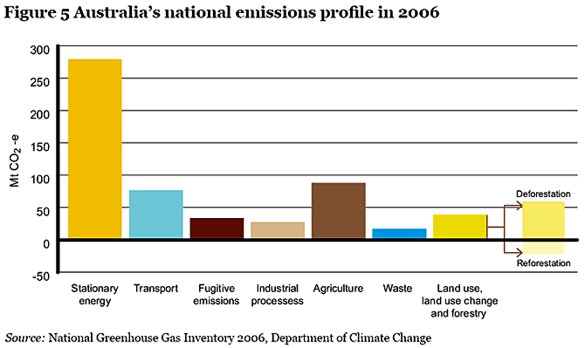

The bulk of Australia's emissions come from electricity generation (stationary energy), transport and agriculture. In 2006, Australia's net greenhouse gas emissions using the Kyoto accounting provisions were 576.0 million tonnes of   
CO2 equivalent.

The energy sector was the largest source of greenhouse gas emissions, contributing 69.6% (400.9Mt CO2-e) of emissions. This proportion is less than in many countries, due to the relatively large contribution from the agriculture (15.6%) and land use, land-use change and forestry sectors (6.9%) to   
Australia’s greenhouse inventory. The industrial processes (4.9%) and waste (2.9%) sectors make smaller contributions to this overall national inventory.

**Mechanics of the Carbon Tax Scheme announced July 2011**

The 500 highest carbon dioxide polluting businesses in Australia will have to buy one permit for each tonne of carbon dioxide they create. The initial cost will be $23 for each permit. This system has been called a Carbon Tax.

The price of permits will rise until 2015 when the permits can be traded, bought and sold. This market driven system is called the Emissions Trading Scheme. The government will set emissions caps for each industry, determining the number of permits that are issued each year thus controlling some of the nation's carbon dioxide emissions.

The Carbon Tax and ETS are designed to change energy use and encourage investment in clean energy sources such as wind, solar and gas. The aim is to slow climate change by reducing our total carbon emissions by 5%, 160 million tonnes, by 2020 and 80% by 2050.

An independent regulator will be created to issue permits, oversee the market, collect money and monitor emissions.

Businesses will pass on the cost to consumers via higher prices.

From July 2015, the price of permits will not set by the Government; rather, it emerges from the market. If a firm can reduce carbon pollution more cheaply than the prevailing market price of permits, it will choose to reduce carbon pollution rather than buy permits. Therefore, this kind of scheme provides a strong incentive for participants to reduce their own carbon pollution. By making this business decision around whether to reduce carbon pollution or trade in permits, firms operate within the overall cap at least cost.

Explain why the government has chosen its Carbon Tax scheme with the trading of carbon credits as a way to solve the climate change problem.

Outline the main parts of the Carbon Tax Scheme.

Explain how the price of permits is set.

## 42. Power Generation

Most electricity in Australia is made by burning coal in power stations. Coal is mostly carbon (C) so when it is burnt we produce a lot of carbon dioxide gas (CO2). Power stations are also inefficient, for every 100 tonnes of coal they burn we only manage to convert 40 tonnes into electricity, the rest is wasted as heat.

|  |  |
| --- | --- |
| http://www.reec.nsw.edu.au/geo/climate/image/clch42c.jpg  Wallerawang Power Station near Lithgow is a typical thermal (coal fired) power station producing electricity. Photo courtesy CSIRO | http://www.reec.nsw.edu.au/geo/climate/image/clch42a.gifEnergy source of Australia's electricity.  Name the fossil fuels in the graph above.  What percentage of our electricity is produced from fossil fuels? |

Can you name the main parts of the power station shown in the photo? The diagram below might help but it is missing some things.



Coal is mostly carbon (C) so when it is burnt we produce a lot of carbon dioxide gas (CO2). Power stations are also inefficient, for every 100 tonnes of coal we burn, we only manage to convert 40 tonnes into electricity, and the rest is wasted as heat energy.

## 43. Calculations

The calculations are based on the following.

* Nearly all electricity in Australia is made in coal fired power stations.
* When a power station produces one kWh of electricity, it releases one kilogram of CO2 into the atmosphere.
* One kilogram of CO2 has a volume of 560 litres (fridge size).
* One kilogram of coal burnt in a coal fired power station produces approximately 2kWh of electricity.
* Electric hot water systems use a lot of electricity. To heat 15 litres of water generates about one kilogram of CO2.

## 44. Transport

* The greatest users of fossil fuels are cars, buses, trucks, trains and aeroplanes. They use about half the world's oil.
* In 1996 the world had 676,200,000 cars.
* In Australia, over 80,000,000 tonnes of CO2 is released each year for transport. There was an increase of 29% between 1990 and 2003.
* Each litre of petrol produces 2.5 kilograms of greenhouse gas.
* The volume of a kilogram of carbon dioxide gas is approximately 560 litres. This varies depending on temperature and pressure.

Not all cars are the same, some use less fuel and release less greenhouse gas. The following figures are for city driving and are from the Australian Government Green Vehicle Guide.

|  |  |  |  |
| --- | --- | --- | --- |
| **Small Vehicles** | **Litres of petrol used to go  100 km** | **Large Vehicles** | **Litres of petrol used to go 100 km** |
| Toyota Prius | 4.4 | Holden Commodore | 11.0 |
| Toyota Corolla | 7.5 | Ford Falcon | 11.0 |
| Honda Civic | 6.9 | Ferrari Modena | 19.0 |

## 45. Renewable energy sources: wind

About 1-2% of the solar energy which reaches the Earth is converted into energy in the wind.

Strong winds have the energy to do a lot of damage (work)

People have been using the energy in wind to do work for a long time.

|  |  |  |
| --- | --- | --- |
| http://www.reec.nsw.edu.au/geo/climate/image/e17f.jpg | http://www.reec.nsw.edu.au/geo/climate/image/e17g.jpg | http://www.reec.nsw.edu.au/geo/climate/image/e17e.jpg |
| Name the work being done here. | Explain what will happen and why if the speed of the wind decreases. | What is the energy in the wind being converted into? |

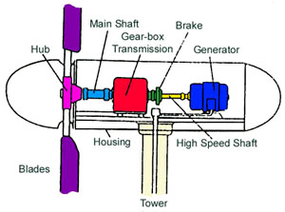**Wind Farms**

The most common size range for larger scale turbines is between 200 - 700 kW. The wind farm at Crookwell in NSW consists of 8 x 600kW turbines, generating a total of 4.8MW.

The greatest challenge to the economic use of wind power is its variability. There are very few areas on the Earth where wind is fairly constant throughout the day and throughout the year. Energy storage, or a backup system, is therefore required for windless or extremely windy periods, and also to level the supply even when the wind is blowing. Credit: Australian Cooperative Research Centre for Renewable Energy

Design and make something that works using wind energy such as a kite, windmill or sailing boat.

Research which countries rely on wind farms for electricity.

Design for simple kite using 3 plastic straws.

**Beaufort Wind Scale**

On the Beaufort scale, wind speeds are divided into 12 categories.

|  |  |  |
| --- | --- | --- |
| **Category** | **Speed** | **Description** |
| **0** | **calm under  1 km/h** | **Smoke rises vertically.** |
| **1** | **light air  1-5 km/h** | **Wind direction shown by smoke-drift, but not by wind vanes.** |
| **2** | **light breeze  6-11 km/h** | **Wind felt on face; leaves rustle; ordinary vanes moved by wind.** |
| **3** | **gentle breeze 12-19 km/h** | **Leaves, twigs in constant motion; wind extends light flag.** |
| **4** | **moderate breeze 20-28 km/h** | **Raises dust and loose paper; small branches are moved.** |
| **5** | **fresh breeze 29-38 km/h** | **Small trees in leaf begin to sway; crested wavelets form on inland waters.** |
| **6** | **strong breeze  39-49 km/h** | **Large branches in motion; whistling heard in telephone wires; umbrellas hard to use.** |
| **7** | **near gale  50-61 km/h** | **Whole trees in motion; inconvenience felt when walking against the wind.** |
| **8** | **gale  62-74 km/h** | **Breaks twigs off trees; generally impedes progress.** |
| **9** | **strong gale  75-88 km/h** | **Slight structural damage occurs  (roof tiles removed).** |
| **10** | **storm  89-102 km/h** | **Seldom experienced inland; trees uprooted; considerable structural damage occurs.** |
| **11** | **violent storm  103-117 km/h** | **Very rarely experienced on land; accompanied by widespread damage.** |
| **12** | **cyclone 118+km/h** | **Very nasty stuff for cows** |

Take a look outside. Estimate the strength of the wind using the Beaufort scale?

Wind energy is renewable and does not cause pollution. Why don't we use it more?

## 46. Renewable energy sources: moving water

People have been using the energy in moving water to do work for ages.

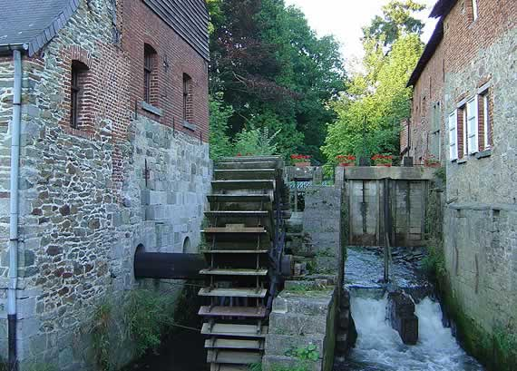

We are now using the energy in moving water to make hydroelectricity.

Tumut 3 Power Station at Talbingo.

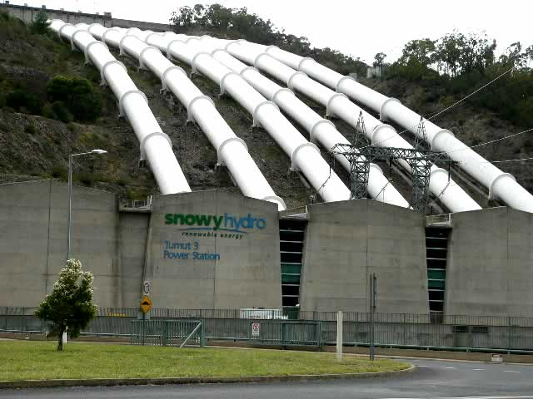

Unlike conventional coal-fired power stations, which take hours to start up, hydro-electric power stations can begin generating electricity very quickly. This makes them particularly useful for responding to sudden increases in demand for electricity by customers ("peak demand").

Hydro-stations need only a small staff to operate and maintain them, and as no fuel is needed, fuel prices are not a problem. Also, a hydro-electric power scheme uses a renewable source of energy that does not pollute the environment. However, the construction of dams to enable hydro-electric generation may cause significant environmental damage.

The amount of electrical energy that can be generated from a water source depends primarily on two things: the distance the water has to fall and the quantity of water flowing. Credit: Australian Cooperative Research Centre for Renewable Energy

Use the model of the marble on a slope to explain why the water supply pipes for the power station need to be on a long, steep slope.

Do an investigation. Roll a marble from the top of a slope and part way up it and measure the distance the marble travels.

List the good points and bad points of hydro-electricity.

## 47. Renewable energy sources: biofuel

We can use the sun's energy to run cars and power stations from renewable plant sources by growing crops and trees to make fuel. These fuels are called biofuels.

Biofuels cycle the existing carbon dioxide in the atmosphere.

Fossil fuels are non-renewable and release carbon into the atmosphere that has been stored in a sink for millions of years.

The production of biofuels such as ethanol and biodiesel has the potential to replace significant quantities of fossil fuels in many transport applications.

The widespread use of ethanol in Brazil has shown that biofuels are technically feasible on a large scale. In the USA and Europe biofuel production (ethanol and biodiesel) is increasing, with most of the products being marketed in fuel blends, e.g. E20 is 20% ethanol and 80% petrol and has been found to be suitable for most spark ignition engines without any modifications.   
Credit: Australian Cooperative Research Centre for Renewable Energy

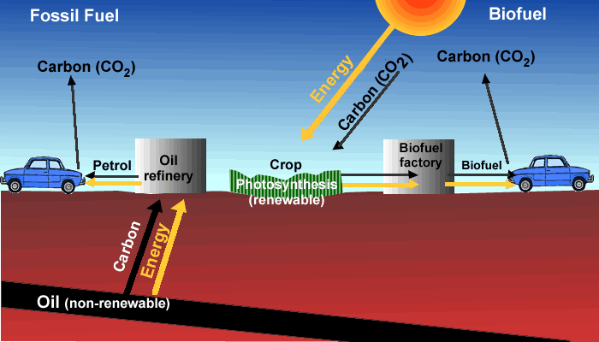

* Draw a carbon cycle diagram for a car using fossil fuel and another for a car using biofuel.
* Some biofuels are made from crops such as corn.  
  List all the good and bad points about this from the point of view of farmers, car owners and people who need food.
* Some biofuels are made from palm oil, a crop which grows in rainforest areas. List the good and bad points about biofuel made from palm oil.
* When a car burns fuel, it produces carbon dioxide gas that goes into the atmosphere. Explain why are biofuels thought to be more environmentally friendly than fossil fuels?
* What are the advantages and disadvantages in using biofuels instead of fossil fuels?

**QUIZ**

Term for a renewable fuel made by growing plants?

## 48. Renewable energy sources: photovoltaic panels

This page on photovoltaic panels is based on work done by the Australian Cooperative Research Centre for Renewable Energy and has been taken from, 'The RE FILES'.

In photovoltaic panels light falls on a two layer semi-conductor device which produces a potential difference between the layers. This voltage is capable of driving a current through an external circuit.

The development of photovoltaic panels in Australia has been stimulated by:

* the need for low maintenance, long lasting sources of electricity suitable for places remote from both the main electricity grid and from people; e.g. satellites, remote site water pumping, outback telecommunications stations and lighthouses
* the need for cost effective power supplies for people remote from the main electricity grid; e.g. Aboriginal settlements, outback sheep and cattle stations, and some home sites in grid connected areas
* the need for non-polluting and silent sources of electricity; e.g. tourist sites, caravans and campers
* the need for a convenient and flexible source of small amounts of power; e.g. calculators, watches, light meters and cameras
* the need for renewable and sustainable power, 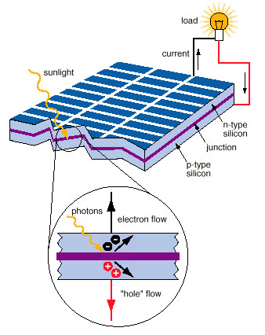as a means of reducing global warming

To understand the operation of a PV cell, we need to consider both the nature of the material and the nature of sunlight. Solar cells consist of two types of material, often p-type silicon and n-type silicon. Light of certain wavelengths is able to ionise the atoms in the silicon and the internal field produced by the junction separates some of the positive charges ("holes") from the negative charges (electrons) within the photovoltaic device. The holes are swept into the positive or p-layer and the electrons are swept into the negative or n-layer. Although these opposite charges are attracted to each other, most of them can only recombine by passing through an external circuit outside the material because of the internal potential energy barrier. Therefore if a circuit is made (see figure 3) power can be produced from the cells under illumination, since the free electrons have to pass through the load to recombine with the positive holes.

List the advantages of photovoltaic panels.